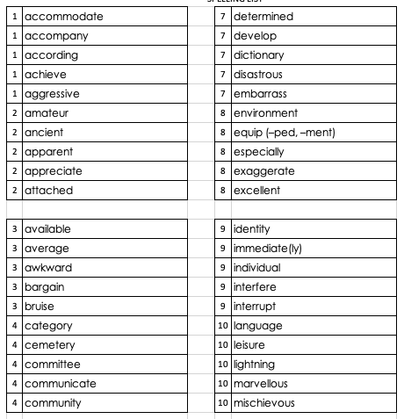
Year 5 and 6 spelling list.

Words are numbered in the order that they will be sent home in Y5. (ie – all the words with 1 by them will be on the first list, etc!)
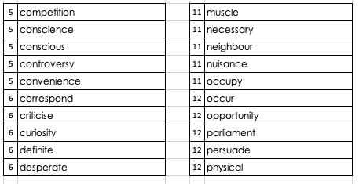
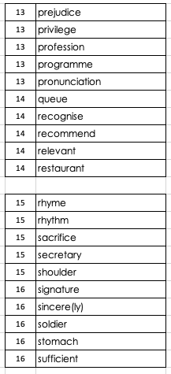 | 