Thoughts for the term……
Weekly reminders

PE Days
2H Tuesday and Wednesday

Reading books - Monday and Friday

Reading Racetrack books - Friday

Library books – Tuesdays, as and when we can

PE

Football

Dance
Geography
This term, we will start off by recapping previous work on the UK. We will then be learning about the continents, oceans and climatic zones around the world.
History
In our history sessions, we will be approaching the familiar topic of ‘The Great Fire of London’ in an exciting way. Enquiry and investigation will be the heart of this area of study, where the children will become history detectives. We will step into the shoes of people from the past and look at how the Great Fire impacted everyday life.
Music
We will be covering a unit called ‘Hands, Feet and Heart’. This unit will cover pulse and we will be learning to play the glockenspiels as an accompaniment to the song.
Maths
We will begin by focusing on the place value of 2 digit numbers. The children will represent these numbers using different maths equipment. We will then apply this when comparing numbers and working out addition and subtraction. Counting in 2s, 5s and 10s will also be a focus.
English
In our phonic/spelling lessons, we will be recapping Chapter 4b as well as learning spelling rules and patterns. We will be learning how to form all of the cursive letters correctly and working on neat handwriting. In our English lessons we will be building sentences and using the correct punctuation. We will be learning about nouns, verbs and adjectives and applying these in our writing. In our ERIC sessions we will be working on improving our pace and working on literal comprehension skills.

Year Two Autumn Newsletter
Computing
We will start off by looking at the basic functions of a computer, followed by our Computer Art topic. This topic will explore the different paint tools and what they can do.
Art
The children will be completing a unit on African art by exploring Kente Cloth. They will focus on primary and secondary colours, as well as analogous and complementary colours. They will then explore using colour to create different effects in their work.
Ask questions – comprehension is key.
Design Technology
Our focus for Autumn term is textiles. We will be designing, making and evaluating Christmas decorations, whilst experimenting with a range of stitch techniques.

Science
We will be building on previous learning about materials. The children will be learning about different materials and their properties, and they will be working scientifically to explore them in a range of ways.
RE
The children will be learning what might be found in a Jewish home and how these objects link to the Jewish way of life.
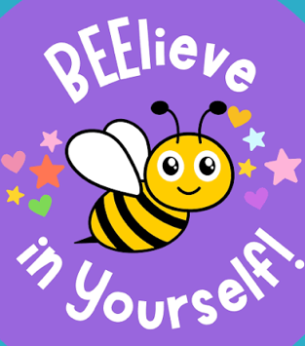
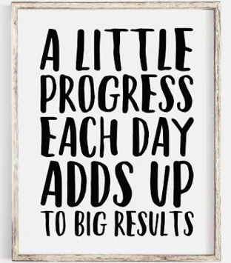
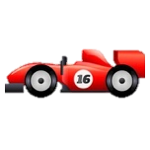
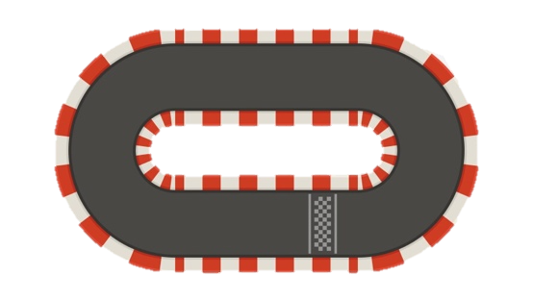
Don’t forget to check our class webpages regularly for photos and updates about what we’ve been learning.

www.flixtonprimaryschool.org.uk
A note on reading….
In order for your child
to move around the
track, you need to
sign to say they have
read 4 times a week.
This can be any book
they have read.
As well as reading
their school books,
please encourage a
love of reading by reading a variety of texts e.g. library books, magazines, signs,
menus, newspapers.

Miss Harris (2H) and Mrs Delaney (2D)

