Welcome to RJ



Hi children and parents. I am Miss Jackson and I am the teacher is RJ. I can’t wait to start our journey together in Reception. l love teaching early years at Flixton Primary School. I had three very enjoyable years in reception and also taught nursery. I have a daughter who is twelve who is almost as tall as me!
In my spare time I enjoy spending time with my family, going to the theatre and reading. I go to a weekly art class too.

Here are some photos of our classroom.

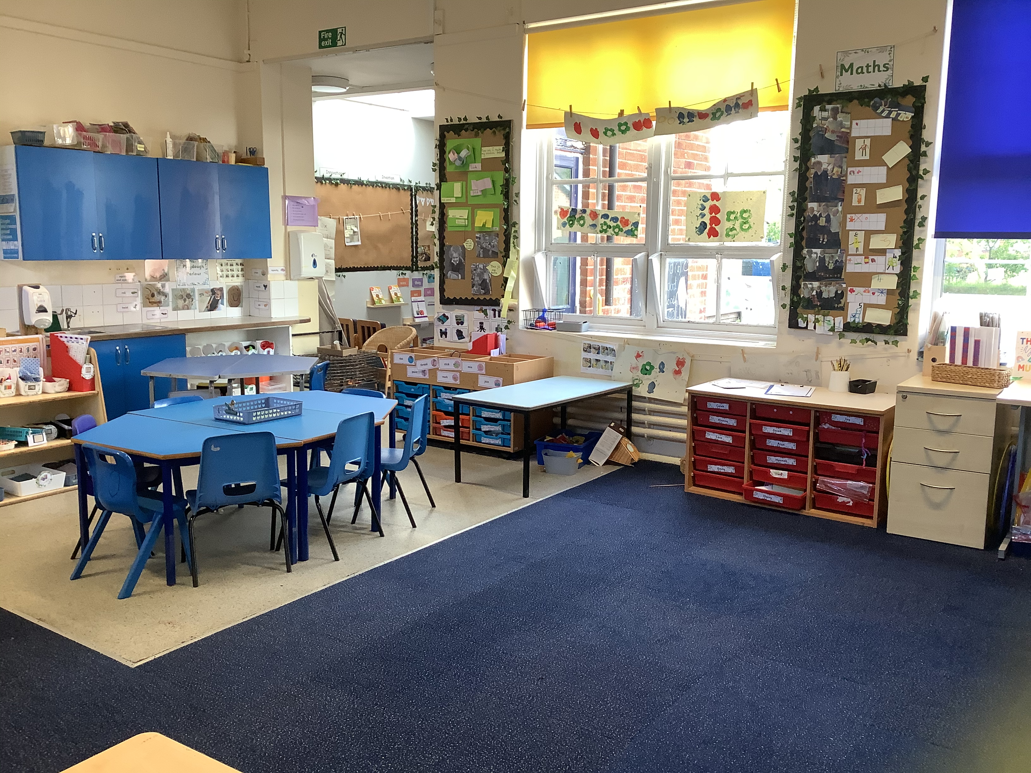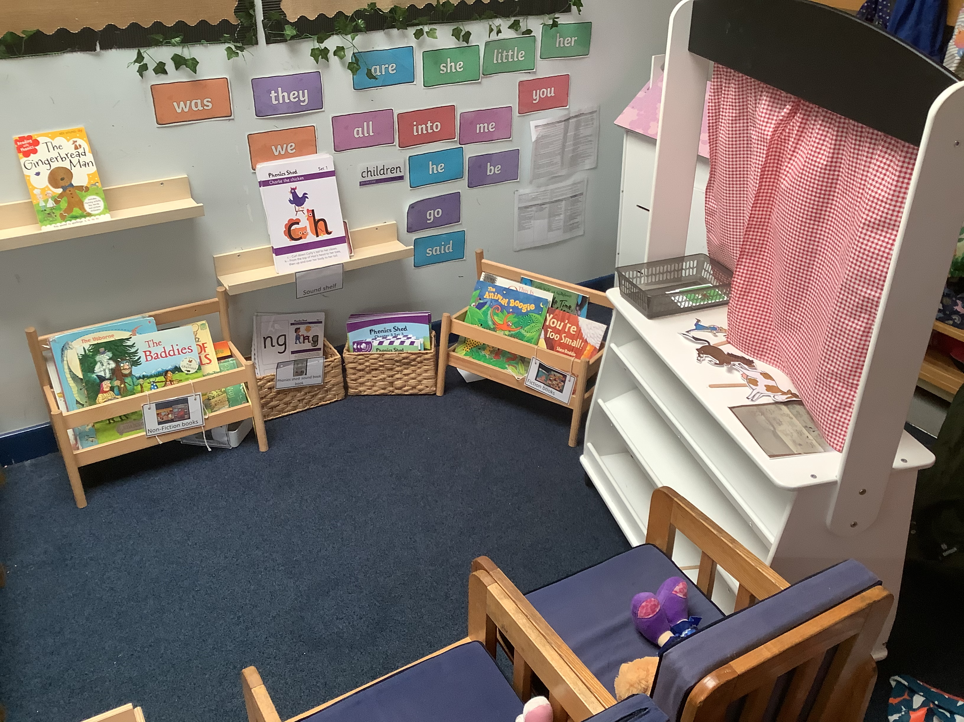
Outdoor area

