Phonic Shed Access at Home

Children can access Phonic Shed games and books at home by using their Spelling Shed login details. Follow the link below and sign in with your username and password.

https://www.edshed.com/en-gb/login

You will then be directed to the main screen.
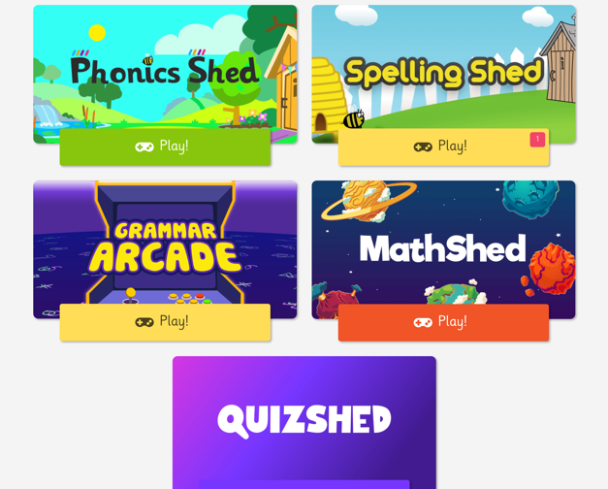

From here children can play games on Phonics Shed, Spelling Shed, Maths Shed, Quiz Shed and Grammar Arcade. Any assignments set by their teacher can be found at the top of the page.

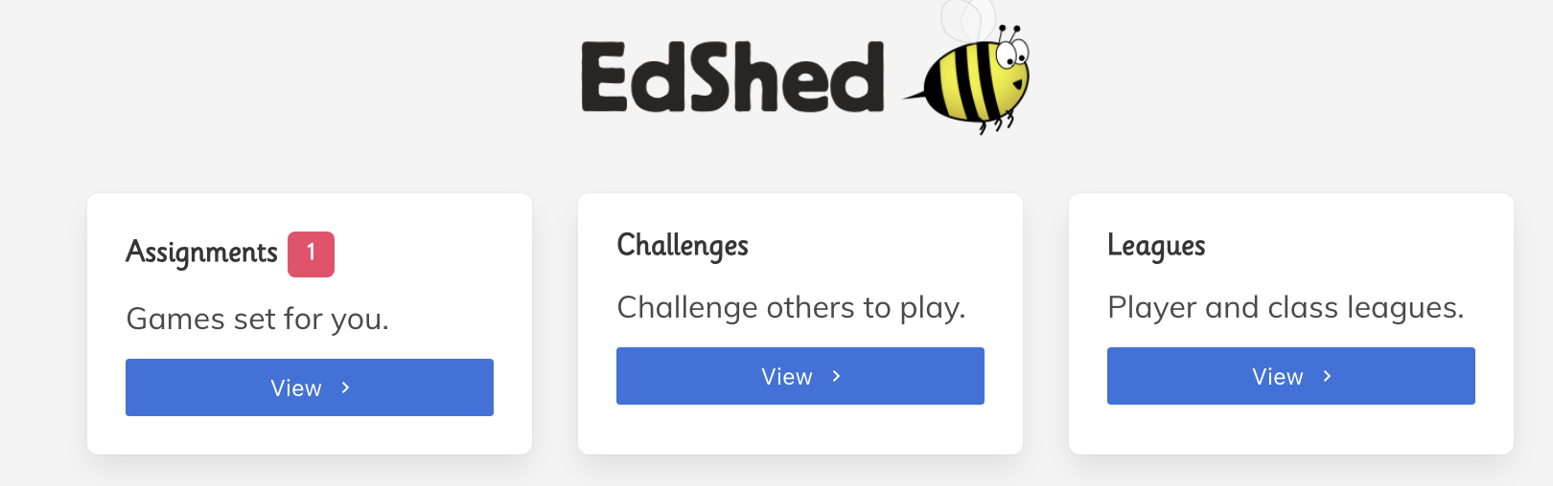

If you click on Phonic Shed, you will be directed to the phonics pathway. There are some ‘Toybox Games’ at the bottom about different sounds (linked to Chapter 1 for Nursery).

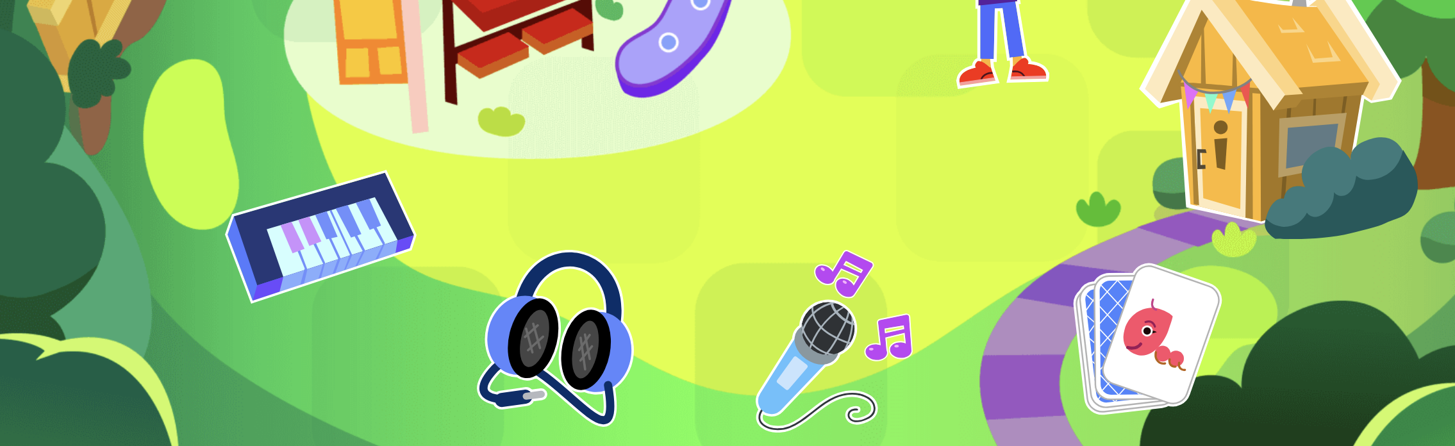

You can follow the path of sounds and click on any sound to play games. The sounds are in the order that they are taught from Chapter 2 – 4b.

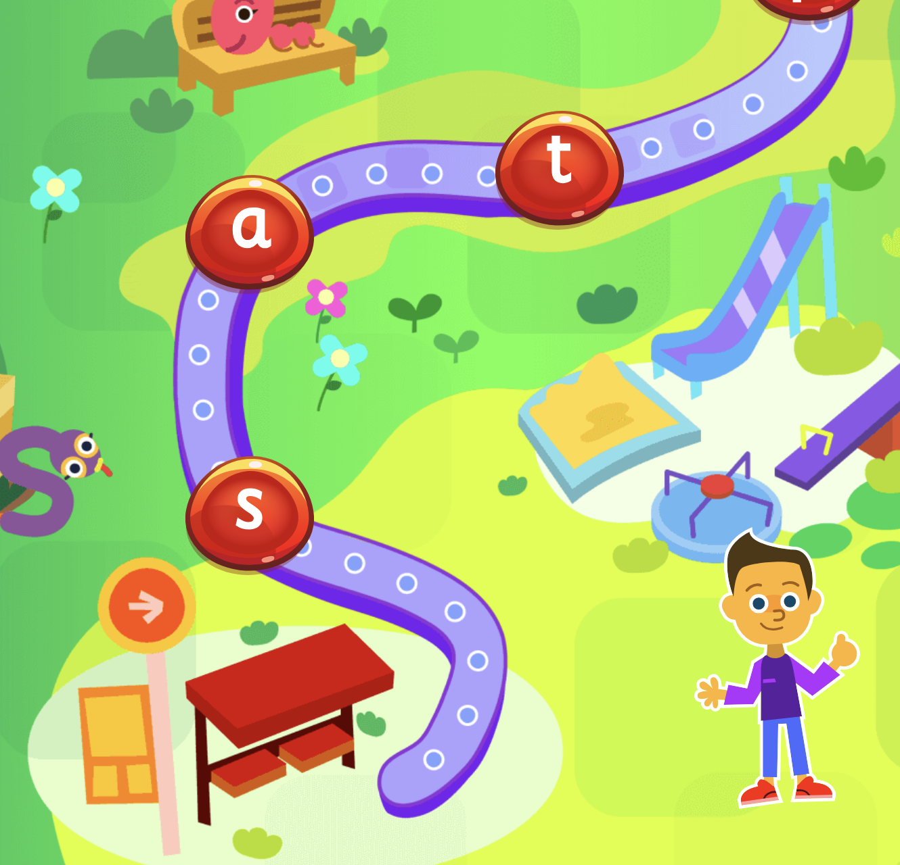

You can access books linked to each sound by clicking the book icon in the top right hand corner. 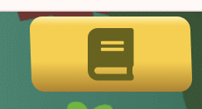 This will take you to the bookshelf. Each Chapter can be selected from the top and there are books linked to each sound/character.

