Welcome to Nursery
Hi, I am Mrs Young (the one with the antlers), and I am the Nursery teacher on Mondays, Tuesdays and Wednesdays, and on Thursday mornings. Mrs Wilson teaches on Thursday afternoons and all day on Fridays. I have been a teacher at Flixton for 13 years and have been in Nursery for the past three years. I have two grown-up boys at home, aged 16 and 18. In my spare time, I enjoy playing rounders, quizzing with my boys and spending time with my family, especially my great-nephews, who are 1 and 4 years old.
Mrs Wilson also has two children, a boy and a girl. She loves reading, playing sport and watching football with her children.
We can't wait to start our journey together in Nursery!

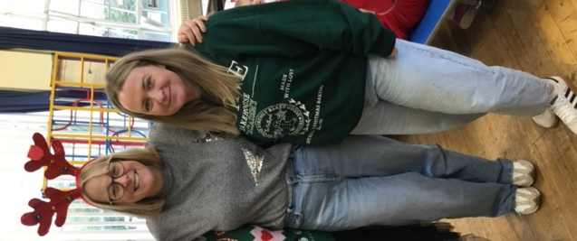

Here are a few photos of our classroom:

