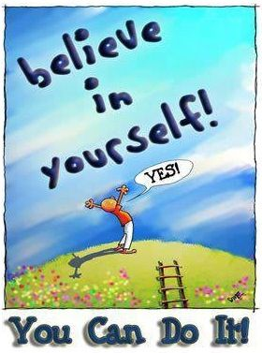
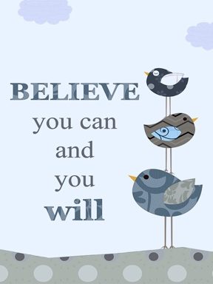
English
We will be moving onto our new set text (which we are keeping as a surprise!) As part of this, we will be recapping:
Accurate punctuation
Commands, statements, questions, exclamation sentences
Adjective pair sentences
Similes
Co-ordinating conjunctions
Subordinating conjunctions
Commas in a list
Cursive handwriting
We will continue to work through our best fit rules for spelling and using suffixes.
History
In history, we’re going to continue our learning about what makes a great explorer, why people explore and the impact some explorers had on the world and us. We will then focus on the question ‘Who is Manchester’s Greatest History Maker?’

Mathematics
This term, we will be recapping the 4 calculations and applying our skills to solve problems. We will also continue to deepen our understanding of how basic number facts can be applied across different areas within maths. We will then be looking at measures, position/direction and shape work in more depth.
Science
In science, we will be finishing our ‘Plants’ unit. We will be learning about what seeds need to germinate and what plants need to survive. We will then move onto our ‘Animals and their Habitats’ unit, looking at a range of habitats and microhabitats.
Art
Our new unit is called ‘Pattern and Printmaking’. We will explore lots of different patterns around us and use various techniques to create our own patterns, including printing.
Computing
In computing, we will be focusing on information technology to create a document that contains formatted texts and images.
PE
In PE, we will be focusing on ‘Dodging’ and then ‘Games for Understanding’.
Ask questions – comprehension is key.
A note on reading….
In order for your child
to move around the
track, you need to
sign to say they have
read 4 times a week.
This can be any text
they have read.
As well as reading
their school books,
please encourage a
love of reading by reading a variety of texts e.g. library books, magazines, signs,
menus, newspapers.

Year 2 Visit: We are hoping to visit Quarry Bank Mill to help bring our geography and science units to life.
Transition: In the second half term, we will be doing lots of activities to support the children’s transition into the Junior Department. This will include having lunch in the junior hall, visiting and working in their new classrooms with us, meeting their new teachers and talking to current Yr3. More information will be provided nearer the time.

Weekly reminders-
P.E.- Tuesday, Thursday (2H), Tuesday, Wednesday (2D)
Reading books – The children can bring these in to change on any day.
Reading racetrack books in - Friday
Library books- Every other Monday

Design Technology
We will be designing and creating our vehicles. Our learning will then be linked to our science work this term and we will be exploring healthy foods. We will be designing healthy snacks and practising the skills needed to make them. We will then be working with Mrs Tatham to make them and most importantly, eat them!

Music
Our new unit in music will focus on composition. In this unit, we will be exploring lots of different percussion instruments and we will be creating and performing our own composition based on our learning on different habitats.
PSHCE
We be looking at ‘rights and respect’ and ‘being my best’. We will also be covering our SRE topics (letters with more info to come) and discussing medicines and risk.

Thoughts for the term……
RE
We will finish our unit on Islam before exploring the question, ‘How should we care for others and the world, and why does it matter? “As always, we will be learning from and about other religions.

Geography
We will start our unit on comparing different localities. We will focus on human and physical similarities and differences between Formby and Flixton. We will revisit learning on continents and oceans and our knowledge of the UK and surrounding areas.

YEAR TWO summer NEWSLETTER

