Year 6 Summer Term
Science:
We will be starting our Animals including Humans topic:
- Identify and name the main parts of the human circulatory system, and describe the functions of the heart, blood vessels and blood.
- Recognise the impact of diet, exercise, drugs and lifestyle on the way their bodies function.
- Describe the ways in which nutrients and water are transported within animals, including humans.
We will also be learning about Evolution and Inheritance:

  - Recognise that living things have changed over time and that fossils provide information about living things that inhabited the Earth millions of years ago.
  - Recognise that living things produce offspring of the same kind, but normally offspring vary and are not identical to their parents.
  - Identify how animals and plants are adapted to suit their environment in different ways.

English:
This term we will be revising lots of our learning.
- In comprehension we will be focusing on higher level deduction and inference skills. As well as working on increasing pace, adding detail to answers and using evidence to justify our answers.
- In writing we will cover different text types and revise Y6 sentence types.
- We will be finishing reading ‘Goodnight Mister Tom’ and reading ‘Wonder’, with lessons structured around the text.

Maths:
We will be focusing on:
- Statistics (including different types of graphs and averages).
- Properties of shape (including measuring angles and nets of 3D shapes).
- Arithmetic (including working with fractions, percentages, decimals and order of operations).
- Accuracy and efficiency of written methods (including decimals).

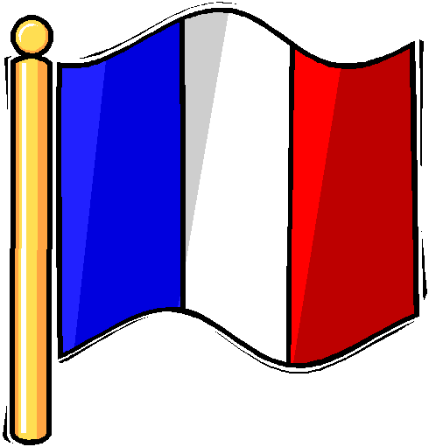

History:

We will complete our topic on WWII. We will learn about the effects of war on other countries and how the war ended.

Y6 Residential
We are looking forward to the residential on 15th – 17th July. During this term, Mr Redmond will meet with Y6 to prepare them for the trip.

PE:
Outdoor (Monday): Football
Outdoor (Wednesday): Athletics

Geography:
We will be continuing to study St Lucia. We will learn about conservation, fair trade and tourism.

PSHCE:
In our weekly PSHCE lessons we will be learning about respect for ourselves and others. We will also cover transition to high school and preparing for change.

We will also be teaching the RSE (Relationships and Sex Education) and DE (Drugs Education) elements of our PSHCE curriculum.
Music:

We will be developing some of our prior learning on rap music to write and perform our own raps.
We will be using our experiences at FPS as inspiration as we prepare for our journey into secondary school.
RE:
This term we will be learning about the impact of arts and architecture on religion. We will also be considering generosity and charity.
Art:
We will be continuing the topic - Movement. We will be learning about how different artists portray movement through their work. We will also be studying the human form and exploring with different media.

Design and Technology:

We will be designing and making board games paying particular focus to purpose, theme and audience.
French:
We will be learning about French speaking countries and celebrations. Then we will be continuing onto World War II.
Computing:
During the Summer term, Y6 will be completing their Scratch games.
We will then be building and programming robots.

