**PE – Football**

**PE – Dance**

**Computing**

**We will start off by looking at the basic functions of a computer, followed by our Computer Art topic. This topic will explore the different paint tools and what they can do.**

**History**

In our history sessions, we will be approaching the familiar topic of ‘The Great Fire of London’ in an exciting way. Enquiry and investigation will be the heart of this area of study, where the children will become history detectives. We will step into the shoes of people from the past and look at how the Great Fire impacted everyday life.

**Music**

We will be covering a unit called ‘Hands, Feet and Heart’. This unit will cover pulse and we will be learning to play the glockenspiels as an accompaniment to the song.

**English**

In our phonic/spelling lessons, we will be recapping Chapter 4b as well as learning spelling rules and patterns. We will be learning how to form all of the cursive letters correctly and working on neat handwriting. In our English lessons we will be building sentences and using the correct punctuation. We will be learning about nouns, verbs and adjectives and applying these in our writing. In our ERIC lessons we will be working on improving our pace and working on literal comprehension skills.

**Geography**

This term, we will be recapping our work on the UK. We will then be learning about the continents, oceans and climatic zones around the world.

**Art**

The children will be completing a unit on African art by exploring Kente Cloth. They will focus on primary and secondary colours, as well as analogous and complementary colours. They will then explore using colour to create different effects in their work.

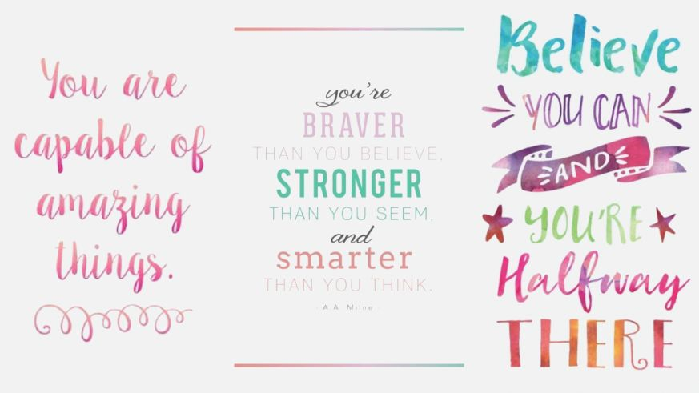

**Ask questions – comprehension is key.**

**Don’t forget to check our class webpages regularly for photos and updates about what we’ve been learning.**

**www.flixtonprimaryschool.org.uk**

Year Two AUTUMN Newsletter

**Thought for the term……**

**A note on reading….**

In order for your child

to move around the

track, you need to

sign to say they have

read 4 times a week.

This can be any book

they have read.

As well as reading

their school books,

please encourage a

love of reading by reading a variety of texts e.g. library books, magazines, signs,

menus, newspapers.

**Design Technology**

Our focus for Autumn term is textiles. We will be designing, making and evaluating Christmas decorations, whilst experimenting with a range of stitch techniques.

**Maths**

**We will begin by focusing on the place value of 2 digit numbers. The children will represent these numbers using different maths equipment. We will then apply this when comparing numbers and working out addition and subtraction. Counting in 2s, 5s and 10s will also be a focus.**

**Science**

We will be building on previous learning about materials. The children will be learning about different materials and their properties, and they will be working scientifically to explore them in a range of ways.

**RE**

The children will be learning what might be found in a Jewish home and how these objects link to the Jewish way of life.

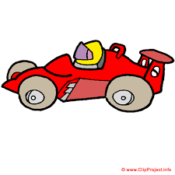

Weekly reminders -

**P.E.-**Tuesday and Friday 2H

Tuesday and Wednesday 2D

**Reading Books** - Monday and Friday

**Reading Racetrack Books**- Friday

**Library Books** – Every other Monday

**Spellings on Spelling Shed–** Friday

**Miss Harris (2H) and Mrs Delaney (2D)**