**Year 6 Autumn Term**

**Science:**

Our topic is Light.

We will be learning:

* how light travels.
* the internal and external parts of the eye.
* how we see objects.
* how shadows are formed.

**English:**

* In **comprehension** we will be focusing on retrieval and inference skills.
* In **writing** we will cover different text types and Y6 sentence types.
* We will be working on presentation skills and ensuring handwriting follows our scheme.
* We will be **reading** ‘Rose Blanche’ and ‘Goodnight Mr Tom’, with lessons structured around the text.
* We will also be studying a non-fiction text in order to retrieve, record and present information.

**Maths:**

This term we will be working on:

* Accurate and quick recall of times tables.
* Accuracy of written methods.
* Reasoning and solving problems.
* Place value of numbers up to 10,000,000.
* Rounding numbers.
* Understanding negative numbers.
* Calculating with fractions.
* Converting measures.

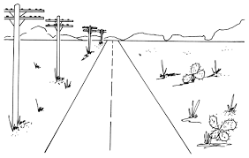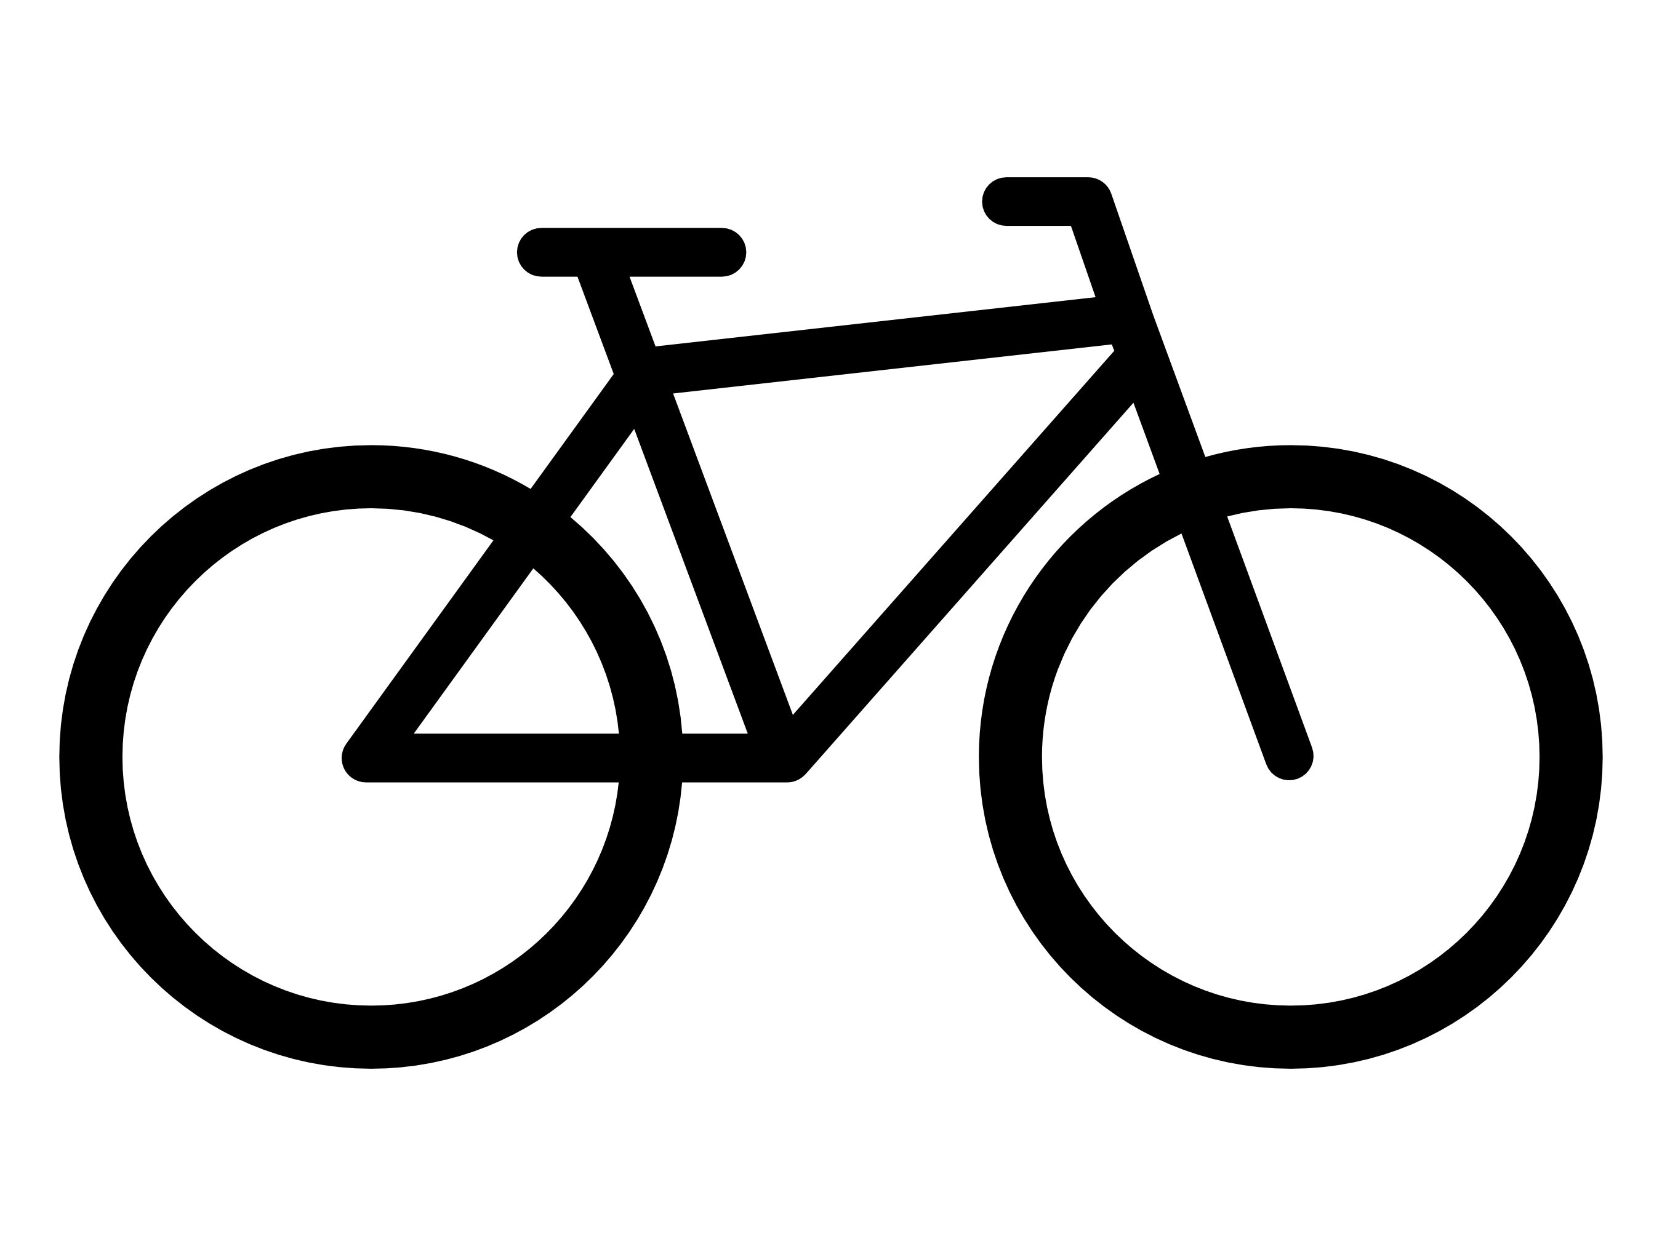****

**Music:**

Our topic is Rap

music and we will be

rapping to ‘The Fresh

Prince of Bel Air’.

**PSHCE:**

In our PSHCE lessons we will be studying:

* Self-worth and empathy.
* Respect.
* The Zones of Regulation.
* Our school rules and the 4 Bs.

**Geography:**

Our topic is Salford Quays:

* The location and its regeneration.
* Land use and function.
* To investigate why it was developed.
* The human impact on the area.

**Art:**

Our topic is Perspective:

* Creating an illusion of space.
* The work of Renaissance artists.
* One and two point perspective.

**Design and Technology:**

Our topic is Fairgrounds.

We will be learning all about levers, pulleys and gears.

**Reminders:**

Reading Racetrack books are due in every Friday.

Library sessions will be on Friday for both 6S and 6F.

Make sure you have a full and named PE kit in school.

We will be doing a Bikeability course in the first half of this term – more details to follow.

**French:**

Our topic in the first half of the term is ‘At School’ followed by ‘Healthy Lifestyles’ in the second half.

**PE:**

Indoor PE (Monday): Dance and Gymnastics.

Outdoor PE (Wednesday): Invasion Games

**RE:**

We will be learning about Buddhism.

We will find out about why Buddha is important as well as learning about meditation, the Eightfold Path and the Four Nobel Truths.

**Computing:**

We will be learning how to keep safe online.

Also this term, we will be creating QR Codes to be used within a history Y6 project.

After half term, we will be starting our animation projects.

**History:**

We will be learning about World War II. We will cover:

* Life in Britain during the war.
* The Blitz.
* What life was like for an evacuee.