Reception Newsletter Autumn 1

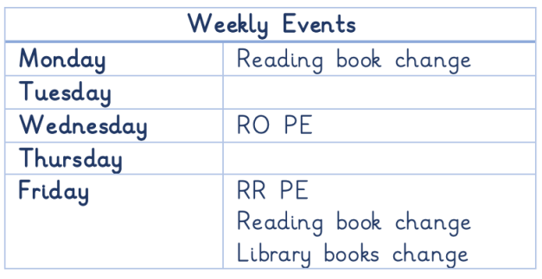

**Maths**

In Maths we will be learning about:

* Numbers to 5
* Patterns
* Number bonds to 5
* Introduction to addition
* Introduction to subtraction

**We are so excited to begin this year with your children. We can’t wait to watch them flourish!**

**Please make sure all items of uniform are clearly named, including PE kits, wet suits and wellies.**

**Any unnamed items will be placed in lost property.**

**Reception Baseline**

This half term all children will take part on the Reception Baseline. You can find more information about what this will entail here: <https://www.gov.uk/government/publications/reception-baseline-assessment-information-for-parents>

**Literacy**

**In Literacy we will be learning about:**

* Recognizing and writing our name.
* Stories linked to ourselves or our families in Autumn 1 and then in Autumn 2 our text will be Lost and Found.
* Letter formation and pencil grip.

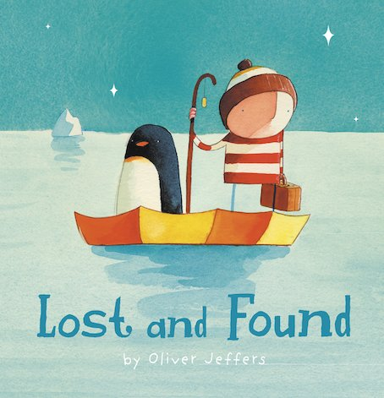

**Phonics**

We will begin our phonics journey in Reception this half term.

We will begin with orally segmenting and blending words.

Then we will learn our Chapter 2 sounds and some tricky words.

Children will sometimes receive home learning on Friday linked to the phonics sounds we have been learning that week. Please encourage children to write letters on the line in pencil.

Children will begin to take reading books home from October.

Dates to remember

PTA Welcome BBQ Thursday 18th September after school.

Phonics workshop for parents – Wednesday 1st October 6pm-7pm.

PE kits will not be needed until after October Half Term.

**Website**

Check the class page on the school website [www.flixtonprimaryschool.org.uk](http://www.flixtonprimaryschool.org.uk/) to see what has been

happening in your child’s class. Check out the ‘gallery’ at the bottom of class pages for photos.

**Useful info** Any queries please use the parent contact email [parentcontact@flixtonprimaryschool.org.uk](mailto:parentcontact@flixtonprimaryschool.org.uk)

(please put your child’s class in the subject)