Ideas for practising spellings:
Pyramid writing  s  sp  spe  spel  spell  spelli  spellin  spelling | 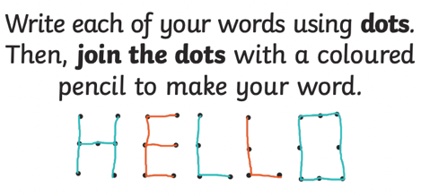  Join the dots | 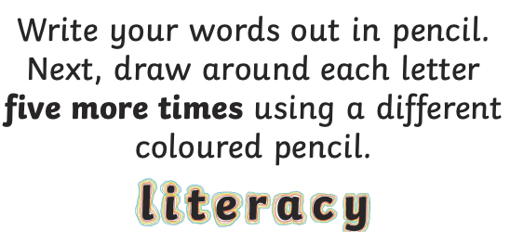  Rainbow words | Spelling races / Speed write  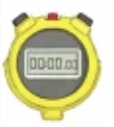  How many times can you write your words in 1 minute?
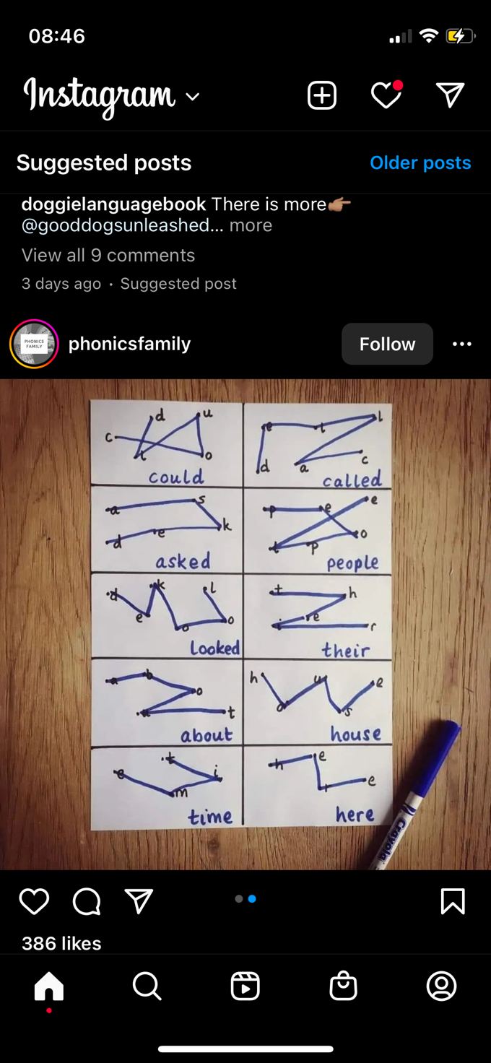  Dot to Dot | Rainbow Write  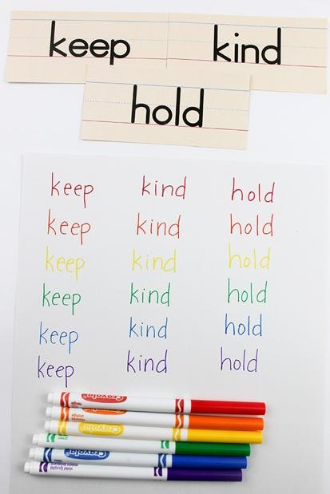 |   Bubble Writing | Spelling shapes  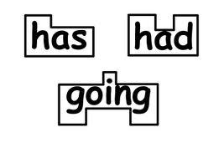
Steps to spelling  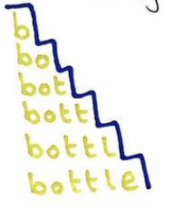 | 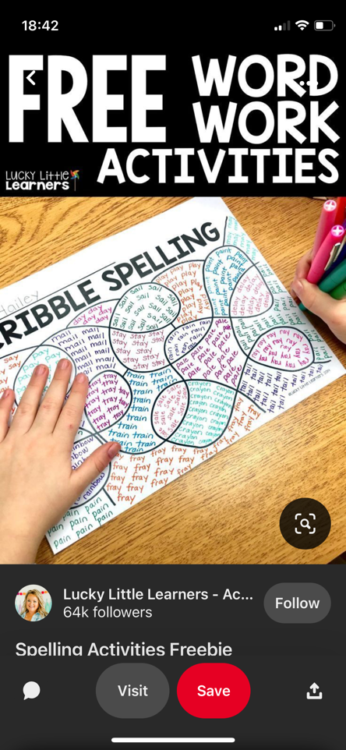  Scribble spelling | 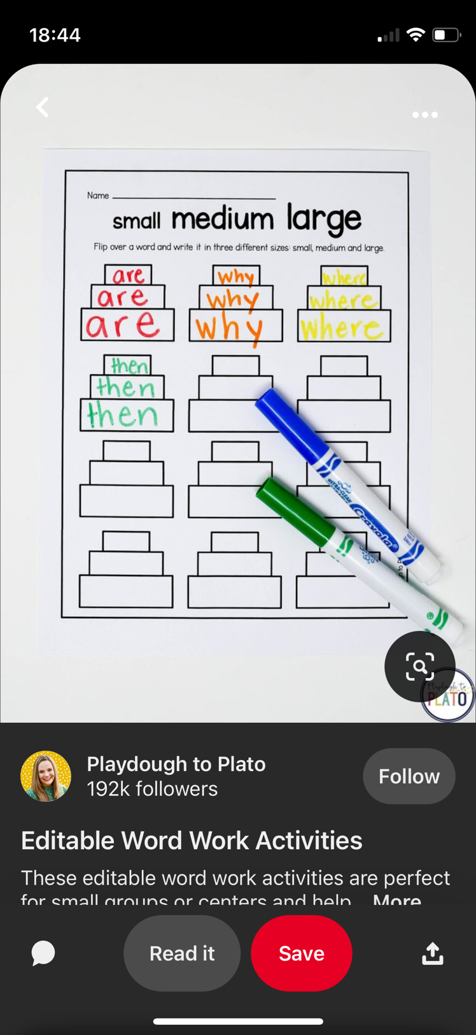  Spelling sizes | Spiral spelling  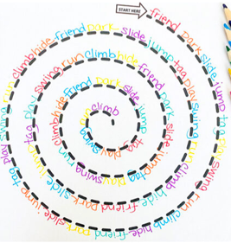
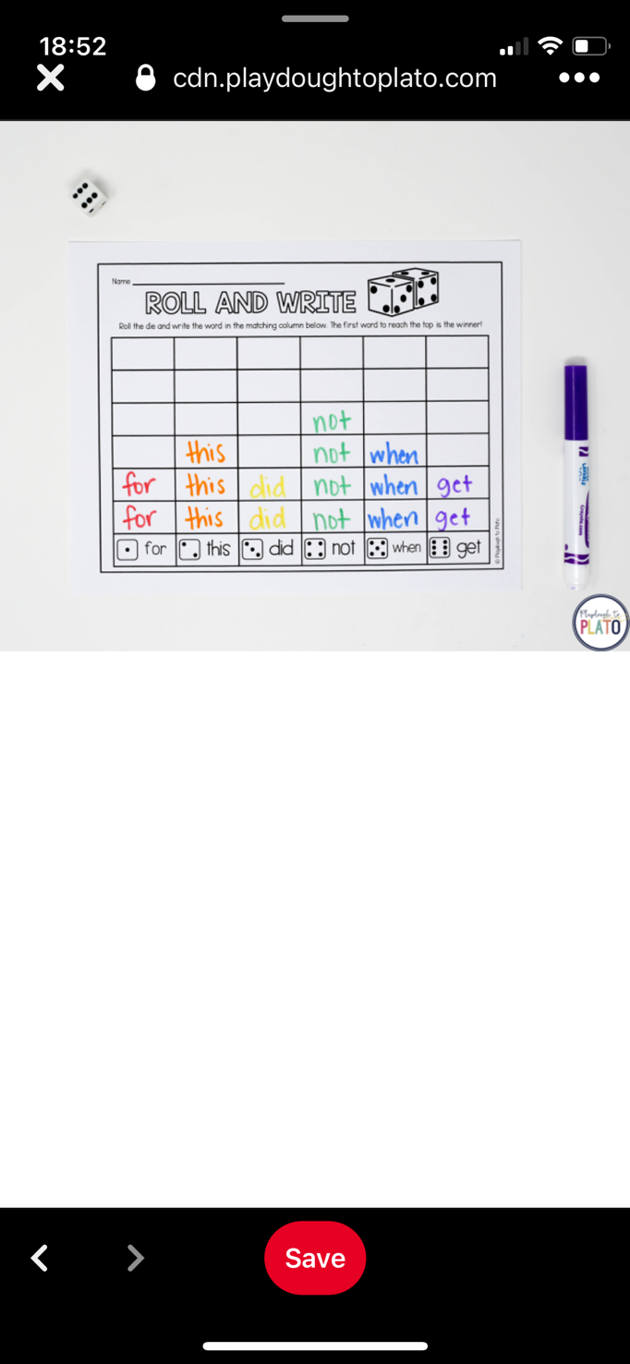  Roll and write | 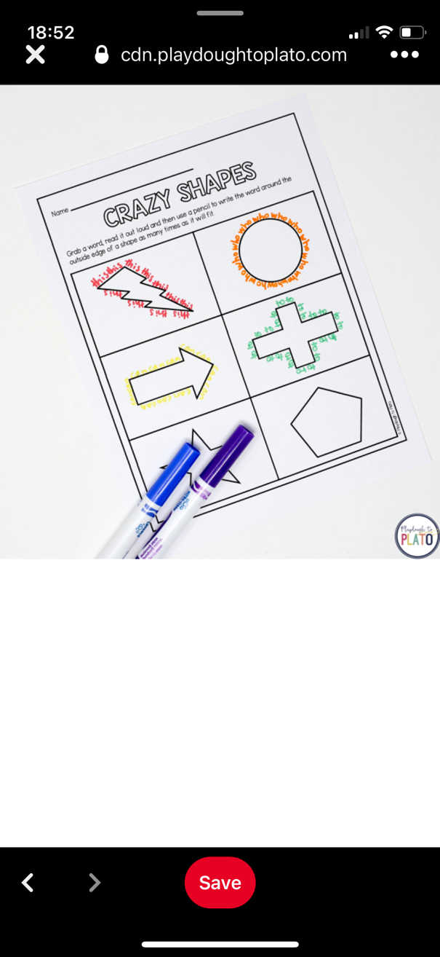  Crazy shapes | Rainbow letters  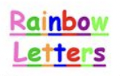 | Word scramble  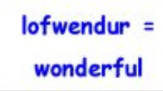
Headlines  Cut letters out of magazines and newspapers to spell your words!  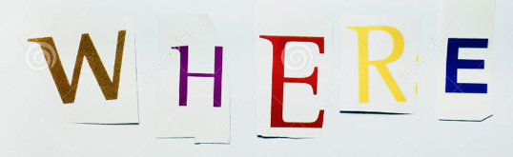 | Super sentences  Write sentences for each of your words  It was an ancient artefact. | Fancy letters  Write each of your words out using ‘fancy’ writing.  embarrass  environment | Upper and lower  Write your word normally.  Then  Rewrite it with the vowels in lowercase and the consonants in upper case letters.  SPeLLiNG
Consonant circles  Write out your words and circle all of the consonants.  a m a t e u r | LSCWC  Look at your word.  Say it.  Cover it.  Write it.  Check it!  Repeat! | Blue vowels  Write out your word. Trace over all the vowels in blue (or a colour of your choice!).  attached | Syllables  Write out the word. Divide it into syllables.  cem-e-tery
Mnemonics  Write a sentence or phrase to help you remember the letters in the word.  Big Elephants Can Always Understand Small Elephants.  Fri the ends of your friends. | Backwards words  Write your words forwards and backwards.  Where erehW | Make a wordsearch  Make a word search using your words. After a few days, come back and see if you can find the words!  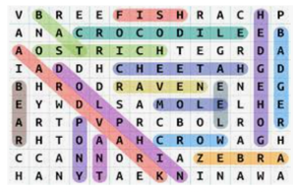 | Words within words  Write your word then write at least two words that can be made from the same letters.  determined  term  deter  mine
Words without consonants  Write your words in a list, but replace all the consonants with a line.  Go back to your list some time later and see if you can fill in the consonants!  a_ai_a_ _e | Spelling flashcards  Make a set of spelling flashcards.  When you look at the flashcard, say the word and spell it out loud.  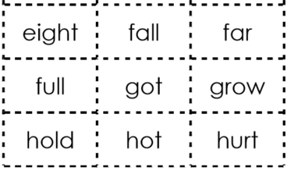 | Draw an image around the word  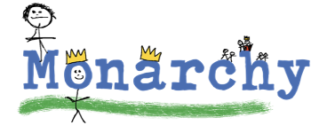 | Say the word in a silly way  (eg – pronouncing silent letters)  En-vi-ron-ment

