St Anne’s Play ground Design Autumn 2025
Tree climbing
Den building Area
Shelter for den building
Mud Kitchen
Digging Area
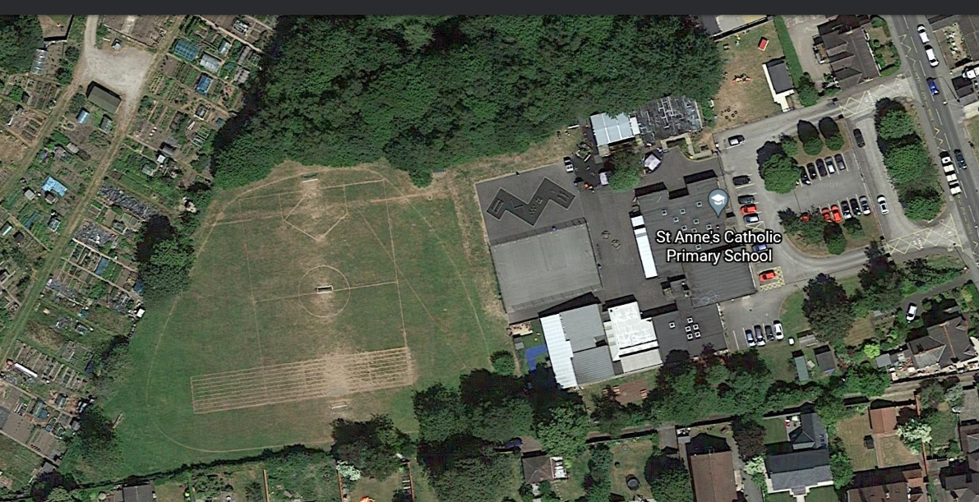
Reading shed
Prayer Garden
Sensory space
Small world
Rockery
Completed
PHASE 1 November/December 23
PHASE 2: March/April 24
PHASE 3: June/July 24
PHASE 4: Autumn 25

Tyres
Water Area (with sinks)
Dance/performance area
Music
Scooter Store
Allow grass to grow long. Wood boarder.
Storage
Boat
Sandpit
Trampoline
Tepee tent/shelters
Log and picnic benches
Running Track

