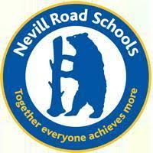
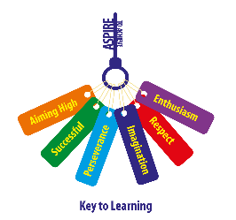
Nevill Road Junior School
Parent Newsletter – 17.9.21

Dear Families,
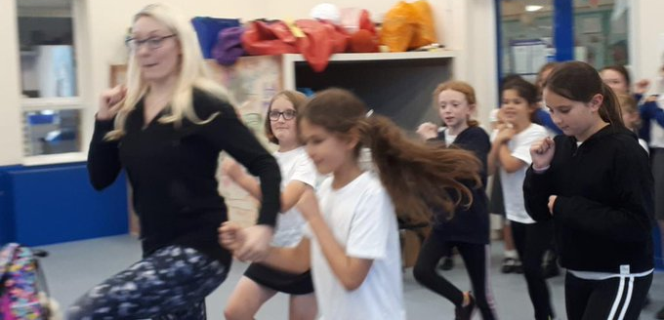
It has been a busy week at the Juniors - we have seen our clubs start back up again including Peformance Club, tennis and lacrosse. I have loved delivering face to face assemblies and being able to spend more time in classrooms with the staff and children. Our hall and dining room have also been back in action after 18 months! I would also like to welcome our new families. Since the beginning of term we have had 14 new children join our growing Nevill Road family!
Our Curriculum
Our first curriculum workshop of the year took place last Friday! Dr Diane Davies, a Mayan archaeologist specialist, came in to work with Year 6 on their Topic to investigate their enquiry questions including:
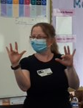
Where and when did the Maya live? Why did it take so long to discover Mayan settlements? How did the Mayans write & what was their number system?
The children enjoyed looking at a variety of artefacts and making clocks inspired by the Mayan number system.
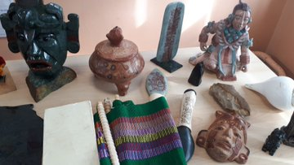
Our ASPIRE theme this half term is Aiming High and in our circles we discussed the amazing achievements of Emma Raducanu in the US Open Championship. Mrs Jordan also launched our new timetables challenge, where children will be able to achieve bronze, silver and gold awards to help them learn their multiplication and division facts. Our 100 reads challenge is proving as popular as ever and four badges have already been presented! Today you will be receiving your year group newsletter and Curriculum Maps.
Please follow us on twitter @NRJuniors to see daily updates on school life.
Health and Safety Reminders
It is strongly advised by the Local Authority that children do not wear any jewellery in school. When doing PE earrings should either be left at home on PE days, or children need to be able to remove them themselves. Long hair must also be tied back for safety.

Please be mindful of the parking and traffic situation outside the school gates and in the surrounding area. The health and safety of the children and adults is of great importance – so please park responsibly, ensure we all have good road sense and if possible, enjoy the walk, cycle or scoot to school.

PE kits and school uniform
Please remember to send children in to school in their kits on PE days. Children must wear white tops, no football shirts.
On non PE days, we ask that children wear school shoes and not trainers.
Thank you

Diary Dates
Friday 24th September – McMillan Coffee Morning cake sale and dress down day (bring £1 donation, 50p per cake)
Thursday 23rd September – 4P River Study Macclesfield Forest
Monday 27th September – 4T River Study Macclesfield Forest
Thursday 30th September – 4K River Study Macclesfield Forest
WB Monday 4th October – Parent meetings (telephone calls)
Tuesday 5th / Wednesday 6th – Y3 SEND support meetings
WB Monday 11th October – Y4 / 6 Road Safety Awareness
Monday 11th October – Y6 Conway / SATs meeting (5.00pm)
Monday 18th October – RSHE Parent Workshop (9.15am)
Friday 22nd October – End of Term

Homework Expectations
We know that homework is a bit like marmite…you either love it or hate it and we fully appreciate that at times it is difficult to fit it in to the week. However, we see in school the difference it makes for those children who do complete the activities and are always here to help if you need further support.


On Friday 24th September we will be trying to raise has much as we can to support this fantastic cause. Please bring cake donations into school on Thursday 23rd September. Cakes cost 50p each and for a further £1, children may come into school in their own clothes.

Have a great weekend.
Kind regards
Mrs Cliff

Together Everyone Achieves More

