Nevill Road Junior School
Reading Progression

Contents
Progression in Reading Lessons Introduction 2
Reading Skills Progression Grid 4
Year Three Progression 5
Year Four Progression 7
Year Five Progression 9
Year Six Progression 11
Guide for average words in reading extracts chosen 14
Guide for Lexile Level in reading extracts chosen 14

Progression in Reading Lessons

This document should be read alongside the school’s reading and phonics policy. This document discusses how we ensure progression within reading lessons, rather than whole curriculum reading or reading for pleasure.

The progression in the teaching of reading at Nevill Road Juniors is embedded through two interwoven strands:

1.Selection of texts: To ensure progression, books are carefully selected using Lexile level, phonics, fluency and children’s age.
Books for reading lessons also consider wider curriculum coverage and children’s enjoyment in reading.

2.Skills: The progression of skills in understanding what is being read are mapped out across the years to support children in mastering the ability to comprehend.
If needed, children are also supported in their decoding skills. This is shown in the phonics progression document.

In planning the progression of our reading, we consider the Scarborough reading rope as mentioned in the National Curriculum:
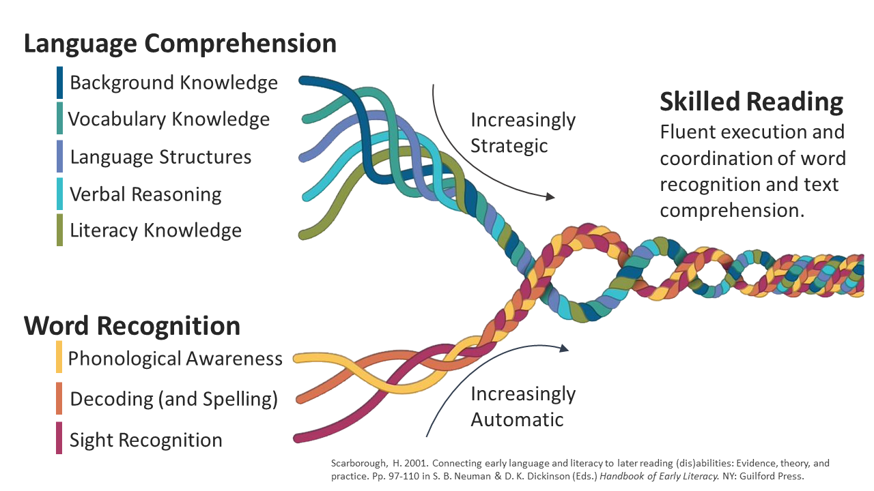

Reading Skill | Year 1 | Year 2 | Year 3 | Year 4 | Year 5 | Year 6
Retrieve | Main focus | Must be secure. | Retrieval from text not directly above | Continue with retrieval
Infer | More able can begin to infer if ready | Make a simple inference | Begin to justify an inference- questions broken down into two parts.  Example  a) How does she feel?  b) Why? (1mark each) | Merge into one question.  Example  How does she feel? Can you explain why? (2marks) | 3 mark questions when more able are ready. | Impression tables  3 mark questions.
Define | Word meaning | Word meaning | Word meaning | Word meaning | Word meaning | Word meaning
Sequence (KS1)  Summarise (KS2) | Language of sequencing  Beginning; Middle; End | Sequencing | Sequencing and introduction to summarising | Summarising | Continue with summarising
Predict | Discuss simple predictions | Make simple predictions | Make sensible predictions using evidence, broken down | Make sensible predictions with evidence. | Focus teaching in English/introducing texts. | Focus teaching in English/introducing texts.
Relate  (narrative content) |  |  |  |  | Introduce relationship | Continue with relationship
Explore  (word effect) |  |  | Introduce exploration | Secure exploration | Continue with exploration
Compare |  |  |  | Introduce comparison | Secure comparison | Continue with comparison

Reading Skills Progression Grid

Year Three Progression
Year 3
National Curriculum | - I can usually read fluently and decode new words that are unfamiliar  - I can read longer words with some support  - I can test out different ways to pronounce new words  - I can read further exception words  - I am starting to use my knowledge of root words, prefixes and suffixes to read and understand new words  - I can listen to and talk about a wide range of fiction, plays, poetry, non-fiction and reference books  - I can use a dictionary to check the meaning of words  - I can retell a wider range of books, e.g. myths and legends  - I can read aloud and perform poems using intonation, tone, volume and action  - I can discuss words and phrases that capture the reader’s interest  - I can understand what I have read by:  - Checking the text makes sense and discussing my understanding  - Asking questions to help me understand  - Making inferences about character’s feelings, thoughts and actions  - Predicting what might happen using the text  - I can retrieve and record information from non-fiction texts  - I can participate in discussions about books, take turns and listening to other people’s opinions.
Reading Lesson Structure | - Decoding, fluency, comprehension and enjoyment focus throughout the whole curriculum.  - Day 1: Pre Read  - Day 2: Reading Gem lesson (Teach)  - Day 3: Gem Group task  - Day 4: Independent questions (using all gems)  NB: Same text/extract used all week

Y3 | Autumn 1 | Autumn 2 | Spring 1 | Spring 2 | Summer 1 | Summer 2
Key Reading Skills focus | Retrieve x3  Define x2  Infer x2  Sequence x1 | Retrieve x2  Define x2  Infer x1  Sequence  Predict x1 | Retrieve x1  Define x1  Inference x2  Explore x2 | Retrieve x2  Define x1  Inference x2  Summarise x1 | Retrieve x1  Define x1  Inference x1  Explore x1 | Retrieve x1  Define x1  Inference x1  Explore x1  Summarise x1  Predict x1
Reading Lesson Structure | Recap and review of existing knowledge and skills. | Predict: Beginning to explain my predictions using evidence. | Infer: Making inferences about character’s feelings, thoughts and actions. Beginning to explain my inferences.  Explore: Beginning to discuss words and phrases that capture the reader’s interest and imagination | Infer: Making inferences about character’s feelings, thoughts and actions. Beginning to explain my inferences.  Summarise: Beginning to simply summarise the key details of texts | Explore: Discussing words and phrases that capture the reader’s interest and imagination  Infer: Making inferences about character’s feelings, thoughts and actions. Justifying inferences using simple evidence. | Summarise: Beginning to simply summarise the key details of texts Consolidation of prior learning.
Suggestions for books and extracts | Lighthouse  Stone Age Boy  How to Wash Woolly Mammoth | Cave Baby  Ug  Man on the Moon  Poetry – T’was the night Before Christmas  Fireworks/Halloween  Elf on the Shelf |  | Non-chronological reports –tigers | Egyptian Cinderella  Howard Carter | The Blue Birds song – Poetry  Oliver
Benchmarking/
Assessment

Year Four Progression
Year 4
National Curriculum | - I can read most words easily  - If I come across a new word, I can automatically decode it  - I can read further exception words  - I can use my knowledge of root words, prefixes and suffixes to read and understand new words  - I can listen to and talk about a wide range of fiction, plays, poetry, non-fiction and reference books  - I can read books that are structured in different ways and written for different purposes  - I can use a dictionary to check the meaning of words  - I can retell a wider range of books, e.g. myths and legends  - I can identify themes and conventions in a wide range of different books  - I can read aloud and perform poems and play-scripts using intonation, tone, volume and action  - I can discuss words and phrases that capture the reader’s interest and imagination  - I can recognise some different forms of poetry  - I can understand what I have read by:  - Checking the text makes sense and discussing my understanding  - Explaining the meaning of words in context  - Asking questions to help me understand the text  - Making inferences about character’s feelings, thoughts and actions. I can then justify my inferences with evidence  - Predicting what might happen using the text  - Identifying the ideas in a text and summarising them  - Identifying how language, structure and presentation help the meaning of a text  - I can retrieve and record information from non-fiction texts  - I can participate in discussions about books, take turns and listening to other people’s opinions.
Reading Lesson Structure | - Decoding, fluency, comprehension and enjoyment focus throughout the whole curriculum.  - Day 1: Pre Read  - Day 2: Reading Gem lesson (Teach)  - Day 3: Gem Group task  - Day 4: Independent questions (using all gems)  NB: Same text/extract used all week

Y4 | Autumn 1 | Autumn 2 | Spring 1 | Spring 2 | Summer 1 | Summer 2
Key Reading Skills focus | Retrieve x3  Define x2  Infer x2 | Retrieve x2  Define x1  Infer x1  Summarise x2  Predict x1 | Retrieve x1  Define x1  Infer x2  Summarise x1  Explore x1 | Retrieve x1  Define x1  Infer x2  Summarise x1  Compare x1 | Retrieve x1  Define x1  Infer x1  Compare x1 | Retrieve x1  Define x1  Infer x1  Summarise x1  Compare x1  Predict x1  Explore x1
Skills and strategies being introduced | Recap and review of existing knowledge and skills. | Predict: Predicting what might happen in the text using evidence.  Summarise: Beginning to be more specific with summarising. | Explore: Discussing words and phrases that capture the reader’s interest and imagination and beginning to justify our opinions | Infer: Making inferences about character’s feelings, thoughts and actions. I can then justify my inferences with evidence.  Compare: Beginning to make simple comparisons within texts and between texts. | Compare: Making simple comparisons within texts and between texts. | Consolidation of prior learning.
Suggestions for books and extracts | Paddington  Rivers  The Tunnel | Sound  Ancient Olympics | Lean on Me |  | Hadrian’s Wall  Escape from Pompeii | Bouddica
Benchmarking/
Assessment

Year Five Progression
Year 5
National Curriculum | - I usually read fluently  - I can read most words and decode new words automatically  - I’m becoming confident and independent when decoding unfamiliar words  - I can use my knowledge of root words, prefixes and suffixes to read and understand new words  - I can listen to and discuss about a wide range of fiction, plays, poetry, non-fiction and reference books  - I can read books that are structured in different ways and written for different purposes  - I can recommend books to my friends and give reasons for my choices  - I can retell a wider range of books, including classics, modern fiction and stories from a range of other cultures  - I can identify themes and conventions in a wide range of different writing  - I can prepare, read aloud and perform poems and play-scripts using intonation, tone, volume and action. This makes the meaning clear to the audience  - I can learn a wide range of poems by heart  - I can understand what I have read by:  - Checking the text makes sense and discussing my understanding  - Explaining the meaning of words in context  - Asking questions to help me understand the text  - Making inferences about character’s feelings, thoughts and actions. I can then justify my inferences with evidence  - Predicting what might happen using the text  - Identifying the ideas in a text and summarising them  - Identifying how language, structure and presentation help the meaning of a text  - I can retrieve, record and present information from non-fiction texts  - I can discuss and evaluate how authors use language  - I can participate in discussions about books, take turns and listening to other people’s opinions. I can also challenge other people’s views courteously
Reading Lesson Structure | - Decoding, fluency, comprehension and enjoyment focus throughout the whole curriculum.  - Day 1: Pre Read  - Day 2: Reading Gem lesson (Teach)  - Day 3: Gem Group task  - Day 4: Independent questions (using all gems)  NB: Same text/extract used all week
Y5 |  | Autumn 1 | Autumn 2 | Spring 1 | Spring 2 | Summer 1 | Summer 2
Key Reading Skills focus |  | Retrieve x3  Define x2  Infer x1  Predict x1 | Retrieve x1  Define x1  Infer x2  Summarise x1  Explore x2 | Retrieve x1  Define x1  Infer x1  Summarise x1  Compare x1  Relate x1 | Retrieve x2  Define x1  Infer x2  Relate x1 | Retrieve x1  Define x1  Infer x1  Summarise x1 | Retrieve x1  Define x1  Infer x1  Summarise x1  Compare x1  Relate x1  Explore x1
Skills and strategies being introduced |  | Recap and review of existing knowledge and skills. | Consolidation of prior learning. | Relate: Starting to identify how language, structure and presentation help the meaning of a text | Relate: Identifying how language, structure and presentation help the meaning of a text  Inference: Giving extended responses when making inferences. | Inference: Giving extended responses when making inferences. | Consolidation of prior learning.
Suggestions for books and extracts |  | Harriet Tubman  Leaves | Black Powder  Viking Boy | Beowulf  Horrible Histories | Macbeth | The Viewer | Kensuke’s Kingdom
Benchmarking/
Assessment

Year Six Progression
Year 6
National Curriculum | - I read books for my age group confidently and fluently  - I can use my knowledge of root words, prefixes and suffixes to read and understand new words  - I can listen to and discuss about a wide range of fiction, plays, poetry, non-fiction and reference books  - I can read books that are structured in different ways and written for different purposes  - I can recommend books to my friends and give reasons for my choices  - I can retell a wider range of books, including classics, modern fiction and stories from a range of other cultures  - I can make comparisons within books and between different books  - I can identify themes and conventions in a wide range of different writing  - I can prepare, read aloud and perform poems and play-scripts using intonation, tone, volume and action. This makes the meaning clear to the audience  - I can learn a wide range of poems by heart  - I can understand what I have read by:  - Checking the text makes sense and discussing my understanding  - Explaining the meaning of words in context  - Asking questions to help me understand the text  - Making inferences about character’s feelings, thoughts and actions. I can then justify my inferences with evidence  - Predicting what might happen using the text  - Identifying the ideas in a text and summarising them  - Identifying how language, structure and presentation help the meaning of a text  - Summarising the main ideas from the text and finding key details that support them  - I can retrieve, record and present information from non-fiction texts  - I understand the difference between fact and opinion and can find examples within the text  - I can discuss and evaluate how authors use language  - I can participate in discussions about books, take turns and listening to other people’s opinions. I can also challenge other people’s views courteously  - I can explain and discuss my understanding of what I’ve read, including by presenting and debating  - I can justify my views with reasons and evidence
Reading Lesson Structure | - Decoding, fluency, comprehension and enjoyment focus throughout the whole curriculum.  - Day 1: Pre Read  - Day 2: Reading Gem lesson (Teach)  - Day 3: Group work on 3 mark questions  - Day 4: Independent questions (using all gems)  NB: Same text/extract used all week
Y6 | Autumn 1 | Autumn 2 | Spring 1 | Spring 2 | Summer 1 | Summer 2
Key Reading Skills focus | Retrieve x3  Define x2  Infer x2 | Retrieve x 1  Define x 2  Infer x 1  Summarise x1  Explore x1  Predict x1 | Retrieve x1  Define x1  Infer x2  Summarise x1  Compare x1 | Retrieve x1  Define x1  Infer x2  Summarise x1  Relate x1 | Retrieve x1  Define x1  Infer x1  Relate x1 | Retrieve x1  Define x1  Infer x1  Summarise x1  Compare x1  Relate x1  Explore x2
Skills and strategies being introduced | Recap and review of existing knowledge and skills. | Consolidation of prior learning. | Inference: Giving extended responses when making inferences. | Inference: Making impressions about characters and situations and justifying these with evidence. | Inference: Giving extended responses when making inferences, including making impressions and justifying these with evidence. | Consolidation of prior learning.
Suggestions for books and extracts | Whitefang  Jabberwocky (Poem)  Flotsam | Treasure Island  Flanders Fields  Fantastic Beasts and Where to Find them | The Arrival  World of Food | Rose Blanche | SATs Prep | Highway Man
Benchmarking/
Assessment

Key Stage 2 Reading Lessons*
In Key Stage 2, all classes are taught daily for a minimum of 30 minutes through a whole class approach to Guided Reading. The skills taught follow the reading progression as set out earlier in this document.
Session 1: Pre-read focusing on the Vocabulary and background knowledge needed to understand the focus text. The vocabulary identified is chosen carefully, with a focus placed on Tier 1 and 2 words, with Tier 3 being discussed as appropriate. Children are introduced to the text in this session.
Session 2: Guided read (Teach): focused on teaching a reading skill in context. Children read the text again and discuss it together. The focus skill is taught and modelled. Then the class works together to discuss questions based on that skill, with the teacher guiding discussion.
Session 3: Children work in groups of 5 to apply the focus skill taught yesterday to the text. Using the roles of reciprocal reading (The Questioner. The summariser, The predictor. The Clarifier. The Boss). All discussion based. Children can write notes to capture learning on their reciprocal Read sheet. (Which could have the focus gem in the corner). Use Reading Gem Question stems to challenge all children. Staff support identified children.
Session 4: Multi skill focus. Children work more independently to apply a range of focus skills to the text by answering comprehension questions taken from the Reading Gem question stems for Key Stage 2. Staff support identified children. Discuss answers as a class with time for editing and direct feedback.
Session 5: (Optional) Reading for pleasure time or Deepening Understanding resource.
The texts chosen for whole class teaching will be matched to children’s level of fluency and take advantage of curriculum links where appropriate. We aim to read a wide range of fiction, non-fiction and poetry throughout each year group, making links between texts and subjects. We also believe that it is crucial that children begin to build critical literacy whilst at school, therefore we are mindful of this when choosing texts to discuss. At least one text per term is chosen specifically to support the teaching of this important skill. Children are given regular opportunities to apply their Reading skills and vocabulary knowledge in all curriculum areas. We make careful links between curriculum subjects, with Reading forming a key part of teaching across the whole curriculum at Nevill Road.
Children who are not yet secure with decoding, access the whole class Guided Reading sessions with support from staff. This includes a pre-teach session at the start of the week, where children are introduced to the text and read the text multiple times prior to whole class teaching to support fluent decoding and understanding. In addition to whole class teaching, these children also access regular small group guiding reading with an adult, focused on a phonically decodable book appropriate to their phonics knowledge. Some children also continue to have phonic interventions where needed. (See phonics policy).

(*This has been taken from the reading policy for ease of reference!)

Guidance for reading extracts chosen
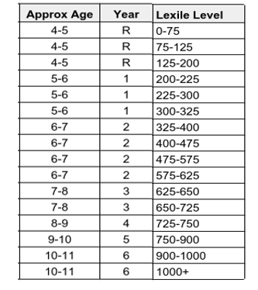
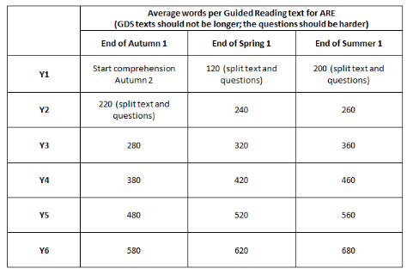

This diagram is an example of word count used when we choose our extracts for guided reading. The diagram is only used as a guide. The length of the text chosen will also depend on vocabulary, cohort, and lexile level.

This diagram is an example of how we identify the level of a book or extract chosen for guided reading. The diagram is only used as a guide. The extract chosen will also depend on themes within the book, vocabulary, word count and children’s maturity

