Background notes for parents/carers

About the theme – Advent/Christmas
The Advent/Christmas – Loving theme considers Christians’ preparation for the gift of God’s love in Jesus which is celebrated by Christians at Christmas. It focuses on the witness of loving as a way of life.

The season of Advent and the three-fold coming
Advent marks the beginning of the Church’s year.The word ADVENT comes from the Latin word
‘adventus’ which means ‘arrival’, ‘coming’ or ‘a drawing near’. During Advent, Christians focus on preparing for a three-fold coming.

- The coming of Christ in history (the birth of Jesus which we celebrate on December 25) and a remembrance of how the people of God waited expectantly for the Messiah;

- How Advent encourages believers to prepare to meet Jesus who comes every day in their lives;

- That believerswait in joyful expectation for Jesus to come again in glory at the end of time (the Second Coming).

Therefore Advent affirms that
- Christ has come
- He is present in the world today
- He will come again in power.

Advent is a time of waiting injoyful hope for the coming of Jesus into the world. It is also a penitential season; one that prepares Christians for theSecond Coming (hence the liturgical colour of the season is purple). Advent has a strong, positive message. Simply put it is – ‘get ready!’ Or as the Scriptures put it – ‘prepare the way of the Lord’. For Catholics the call to work for charity and the common good are heightened during Advent. It is a time of renewal, personal growth and transformation.

The four Sundaysbefore Christmas Day are known as the fourSundays of Advent. The themes for each week of Advent are: ‘Wake up!’, ‘Prepare the way of the Lord’, ‘Rejoice’ and ‘Emmanuel is with us’. These are sometimes translated as hope, love, joy, and peace.

The symbols, prayers and readings of the season help Christians to reflect on God’s love which is made known in the wonderful gift of Jesus.

Year 4 ‘Gift’

During the topic ‘Gift’, pupils explore Advent and Christmas – the Church’s seasons of preparing to receive God’s gift of love and friendship in Jesus. They are asked to think about how we show gratitude to one another for gifts and then to reflect upon how we should show gratitude to God for the gift of his love in Jesus. They listen to the words of Isaiah who tells us of God’s gift of the Promised One. Although Catholic Christians regard Advent as a penitential time, the children in Year 4 learn all about Gaudete Sunday or ‘Rejoice’ Sunday. They then move on to looking at how the Church celebrates at Christmastime and what will be seen and heard in our churches.

Key Vocabulary | YEAR 4  Gift  ADVENT/CHRISTMAS THEME  God’s gift of Jesus is a gift of love to all people of all time. Jesus reveals God’s love for humanity and the possibility of friendship. This gift is celebrated each Christmas. During the season of Advent, we explore this gift of love and the promise of Jesus’ return at the end of time.  Children will know and understand:  • The gift of love and friendship  • Advent and Christmas: The Church’s seasons of preparing to receive God’s gift of love and friendship in Jesus  See the Background Notes for Parents and Carers  Week 1: Looking at the gifts of love and friendship. The children learn about demands that friendship makes upon the giver but also the joys of the friendship. Focus on gratitude and how we show gratitude for the gifts we have been given. Ask your child to complete a heart to show what they are grateful for.  Week 2: Understanding that Jesus is God’s gift of love and friendship to everyone, as explained through Scripture. The Scripture comes from John and also Isaiah. Ask your child to write a letter to God, thanking him for the gift of Jesus.  Week 3: How the church celebrates the gift of God’s love through Jesus. Gaudete Sunday and what goes on in church throughout the Christmas season which lasts until the Baptism of Jesus. Ask your child to make a leaflet to tell people how the church celebrates Christmas.  Week 4: Look back at the key vocabulary and remember all that has been learnt during the topic ‘Gift’  Celebrate with a simple Act of Worship (see below).
Advent

Isaiah

Messiah

Mary’s gift of herself to God

Gaudete

gift

friendship

loyalty

commitment

God’s gift of love and friendship

Children of God

Overview

Year 4
In Year 4, the children learn that God has given the gift of his love to everyone. This gift is Jesus and Advent is the time of preparation for that gift. They learn about the joys and the demands of friendship in everyday life and make the links to the joys and demands of life as a Christian. They learn how the Church celebrates the gift of Jesus at Christmas.

Week 1: Read the story (see below) and reflect upon the key questions. Explore how the gift of love and friendship will make demands on the giver and require commitment and loyalty. Think what might motivate the giver to be generous.
Task - Think about all the gifts people share with you: the love, care, time, patience, fun and encouragement they give you. What gift are you most grateful for?
I am grateful for … when …
What do you think is the most important gift of all? Is it one you try to share with others? Write it on the heart shape and decorate your heart.
Week 2: Read the letter of John (see below). It was probably written when he was an old man and had spent years thinking about God’s love for us and our love for one another. It helps to explain more about Jesus coming to earth as God’s gift to everyone and reflect upon the key questions below.
- What does John say love is?
- What does he say about where the gift of love comes from?
- What does he say is the best way God shows love for us?
- What does God’s gift of love mean for us and how does it affect the way we live our lives?
- Why do you think Jesus came to earth?

Now we hear from Isaiah, a prophet from the Old Testament, who was waiting for the coming of the Messiah, the one promised by God who would show God’s love and bring peace. For centuries, the people of God longed for and waited in hope for the coming of the Saviour. Thiswas especially true when there were difficulties and the people were treated badly. Read Isaiah 40: 9-11 (see below) and reflect on the key questions.
- What is the Good News?
- Why is it Good News?
- How is God described in this Scripture text? What adjectives are used?
- What kind of person does a shepherd have to be? In those days, the shepherd would have lived out in the field with the sheep to protect them.
- How were the people to prepare for the coming Messiah?

Task - Write a ‘thank you’ letter to God for sending us the gift of Jesus. Say why you are glad that Jesus lived among us. Give reasons why this helps you to be a better person.
Week 3: Now we look at how the Church celebrates the gift of God’s love. The four weeks of Advent have different themes. The third Sunday of Advent is called ‘Gaudete Sunday’; Gaudete is a Latin word for Rejoice. It is meant to be a break about midway through the season of Advent. It encourages and reminds people of the nearness of Jesus’ coming. The whole season of Advent is a time of expectation and preparation for Christmas, as well as remembering that Jesus will come again at the end of the world, as he promised.
On Gaudete Sunday, you will often hear the word Rejoice. Read the section from St Paul to the Philippians and answer the questions below.
- What does Gaudete mean?
- Why does the Church celebrate Gaudete Sunday during Advent?
- Why is Advent a time of expectation?
- Which part of the letter from Paul do you like best and why?
- If you were living in Philippi how you would feel if you received this letter from Paul?
- What does Paul ask the people of Philippi to think about and why?

Read about what happens in Church during the Christmas season. (See below) Christmas is the season during which the Christian family thinks about and celebrates God’s gift of love, made known in Jesus. The Christmas season begins with the joyful celebration of Mass at Night on Christmas Eve and ends in January with the celebration of the feast of the Baptism of Jesus.
The Church tells the Christmas story by using symbols, by listening to stories from the Bible which tell about the gift of Jesus, by singing hymns, carols and songs and by saying special prayers.
The parish church is decorated with lots of flowers and candles. The priest wears white or gold vestments. There will be a crib with the figures of the Christmas Story; the Wise Men will probably not appear until the feast of the Epiphany.
- What is being celebrated at Christmas?
- What are the signs and symbols that can be seen in Church at Christmas?
- What are the signs and symbols that can be seen in our homes at Christmas?
- Why do you think the colour of the priest’s vestments change from purple to white or gold?

Task - Write a leaflet describing the importance of Christmas for Christians and the reasons for their words and actions at that time.

Week 4: Look back at the key vocabulary and remember all that has been learnt during the topic ‘Gift’.
Celebrate with a simple Act of Worship (See below)

Week 1
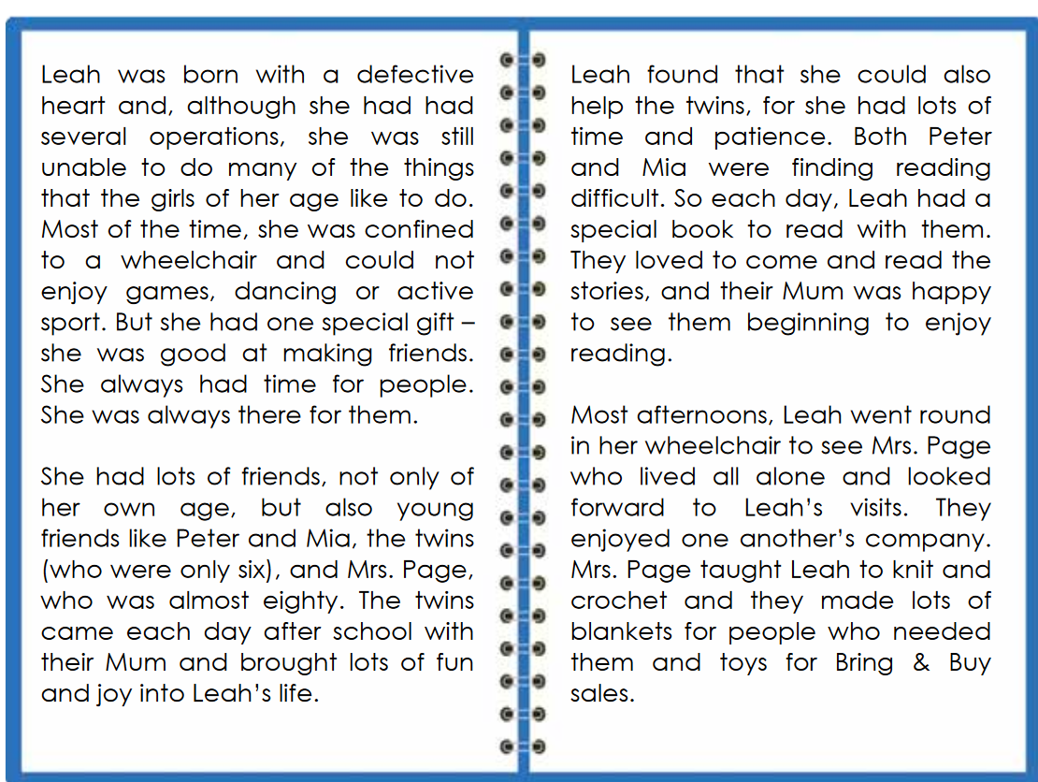

- How did you feel when you heard/read this story?
- What was Leah’s special gift?
- What gifts did the twins bring to Leah?
- What gifts did Leah give to them?
- What gifts did Leah and Mrs Page share with one another?
- What in the story makes you stop and think?
- What other friends do you think Leah may have had?
- What do you value most about the gift of friendship?
- What do you offer others in your friendship and why?

Week 1

I am grateful for _____________________________________ when

________________________________________________________


Task - Think about all the gifts people share with you: love, care, time, patience, fun and encouragement they give you. What gift are you most grateful for?
I am grateful for … when …
What do you think is the most important gift of all? Is it one you try to share with others? Write it on the heart shape and decorate your heart.

Week 2

Q What does John say love is?
Q What does he say about where the gift of love comes from?
Q What does he say is the best way God shows love for us?
Q What does God’s gift of love mean for us and how does it affect the way we live our lives?
Q Why do you think Jesus came to earth?

Week 2

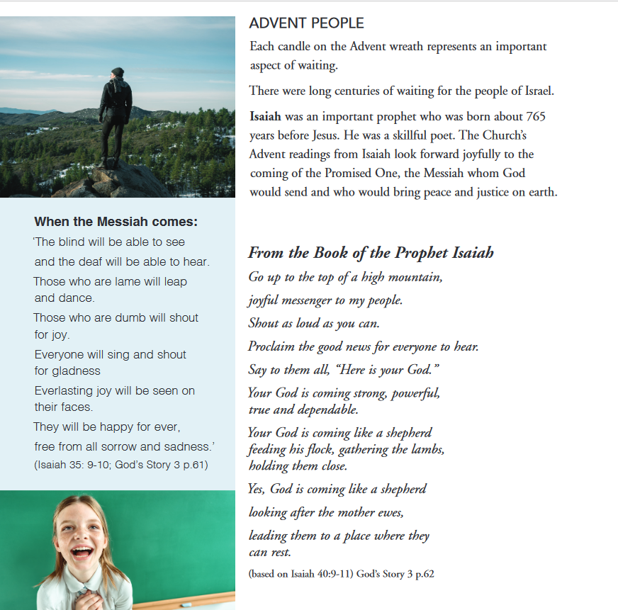

Q What is the Good News?
Q Why is it Good News?
Q How is God described in this Scripture text? What adjectives are used?
Q What kind of person does a shepherd have to be? In those days, the shepherd would have lived out in the field with the sheep to protect them.
Q How were the people to prepare for the coming Messiah?

Week 3

Q What does Gaudete mean?
Q Why does the Church celebrate Gaudete Sunday during Advent?
Q Why is Advent a time of expectation?
Q Which part of the letter from Paul do you like best and why?
Q If you were living in Philippi how you would feel if you received this letter from Paul?
Q What does Paul ask the people of Philippi to think about and why?

Week 3

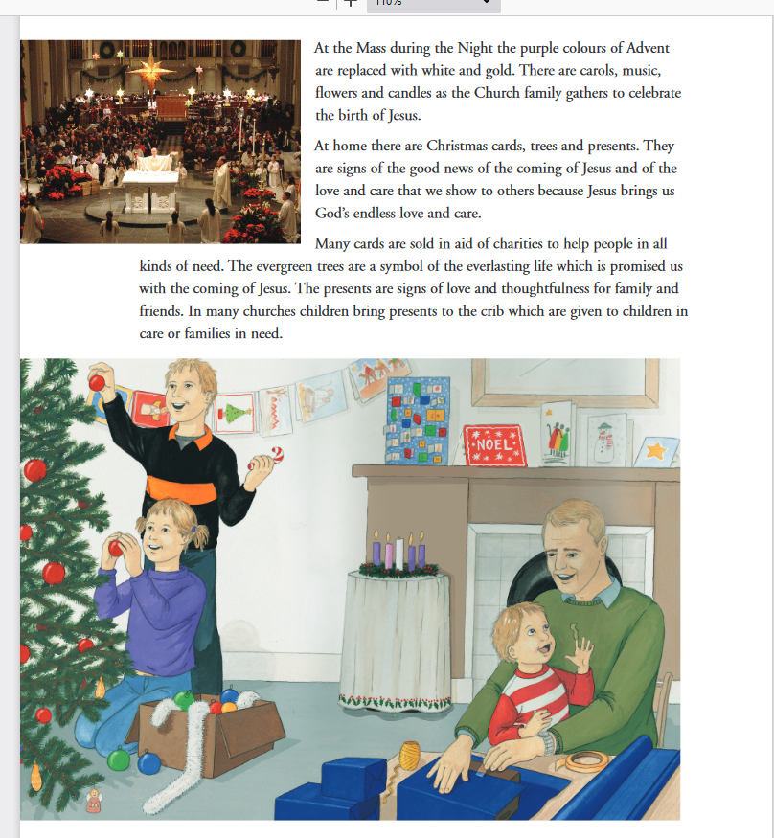

Q What is being celebrated at Christmas?
Q What are the signs and symbols that can be seen in Church at Christmas?
Q What are the signs and symbols that can be seen in our homes at Christmas?
Q Why do you think the colour of the priest’s vestments change from purple to white or gold?
Week 4

Act of Worship

“GIFT”
Year 4
‘Advent and Christmas: the Church’s seasons of preparing to receive
God’s gift of love and friendship in Jesus’.

Place some or all of the following on the sacred space

Gathering

Together


Advent wreath or a candle
Bible opened at First Letter of John 1: 4, 9-12
cross

When we light the candles on an Advent wreath it helps us to remember that the time for celebrating the gift and friendship of Jesus at Christmas is coming nearer. We gather in the name of the Father…
In our topic called ‘Gift’, we have been reflecting on the gifts of love and friendship and explored what qualities are needed to be a loving friend.
We have also been learning that Advent is a season during which the Christian family thinksabout God’s great gift of love and friendship made known in Jesus who the Father sent to live among us on earth.
This reading is from one of the letters of John. It was

The Word
of God
probably written when he was an old man and had spent many
years thinking about God’s love for us and our love for one
another. It helps to explain more about Jesus coming to earth

and God’s gift to everyone.

A Reading from the First Letter of John
God’s love for us was shown in this way.
God sent Jesus into the world.
God’s only Son was given to us so that we could have life through him.
This is what love is: not our love for God but God’s love for us, when God sent Jesus to take away our sins.
My dear people, since God loves us so much we ought to love one another.
No one has ever seen God, but if we love one another God will live in us and the love which God gives will be made perfect in us.

The Word of the Lord
Thanks be to God.
Think quietly now about the reading you have heard. John told us that because God loves us so much he sent us the gift of Jesus - and so we should love each other.

Response to the Word
In your hearts now, think about what ‘loving’ gift you can give to the people around you between now and Christmas…..A ‘loving’ gift is not something you can buy. It is a quality such as listening, gratitude, giving time to someone, helping.
Choose one ‘loving’ gift that you will try to give and think now how you can give that gift and who you will give it to……
Each year in Advent Christians prepare to celebrate God’s special gift and friendship of Jesus.
God so loved the world that God gave God’s only son. Now let us welcome Jesus into our hearts and homes with an action prayer:

Going

Forth

We praise you, Lord Jesus (hands above heads)
Bless each one of us (heads bowed)
We welcome you into our hearts (hands folded across heart)

