Background Notes for Parents/Carers

About the theme – Advent/Christmas
The Advent/Christmas – Loving theme considers Christians’ preparation for the gift of God’s love in Jesus which is celebrated by Christians at Christmas. It focuses on the witness of loving as a way of life.

The season of Advent and the three-fold coming
Advent marks the beginning of the Church’s year. The word ADVENT comes from the Latin word ‘adventus’ which means ‘arrival’, ‘coming’ or ‘a drawing near’. During Advent, Christians focus on preparing for a three-fold coming.

- The coming of Christ in history (the birth of Jesus which we celebrate on December 25) and a remembrance of how the people of God waited expectantly for the Messiah;
- How Advent encourages believers to prepare to meet Jesus who comes every day in their lives;
- That believers wait in joyful expectation for Jesus to come again in glory at the end of time (the Second Coming).

Therefore Advent affirms that
- Christ has come
- He is present in the world today
- He will come again in power.

Advent is a time of waiting in joyful hope for the coming of Jesus into the world. It is also a penitential season; one that prepares Christians for the Second Coming (hence the liturgical colour of the season is purple). Advent has a strong, positive message. Simply put it is – ‘get ready!’ Or as the Scriptures put it – ‘prepare the way of the Lord’. For Catholics the call to work for charity and the common good are heightened during Advent. It is a time of renewal, personal growth and transformation.

The four Sundays before Christmas Day are known as the four Sundays of Advent. The themes for each week of Advent are: ‘Wake up!’, ‘Prepare the way of the Lord’, ‘Rejoice’ and ‘Emmanuel is with us’. These are sometimes translated as hope, love, joy, and peace.
The symbols, prayers and readings of the season help Christians to reflect on God’s love which is made known in the wonderful gift of Jesus.

Year 2 ‘Preparing’
During the topic ‘Preparing’, pupils explore Advent, the four weeks of preparation for the celebration of the birth of Jesus at Christmas. They hear how Mary prepared for the birth of Jesus and how her cousin Elizabeth helped her. They are introduced to the prophet Isaiah from the Old Testament and hear the names that are given to the Promised One.

Overview
Key Vocabulary | YEAR 2  Preparations  ADVENT/CHRISTMAS THEME  God had prepared His people for the coming of His Son, the Messiah over many hundreds of years. Advent is a time of preparation to celebrate Jesus’ first coming on earth. It also reminds people that he will come again at the end of time.  Children will know and understand:  • Preparing for special times  • Advent four weeks of preparation for the celebration of Jesus at Christmas  See the Background Notes for Parents and Carers  Week 1: Preparing for special times and introduces your child to Advent, the time to prepare for the birth of Jesus. Start a list of preparations for Christmas. Compose an Advent prayer.  Week 2: The children are introduced to the prophet Isaiah and the names given to the Promised One. Use the quote from Isaiah, talk about the titles that are used by Isaiah to describe the promised one.  Week 3: The focus for this week is on the scripture from the New Testament telling the story of the preparations by Mary and Joseph and Mary’s cousin, Elizabeth, for the birth of Jesus. Ask children to retell the story in their own words with as much detail as possible.  Week 4: Look at the key vocabulary for this topic and use it to help your child remember all that he/she has learnt about preparing for Christmas throughout the season of Advent.  Celebrate with a simple Act of Worship (see below).
advent
preparing
Christmas
Nativity
waiting
Isaiah
messenger
Gabriel
Annunciation
Strong friend
Powerful God
Ever-loving Father
Bringer of Peace
Visitation.
Year 2
In Year 2 the children learn that Advent is a time of preparation for the birth of Jesus. They learn about the different ways that Catholic Christians prepare their hearts for this special event. They remember the story of Christmas through the Scripture stories and they are introduced to the prophet Isaiah from the Old Testament, who prophesied the coming of Jesus the Messiah, and they learn some of the special names given to the Promised One.

Week 1:.Talk about preparing to come to school in the morning. What do you do? Is it the same each day? How do we prepare for special occasions: e.g. a party or going on holiday etc. What jobs does each person have to do?
Q Why is it necessary to prepare?
Q What would happen if you didn’t prepare?
Q How do you feel when you are preparing for special times?
Q What sort of preparations do members of the family make for Christmas?
Q What would happen if people didn’t prepare for Christmas?
Q Is there anything you don’t like about preparations – for example, crowded shops?

Task - Start a list of preparations for Christmas. This list can be added to throughout the topic.

Discuss the seasons of the Church’s year, the liturgical year, pointing out the place of Advent (see below). The most important preparation is the loving preparation that Christians make in their hearts. Advent is four weeks of preparing for the birth of Jesus. There are many ways that Christians can show their love as they prepare for Christmas. Use the pictures (see below) to talk about ways of preparing and waiting during Advent for the birth of Jesus. Notice the Advent wreath in the first picture as well as the calendar in the second.

Task - Help your child to compose an Advent prayer, asking God to help them to show their love for others as they prepare to celebrate the birth of Jesus.

Week 2 Isaiah lived a long time before Jesus. He acted as a messenger of God (a prophet), listening to God’s words and encouraging the people of Israel to love and trust in God at all times. This was the way the people prepared. Sometimes the people lost their way and were not sure what to do. Isaiah reminded the people of God’s promise to send them a son, who would be like a light to guide them and bring them joy. (Christians traditionally understand that ‘a son’ refers to the coming of Jesus).
Task - Use the quote from Isaiah 9: 2, 6 (see below), talk about the titles that are used by Isaiah to describe the promised one.

Week 3: Mary prepares to be the mother of Jesus when asked by God’s messenger Gabriel
Mary goes to visit Elizabeth her cousin whom she loved to help her prepare for her baby.
Mary and Joseph would have discussed the preparation for the birth of their baby at their own home. However, the Roman Emperor ordered everyone to return to the place where the father of the family came from. Joseph came from Bethlehem, this meant that Mary and Joseph had to journey from Nazareth to Bethlehem. They would have joined others who were also walking there.
Read the story of the Annunciation and Visitation and the birth of Jesus (see below)
Q What does Gabriel say about the baby?
Q How did Mary’s feelings change as she spoke to Gabriel?
Q Discuss how Gabriel is depicted as ‘rays of light’
Q How did Mary know that her cousin Elizabeth was expecting a baby?
Q Why did this take Mary by surprise?
Q How could Mary have helped Elizabeth to prepare for her baby?
Q What surprised you about Elizabeth’s words to Mary when they met?
Q What feeling does Mary express in her song?
Q What preparations might Mary and Joseph make at home in Nazareth for the birth of the baby?
Q Why did the Roman Emperor want everyone to return to the place their family came from?
Q How would Mary and Joseph have felt when they realised they had to make a long journey?
Q How could Mary and Joseph lovingly prepare the stable for the baby’s arrival?
Q How did Mary dress the baby?
Q How did she know what to call him?

Task – retell the story in their own words with as much detail as possible.
God gave us Jesus as a loving gift to bring light into our lives. Catholics gather to celebrate the birth of Jesus at Mass on Christmas Eve during the night and on Christmas Day. It is a very special time to remember, God gave us Jesus because he loves us. Here is a prayer to share:
Dear Jesus,
When we come to the crib on Christmas morning,
may we love you as Mary loved you,
serve you as Joseph served you,
and come to you as the shepherds and wise men came to you.
Amen.
Talk about what the words might mean.
Week 4: Look back at the key vocabulary and help your child to remember what they have learnt.
Celebrate together with a simple Act of worship (see below)

Week 1

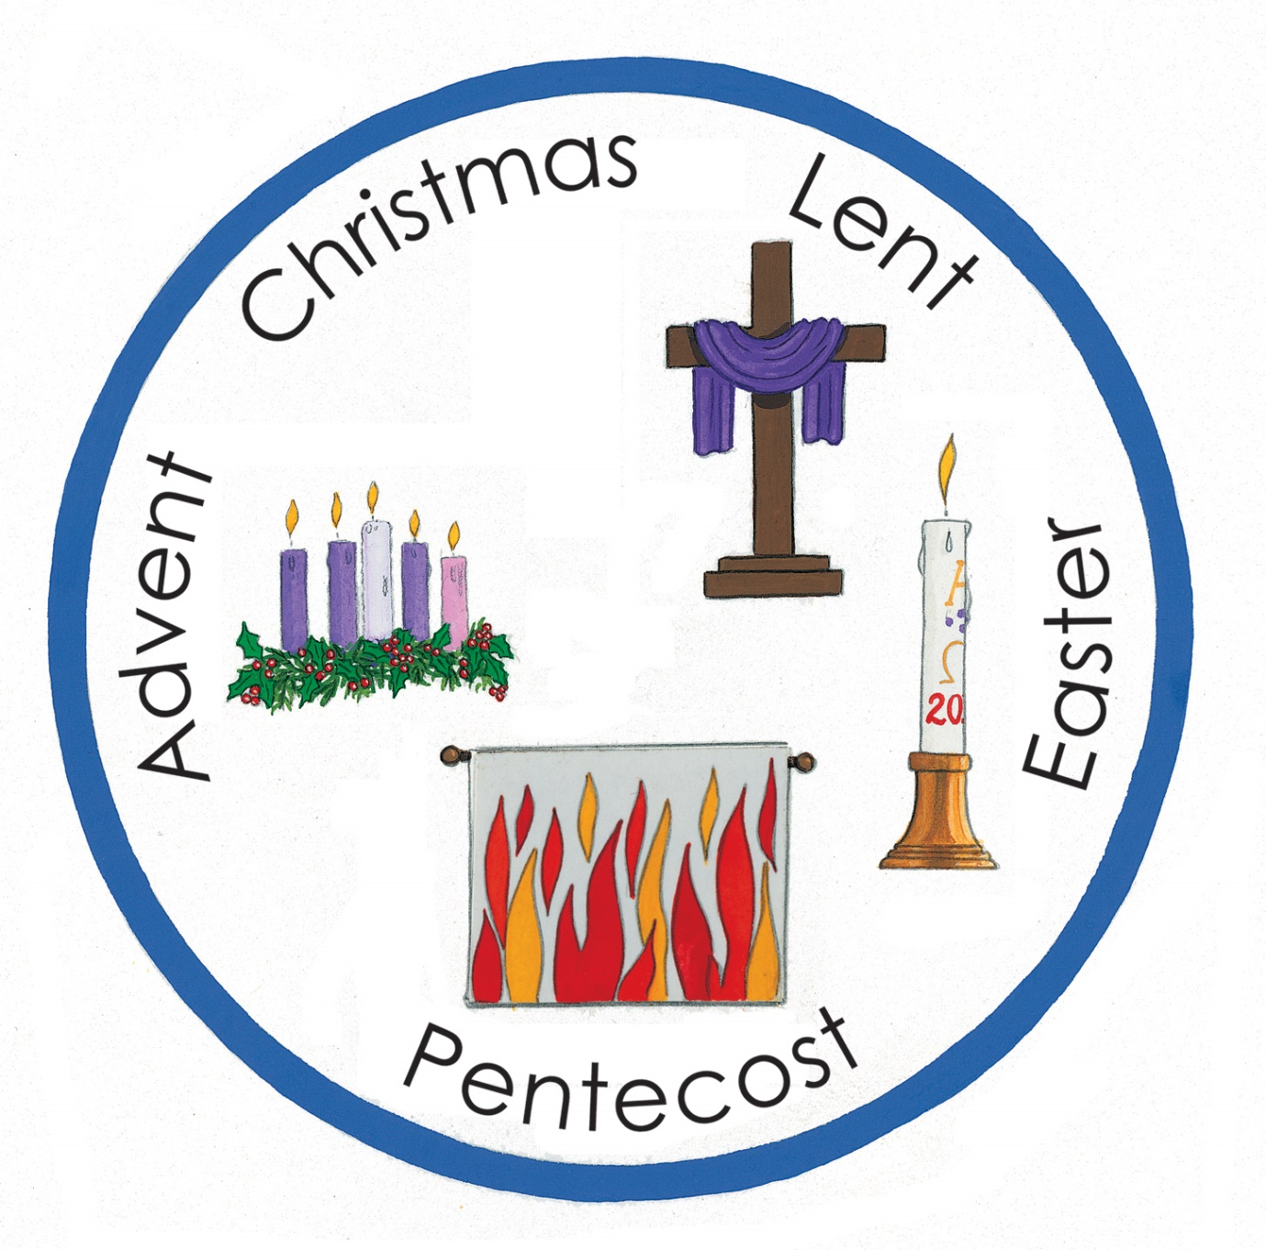

Week 1

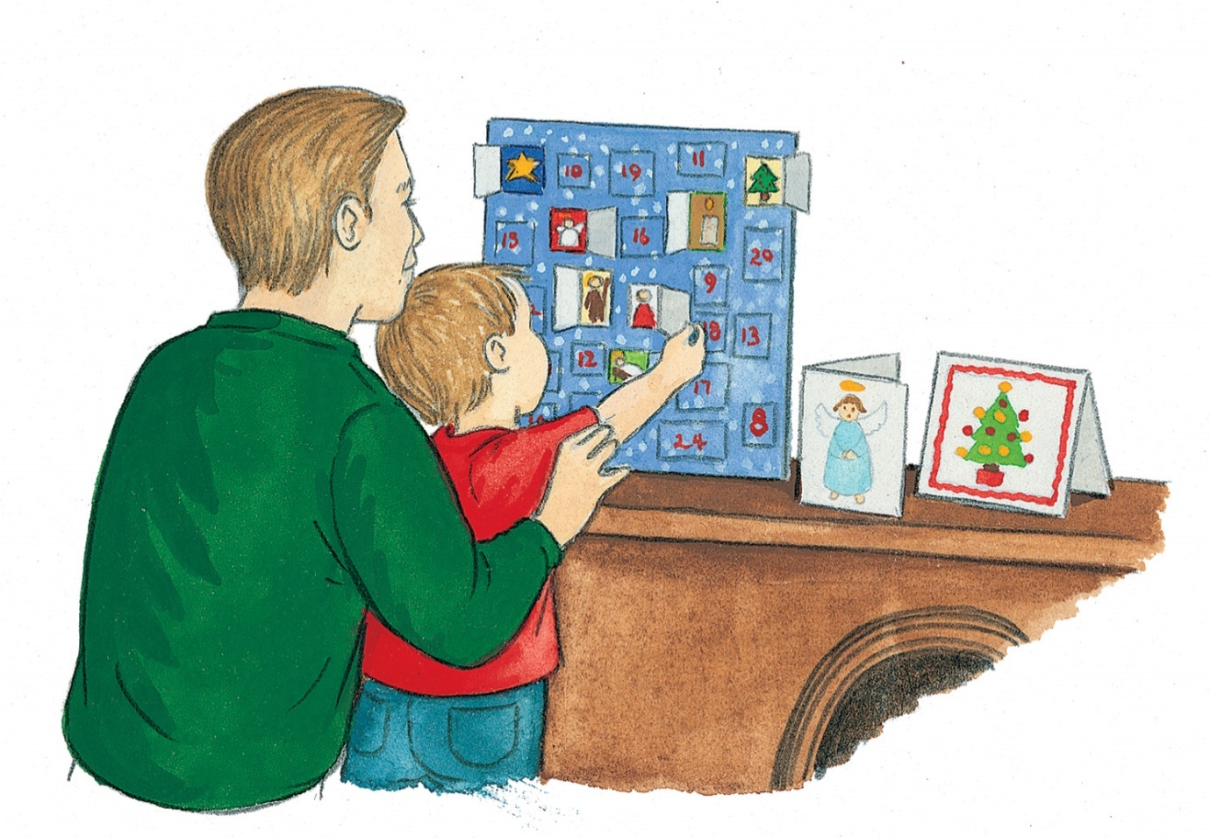

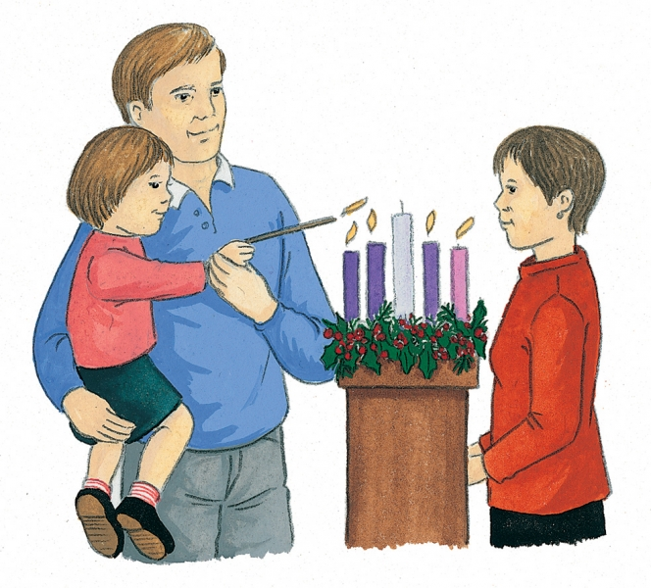

Week 1

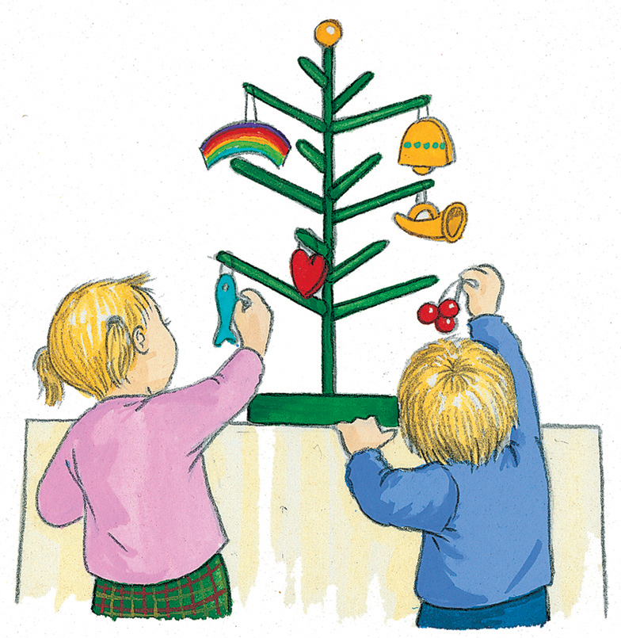( Jesse Tree)

Q How do all these traditions prepare us for the birth of Jesus?
Q Why do you think the wreath is round?
Q Why do you think we use evergreen leaves?

Week 2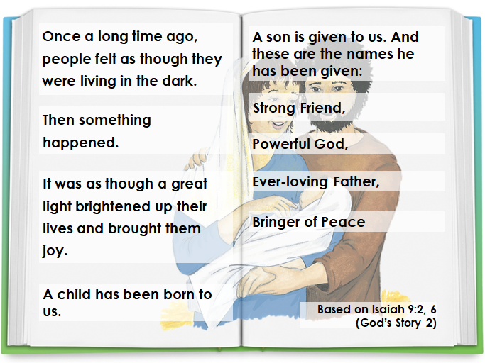

Week 3

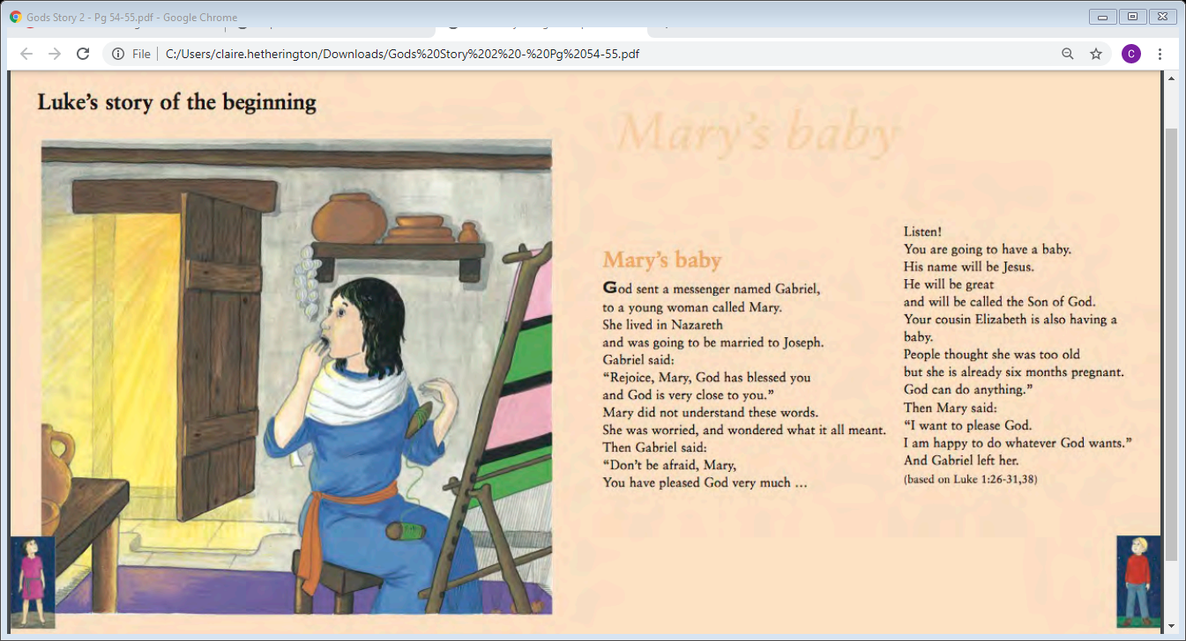

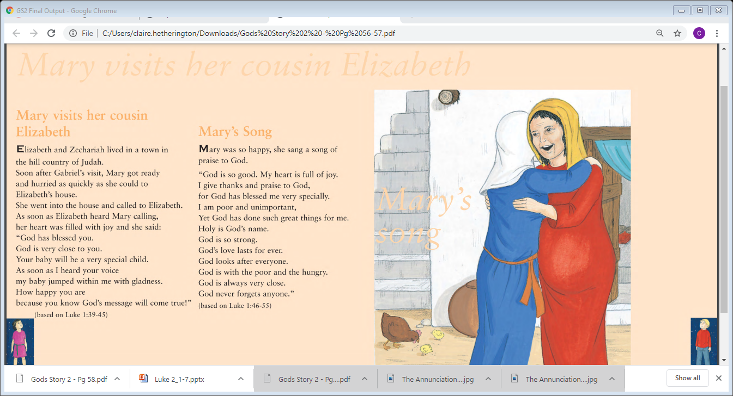
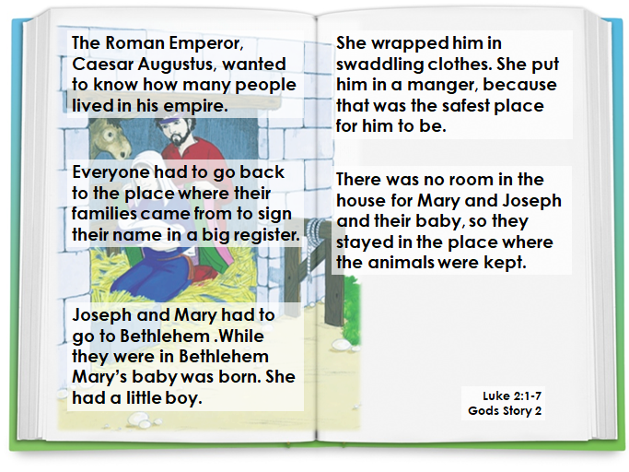
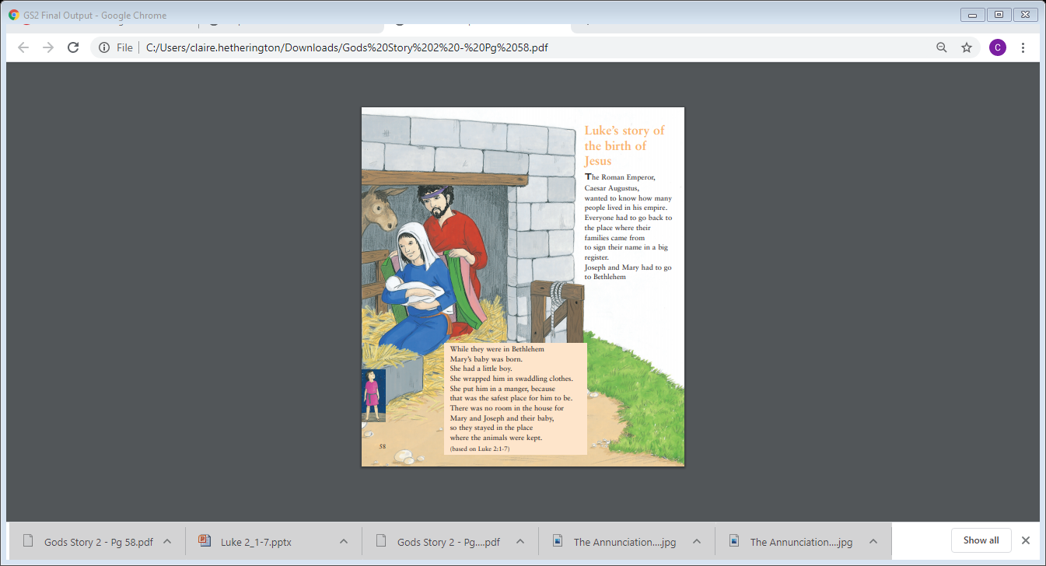

Q How did Mary’s feelings change as she spoke to Gabriel?
Q Discuss how Gabriel is depicted as ‘rays of light’
Q How did Mary know that her cousin Elizabeth was expecting a baby?
Q Why did this take Mary by surprise?
Q How could Mary have helped Elizabeth to prepare for her baby?
Q What surprised you about Elizabeth’s words to Mary when they met?
Q What feeling does Mary express in her song?
Q What preparations might Mary and Joseph make at home in Nazareth for the birth of the baby?
Q Why did the Roman Emperor want everyone to return to the place their family came from?
Q How would Mary and Joseph have felt when they realised they had to make a long journey?
Q How could Mary and Joseph lovingly prepare the stable for the baby’s arrival?
Q How did Mary dress the baby?
Q How did she know what to call him?

Week 4

Act of Worship
‘PREPARATIONS’
Year 2

Gathering
Together
Advent - four weeks of preparation for the celebration
of the birth of Jesus at Christmas.

Place some or all of the following on the sacred space: Advent calendar, Advent wreath (or a picture of one) and Bible (opened at Luke 2: 1-7)

In our topic we have been talking about how we prepare to come to school in the morning and how we prepare for special occasions such as a party or going on holiday. We have learned that Advent is four weeks of preparing for the birth of Jesus and that the most important preparation that Christians make is in their hearts

Since the time that Advent began, we have been preparing for Christmas by opening our Advent Calendar and lighting our Advent wreath.
We have heard how God’s people were prepared for the birth of Jesus many years before he was born and how the Angel Gabriel prepared Mary for the birth of Jesus.

The Word
Of God
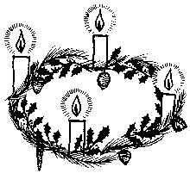
Let us listen now to the story of how Mary and Joseph prepared for the birth of Jesus. This was written down by a man called Saint Luke, a follower of Jesus. He had never met Jesus himself, but he asked the people who had known him about all they could remember, and then wrote it down carefully, so that nothing would be forgotten.

A reading from the Holy Gospel according to Luke.
Glory to You O Lord.

{The ‘Sign of the Cross’ is made on the head, lips and heart that we may think like Jesus, speak like Jesus and love like Jesus}

The Roman Emperor, Caesar Augustus, wanted to know how many people lived in his empire. Everyone had to go back to the place where their families came from to sign their name in a big register. Joseph and Mary had to go to Bethlehem. While they were in Bethlehem Mary’s baby was born. She had a little boy. She wrapped him in swaddling clothes.
She put him in a manger, because that was the safest place for him to be.
There was no room in the house for Mary and Joseph and their baby, so they stayed in the place where the animals were kept.

The Gospel of the Lord.
Praise to You, Lord Jesus Christ

Response to
the Word
Let us think of the different ways we are preparing for the birth of Jesus and ask Him to help us to do it really well. (Quiet time)

Ask your child to repeat the following prayer 3 times:

‘Come into my heart Lord Jesus, there is room in my heart for you’ (x3)
Going
Forth

Let us go out to others and prepare well for the coming of Jesus at Christmas by sharing our love with them.

