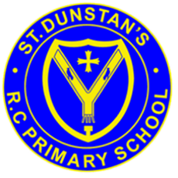
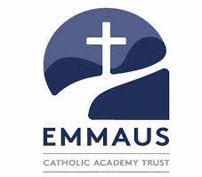
St Dunstan’s RC Primary School
‘We journey with Jesus beside us’

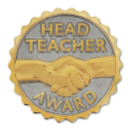

Headteacher’s Message
Dear Parents and Carers,
It has been another wonderful week in school, and I would like to begin by thanking our children for their continued hard work, enthusiasm and positive attitudes towards learning. It is a pleasure to see them growing in confidence, showing kindness to one another and striving to do their very best each day. We are incredibly proud of them! Last Sunday’s Gospel (Matthew 20:1–16) shared the Parable of the Workers in the Vineyard, reminding us of God’s generosity, fairness and unconditional love. Jesus teaches us that everyone is valued in God’s eyes, regardless of when or where they begin their journey.
As a Catholic school, we encourage our children to live out this Gospel message each day by treating everyone fairly, celebrating one another’s achievements, showing kindness and welcoming others with open hearts. We are proud to see our children putting these values into practice through their friendships, their learning and their everyday actions. A big thank you to everyone who joined us for our recent SEND coffee afternoon. It was a lovely opportunity to come together as a school community, share conversations and strengthen the partnership between home and school.
Our children have been working incredibly hard with their phonics and reading. As we continue to develop confident, fluent and enthusiastic readers, we would like to remind all parents and carers of the importance of reading every day at home. Reading regularly makes a significant difference to children’s progress, confidence and enjoyment of learning. We ask that all children in Key Stage 1 and Key Stage 2 read daily for 15-20 mins and record their reading in their reading diaries.
For our Reception and Key Stage 1 children, we ask parents and carers to support them by listening to them read and recording this in their reading diaries. For our Key Stage 2 children, we encourage them to take ownership of recording their daily reading themselves. Our teachers will be checking reading diaries regularly, so your support in ensuring these are completed is greatly appreciated.
Wishing you a blessed weekend.
Mrs Bailey

Headteacher’s Award
David (Y2) for wonderful contributions during our R.E Lessons

Headteacher: Mrs S Bailey Bacup Street, Moston, Manchester, M40 9HF
Telephone: 0161 681 5665 Email: admin@st-dunstans.manchester.sch.uk
https://www.stdunstansmoston.com

The link below is to this week’s edition of the Wednesday Word. Please continue to read and discuss the Wednesday Word every week as a family by visiting:
The Wednesday Word | The Sunday Gospel | Catholic Church
“One child, one teacher, one book, one pen can change the world."

Malala Yousafzai


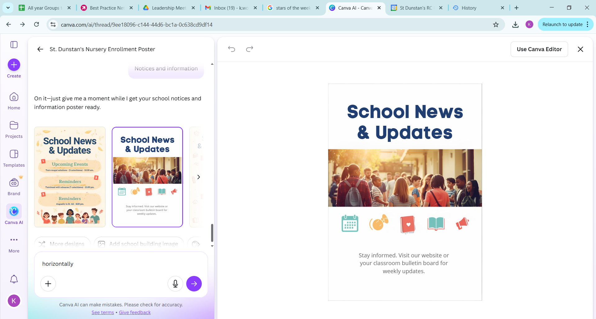
Healthy Snack
Children in Years 3 – 6 are welcome to bring a healthy snack to eat at break time. Where possible, please ensure to limit plastic packaging. We are a nut-free school. Children in EYFS and KS1 will be provided with fruit.
Mass – Wednesday 23rd September:
Mass will be celebrated by Year 3 and Years 4 at 9:30.am in the school led by Father Job. Family members are welcome to join us.

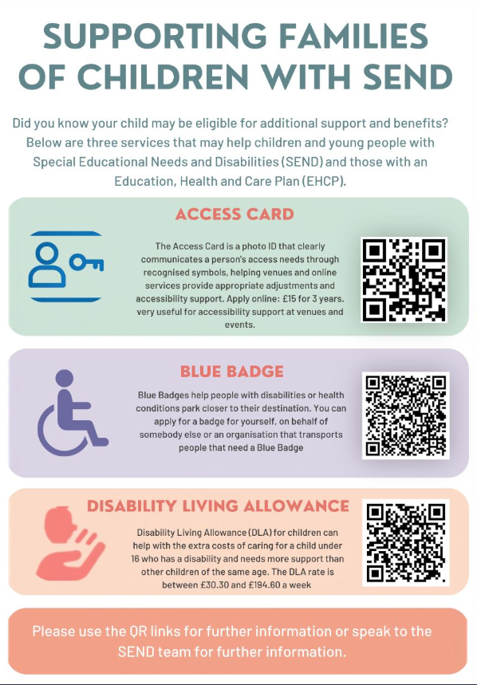
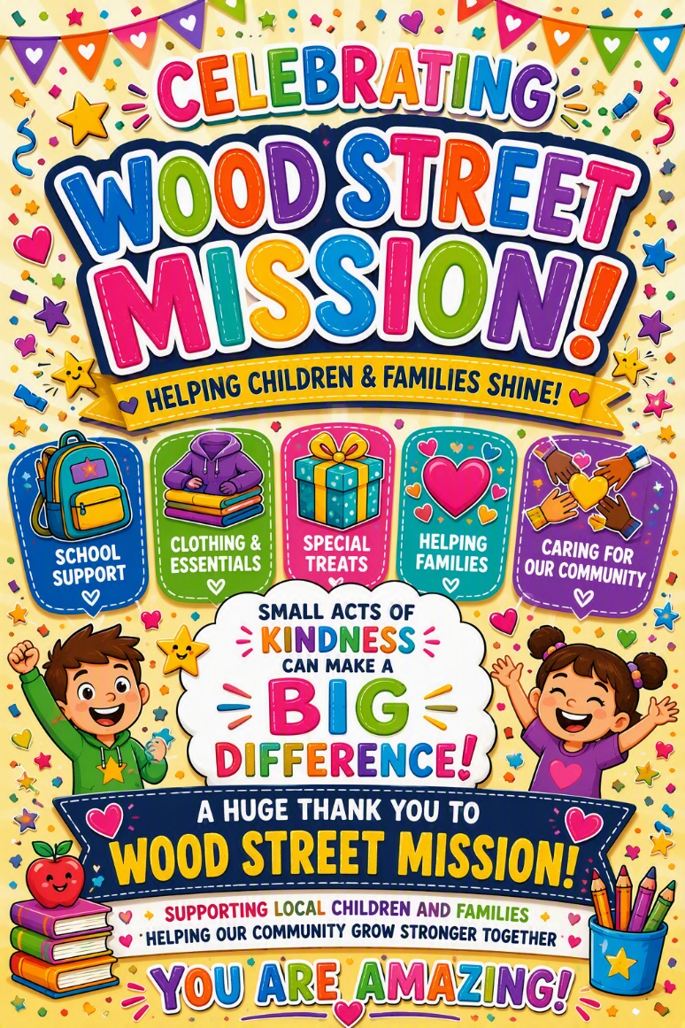
SEND in the Spotlight


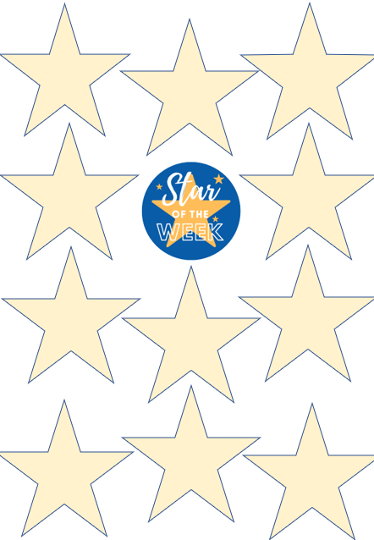
Year 6H:
Aayan – having a fantastic attitude to learning .
Year 5F:
Aayan – having a fantastic attitude to learning .
Year 4P:
Kaelan – always making the right choices around school

Year 3:
Lydia -impeccable behaviour every single day
Year 1/2:
Sami - Always willing to try his best and is very helpful in the classroom.
Nursery:
Ibrham - For being a good role model in class
Year 2:
Isabella – always making the right choices.
Star writer: Nevaeh
Star writer: Ekene
Star writer: Elizabeth
Star writer: Eric
Star writer: Kamsy
Star writer: Bright
Star writer: Leighton
Star writer: Aliona
Star writer: Oghosa
Star writer: Jan
Star writer: Naomi
Year 6W:
Taemar – showing the value of unity.

Year 5LG:
Kearah – Showing the value of unity.
Year 4A:
Noor – settling in so well
Reception:
Divine– Showing great Unity.
What have we been learning this week?
Nursery | This week the children have been learning two new sounds 'm' and 'a' as part of our Read Write Inc. (RWI) phonics programme.
Reception | In English, Reception class made wanted posters after the mischievous gingerbread man that had visited our classroom.
Year 1/2 | This week we have been thinking about the seaside and what we might see and hear there. We also made predications on what we thought might happen in our story.
Year 2 | Year 2 have produced some wonderful writing this week based on our new story ‘Look Up’. We have been learning about ambition and how we can reach for the stars!
Year 3 | We began reading Seal Surfer and used the opening chapters to write a recount in the past tense, focusing on using coordinating conjunctions to extend sentences and add detail.
Year 4A | Year 4 have had a great week of learning and teamwork. We have enjoyed exploring the book Gorilla and have made a great start to our work on place value.
Year 4P | This week, Year 4 have been working hard in Maths, flexibly partitioning 4-digit numbers.
Year 5F | This week children have been imagining that they are Olympic athletes and have written diary entries about their experiences.
Year 5LG | Year 5 have been working on place values with numbers up to 100,000 in maths and building timelines in History.
Year 6H | In Maths, Year 6 have been strengthening their place value skills, working with numbers including millions.
Year 6W | This week, we have learned about the life of Floella Benjamin and written information texts about her life.
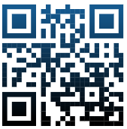
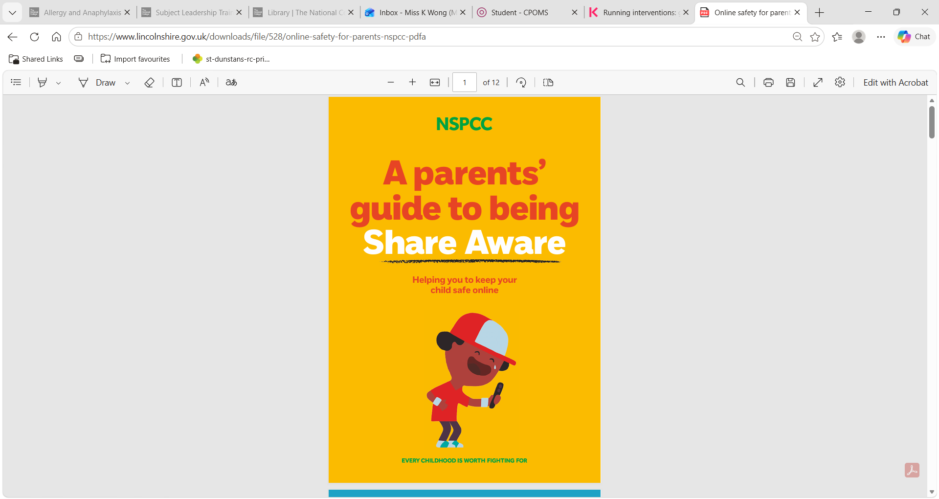
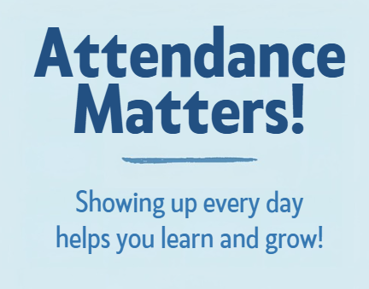
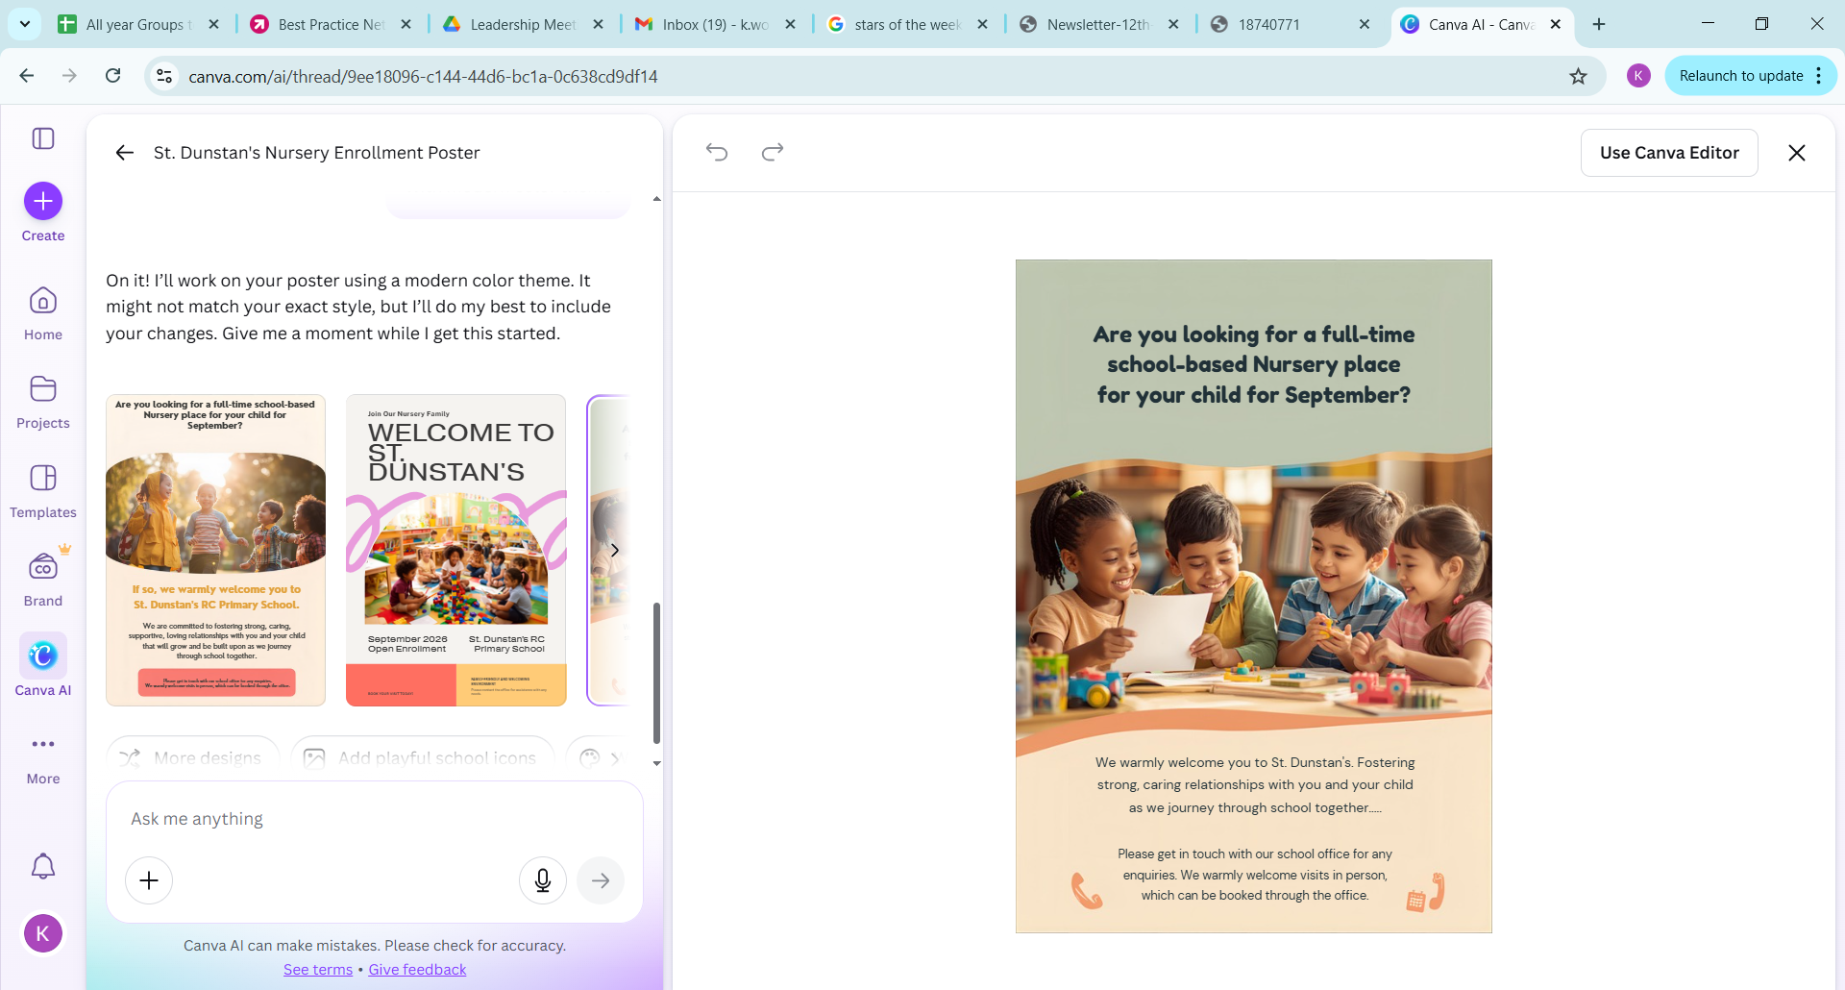
Scan Me

Attendance this week
Nursery 98%
Reception 99%
Year 1/2J 97%
Year 2 – 95%
Year 3- 96%
Year 4A – 99%
Year 4P – 98%
Year 5 LG – 99%
Year 5F – 95%
Year 6H – 98%
Year 6W – 93%

Whole School: 96.7%

