W/C 22.06.2020: Learning Project - Transport
Age Range: EYFS
Weekly Reading Tasks | Weekly Phonics Tasks
Monday- Sing the nursery rhyme ‘Wheels on the Bus’ with your child. Can they add verses about different modes of transport? What sounds and actions do other kinds of transport make? | Monday- Look around the house and garden. Write labels for the different objects found. Ask your child to read the word (support them if needed) and put each label with the correct object.
Tuesday- Follow the story The Bus is for Us with your child. Ask them to recall the different types of transport mentioned in the story. | Tuesday- Play Rhyme Racer - collect all the rhyming words. What rhyming words did you find? CHALLENGE: Can you think of some of your own rhyming words?
Wednesday- Tell your child that they’re going on an imaginary journey. What do they need to take? Play the memory game - ‘I packed my bag and in it I put a…’ Take it in turns and keep adding to the list. Each time repeat the whole list. | Wednesday- If able, your child can have a go at writing some of the tricky words they have been practising reading over the weeks. These include: I, no, go, to, the, into, he, she, me, we, be, into, he, she, me, we, be, you, are, they, my all, he.
Thursday- During your daily walk discuss with your child the things they see. Ask them to note the different transports. When you get home, ask them to recount the events from your journey in order. | Thursday- During your daily walk, ask your child to listen to the sounds each mode of transport makes. Discuss the rhythm and volume of each sound.
Friday- Listen to ‘The Naughty Bus’. Your child can make a wanted poster for the Naughty Bus. | Friday- Think of different types of transport beginning with each letter of the alphabet e.g. a=aeroplane, b=bike, c=car.
Weekly Writing Tasks | Weekly Maths Tasks- Capacity
Monday- Ask your child to draw pictures of different types of transport and label them. CHALLENGE: Sort them into water, air and road. | Monday- Give your child a small cup. Using different sized spoons fill the cup with water. How many small spoons will it take to fill the cup? How many large spoons?
Tuesday- Your child can make their own road safety poster - Stop, Look, Listen. | Tuesday- Play Happy Glass. Talk about the glass being empty and what you need to make the glass full.
Wednesday- Imaginary journey-where would your child go? Why would they go there? What would they do there? They could draw out their imaginary land and label it with describing words. | Wednesday- Provide your child with a selection of containers in the bath, sink or paddling pool. Experiment together, showing the bottles and containers as full, half full, empty and overflowing.
Thursday- Your child can write simple sentences about their daily walk journey. What did they see and hear? Pictures and labels will simplify this if needed. | Thursday (theme)- Sit with your child and look out the window. Count how many vehicles they can see. Sort them in different ways such as: size, colour, etc.
Friday- Make your very own Naughty Bus and use this to retell the story. Your child could make a different mode of transport as a challenge. | Friday- Ask your child to fetch a selection of their soft toys. Provide them with a range of different boxes (use recycling boxes). Ask them to choose an appropriate sized box for each animal to make into its car. Will a large teddy fit in a small box?

Learning Project - to be done throughout the week
The project this week aims to provide opportunities for your child to learn more about transport. Learning may focus on modes of transport, transport in the past, the science behind transport, road safety and how to be safe around water.

Make Paper Planes
- Make paper airplanes using this guide. Ask your child/ children to come up with a name for their airplane and write this on the side. Have a competition to see whose airplane will fly the furthest/ highest. You could ask them to create a certificate for the winner. Take a photograph of the winning plane to share your success and upload to Twitter at #TheLearningProject.

Traffic Lights
- Play the traffic light game- Ask your child to help create a set of traffic lights. This could be as detailed or simple as you like. Ask your child to run around the garden/ outdoor space. When you point to a colour on the traffic light they have to do the following:
  - Red- Stop or freeze where they are
  - Orange- Walk slowly
  - Green- Run
You can extend this by adding in different colours or actions e.g. when you bounce a ball on the ground, they have to jump up and down.

Origami Boat
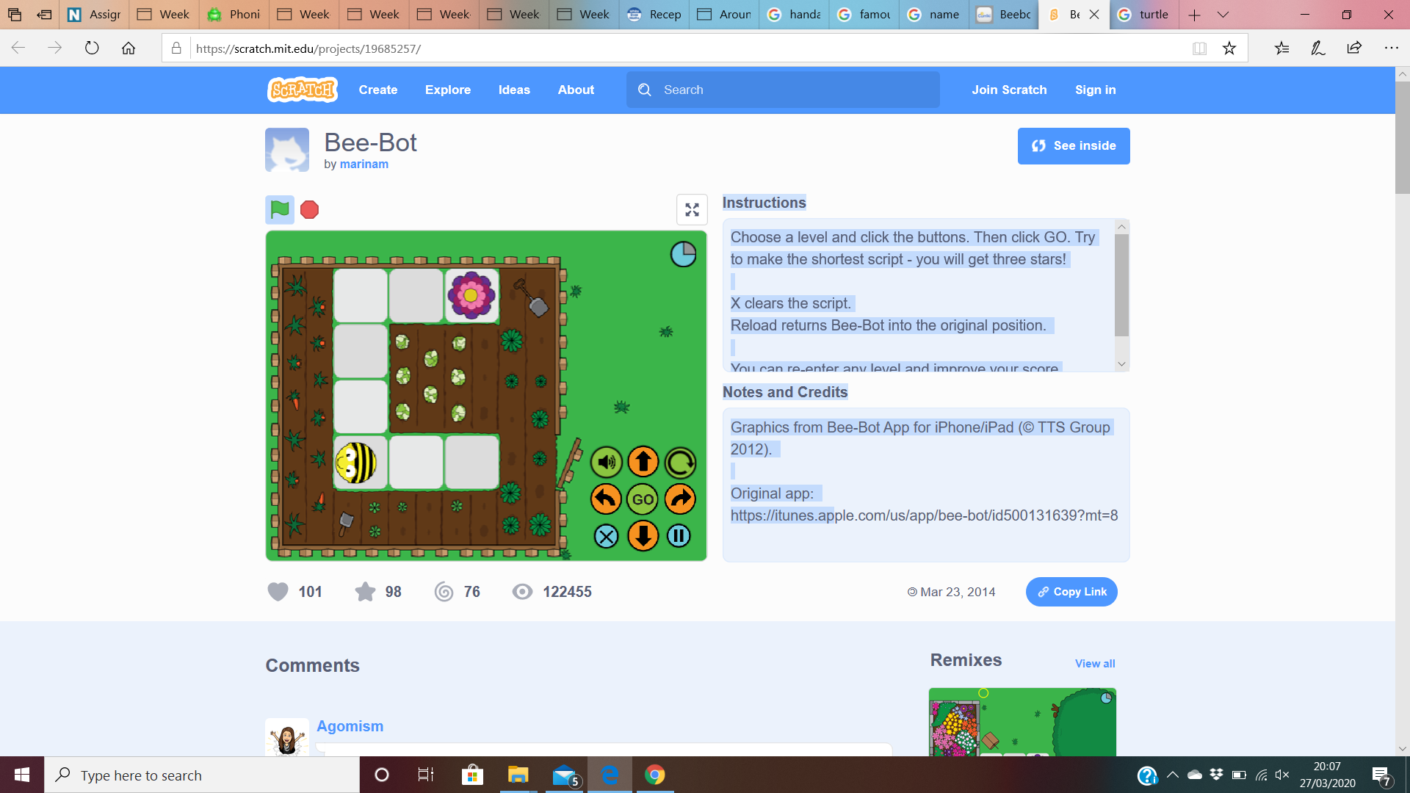
- Follow the instructions here to make your very own origami boat. You could float these in a paddling pool, in the sink or in the bath. Experiment with filling your boats up with objects, does it still float?

Follow the instructions -
- Give instructions to guide each other around the house/garden i.e. forward two steps, turn left, forward two more steps.
- Can you support your child in drawing a map to show the way around the house? CHALLENGE: Work with your child guiding Bee Bot to the flower. Use the arrows and press ‘Go!’

Learn to Ride a Bike
- Support your child in learning to ride a bike. They could even do an obstacle course to help develop their control or have races to improve their speed.
STEM Learning Opportunities #sciencefromhome
Brilliant Boats
- Collect different materials from around your house. Paper, yoghurt pots, cereal boxes, tinfoil cake tins. Which objects make the best boats? Which boat will carry the most coins or marbles?
Additional learning resources parents may wish to engage with
White Rose Maths online maths lessons. Watch a lesson video and complete the worksheet (can be downloaded and completed digitally).
Numbots. Your child can access this programme with their school login.
IXL Click on Maths, Reception. There are interactive games to play and guides for parents.
Talk for Writing Home-school Booklets are an excellent resource to support your child’s speaking and listening, reading and writing skills.
The Learning Projects are based on the National Curriculum expectations for the key stage which your child is in. It may be that your child finds the tasks set within the Learning Project for their year group too simple. If this is the case, then we suggest that your child accesses the Learning Projects which are set for the key stage above. Equally, if the projects are too challenging, then we advise that your child accesses the projects for the key stage below.
If your child requires more of a challenge, or you believe that there are some gaps in their learning then Century Tech is a fantastic resource that is currently free for home learning. The app is designed to address gaps and misconceptions, provide challenge and enables children to retain new knowledge. It uses artificial intelligence to tailor the learning to your child’s needs. Sign up here.
#TheLearningProjects
in collaboration with
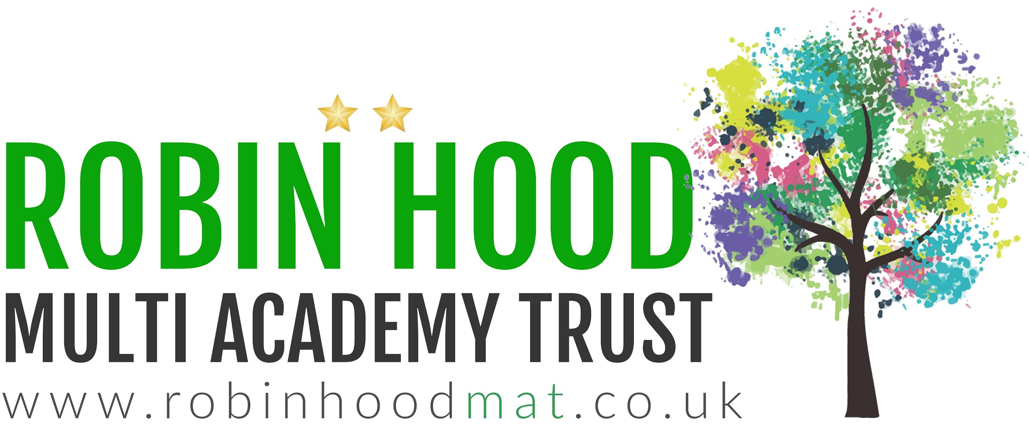

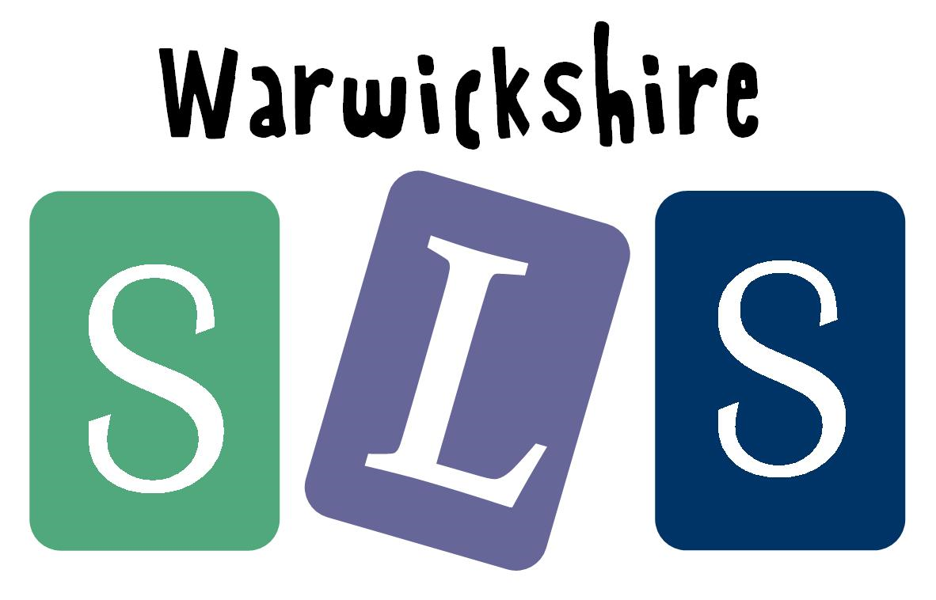
www.robinhoodMAT.co.uk

