W/C 11.05.2020: Learning Project - The Rainforest
Age Range: EYFS
Weekly Reading Tasks | Weekly Phonics Tasks
Monday- Watch Go Jetters: Amazon Rainforest. Can your child tell you where the tree frog was found? What sound did it make? Which rainforest insect steals the picnic? What happens when the tree frogs aren’t there to eat the ants? | Monday- Ask your child to find different things around the house/garden. Can they segment each word into sounds i.e. c-u-p (cup), b-e-d (bed) t-ea (tea), ch-air (chair)? If they are able, they could write these too.
Tuesday- Help your child to look through cookery books for a recipe involving cocoa/chocolate. If you have the ingredients, make the sweet treat! | Tuesday- Think of words to describe the rainforest animals - each word should start with the same letter i.e. mad, munching monkey or large, loving lion.
Wednesday- Ask your child to use pictures from a familiar story book to make up their own story or to retell their favourite story. | Wednesday- Daily Phonics - Practise the sounds your child is working on and blend words. This can be oral blending (e.g. spoken out loud a-n-t) or written.
Thursday- Enjoy listening to online stories together including: Slowly, Slowly, Slowly Said the Sloth and The Tiger Who Came To Tea. | Thursday- Play ‘I Spy in the Rainforest’. ‘I spy, with my little eye, something beginning with t’. CHALLENGE: Change it to ‘I spy, with my little eye, my word includes the digraph ee’ - ‘Tree’.
Friday- Ask your child to read these tricky words: I, no, go, to, the, into, he, she, me, we, be. CHALLENGE: Ask your child to find these tricky words in the stories you are reading. | Friday- Play the Word Machine - Ask your child to read each word carefully. Match the correct word to the picture. If you get it right, you will hear a clap. Click ‘Next’ and have a go at another word.
Weekly Writing Tasks | Weekly Maths Tasks- Number Recognition and Counting
Monday- Say or write a list of all the animals you would find in the rainforest. CHALLENGE: Can your child think of an animal for each letter of the alphabet e.g. a=alligator, b=bird. | Monday- Use this tens frame to practise making different amounts. Or, your child can practice making amounts to 10 using different objects from the garden e.g. leaves.
Tuesday- Talk about the rainforest with your child and ask: What can you see? What can you hear? Ask your child to draw a picture of the rainforest and write a sentence about what they can see or hear. | Tuesday- Practice writing the numerals to 10 and then up to 20 if your child is able. You could do this in chalk in the garden, using felt tips, crayons or anything that will engage your child.
Wednesday- Use this animated letter formation tool to help your child practise letter formation. You can select those they find most challenging. | Wednesday- Play this Ladybird Spots-Counting, Matching and Ordering Game. You can tailor the difficulty to your child’s level.
Thursday- Using the story The Tiger Who Came To Tea, draw a picture of the tiger and label the picture using words to describe him e.g. stripy fur, sharp teeth. | Thursday (theme)- Make a garden trail using arrows made from sticks. Ask your child to follow the trail and identify the direction. This could be done on your walk.
Friday- Ask your child to create a rainforest animal mask then talk about the sounds that different animals make. CHALLENGE: Can they write a sentence to describe the animal e.g. I like the monkey. He is cheeky. He jumps in the trees. | Friday- Use a teddy and count forwards and backwards making deliberate mistakes. Can your child spot the mistakes? Mistakes can include omitted numbers, repeated numbers or a number in the wrong place. CHALLENGE: Ask your child to spot the mistake when the numbers are written down.

Learning Project - to be done throughout the week
The project this week aims to provide opportunities for your child to learn more about the world’s rainforests. Learning may focus on the plants, animals and insects that inhabit the rainforest, food that originates there and weather patterns. It could look at plants and animals that can be found in the garden too.
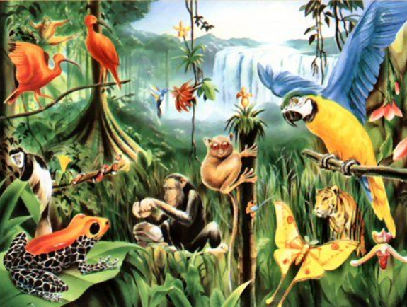
Which Animals Live in the Rainforest?
- Watch this video about animals in the rainforest. Can your child tell you about some of the animals that live in the rainforest? Can they remember any facts? Can they describe the animals?.
- Ask your child to make their own explorers outfit (e.g. binoculars, sunhat, backpack) and head out to the garden or on your daily walk. What creatures can your child find? Are they similar to any you might see in the rainforest? Take photographs.

Draw a Picture of a Rainforest Animal on the Computer
- Ask your child to draw a picture of a rainforest animal. Can they use computing software to recreate their picture? Try Paint.

Play the Animal Jungle Quiz
- Listen to the clues. Can you match the clue to the correct animal?
- Click here to create your own jungle. Drag the animals onto the picture. Where do you think the animals should go? Why? i.e. on the ground, in the trees…
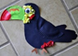
Make a Collage of a Rainforest Animal
- Use collage to create your own rainforest animal using recycled materials from around the house. Share your finished creation to inspire others on Twitter at #TheLearningProjects.

Make an Animal Home
- Create an animal home e.g. a bug hotel using things from the garden. Use a plastic tub or cardboard box. Ask your child what the animal will need in the home in order to survive.
STEM Learning Opportunities #sciencefromhome
Rainforest Materials
- A rainforest has lots of tall trees and grows in warm countries that have a lot of rain. People use the wood from the trees to make paper and furniture. They also take lots of ingredients like sugar and oil to make food. Here you can find a list of food and ingredients that grow in rainforests.
- What plants can we find in the garden? Can you name the different parts of a plant? Stem, leaves, branches, roots, flower? Try using some of the material found in your garden to make something useful. For example, a nature paint brush.
Additional learning resources parents may wish to engage with
White Rose Maths online maths lessons. Watch a lesson video and complete the worksheet (can be downloaded and completed digitally).
Numbots. Your child can access this programme with their school login.
IXL Click on Maths, Reception. There are interactive games to play and guides for parents.
Talk for Writing Home-school Booklets are an excellent resource to support your child’s speaking and listening, reading and writing skills.
The Learning Projects are based on the National Curriculum expectations for the key stage which your child is in. It may be that your child finds the tasks set within the Learning Project for their year group too simple. If this is the case, then we suggest that your child accesses the Learning Projects which are set for the key stage above. Equally, if the projects are too challenging, then we advise that your child accesses the projects for the key stage below.
If your child requires more of a challenge, or you believe that there are some gaps in their learning then Century Tech is a fantastic resource that is currently free for home learning. The app is designed to address gaps and misconceptions, provide challenge and enables children to retain new knowledge. It uses artificial intelligence to tailor the learning to your child’s needs. Sign up here.
#TheLearningProjects
in collaboration with
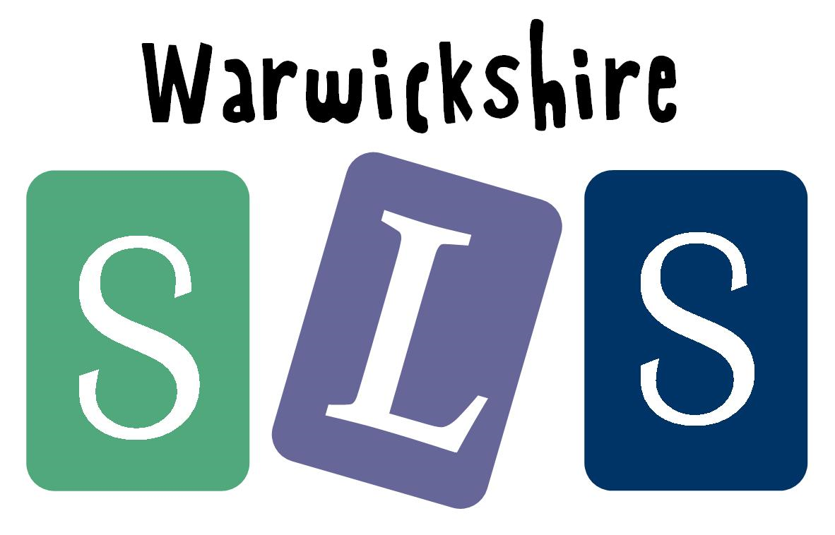


www.robinhoodMAT.co.uk

