

Learning Project WEEK 3- Viewpoints
Age Range: EYFS
Weekly Maths Tasks (Aim to do 1 per day) | Weekly Reading Tasks (Aim to do 1 per day)
- Watch a Numberblocks clip each day at: BBC or CBeebies. Use this guide here to give you ideas on what to do with your children whilst watching an episode.  - Play the Numberblocks pattern spotting game.  - Practise counting up to 20. This can be done through playing hide and seek, singing number songs, chanting, board games etc.  - Listen to a number song from the CBeebies website. After listening to them, watch again and sing along if you can. Talk about the maths you can see in the video clip.  - Look out of the window and count how many houses or buildings can be seen. | - Read a variety of books at home. Favourites can be repeated. Hearing the patterns of language in a story will support your child’s language development.  - Reception age children: Children to read to parents daily. Visit Oxford Owl for free eBooks that link to your child’s book band. You can create a free account at: https://www.oxfordowl.co.uk/for-home/  Complete the linked Play activities for each book.  - With your child, look in magazines, newspapers and books for the tricky words they are currently learning. They could use a highlighter to highlight in magazines and newspapers.
Weekly Phonics Tasks (Aim to do 1 per day) | Weekly Writing Tasks (Aim to do 1 per day)
- Sing Nursery Rhymes and songs together. Add in actions and change the words. Can children think of different rhyming words to add in? Repeat old favourites and learn new rhymes. You can find an A-Z of Nursery Rhymes here: https://allnurseryrhymes.com/  - Daily phonics - Practice the sounds your child is working on and blend words. This can be oral blending (e.g. spoken out loud c-a-t) or written if appropriate. Interactive games found on link below. https://www.phonicsplay.co.uk/  - Play I-spy with things you can see out of the window. You could alternate between the initial sound in the word e.g. “I spy with my little eye something beginning with t”. Or with oral blending e.g. “I spy with my little eye a t-r-ee”  - Play a listening game- Gather a selection of objects that make sounds from around the house. Cover your child’s eyes with a blindfold and make sounds with the objects collected. Can they figure out what the object is without looking at it? | - Practice name writing. Can they write their first name? Middle name? Surname?  - Practice forming the letters of the alphabet. Follow your school’s script.  - Ask your child to write out the tricky words they are working on at the moment on pieces of paper and turn them into a pairs game.  - Ask your child to draw or write a shopping list to help plan for the weekly shop. Encourage them to ask all family members views on what they would like to eat that week.  - Ask your child to help plan a movie night/ afternoon. Select two films from a streaming service or DVD’s you have in the house. Ask them to draw a picture to represent each film or write out the title. Ask them to speak to each member of the house to find out their view on which film they would like to watch. Ask your child to write each person’s name under their chosen film.
Learning Project - to be done throughout the week
The project this week aims to provide opportunities for your child to learn more about different viewpoints. Learning may focus on physical viewpoints in terms of what you can see outside of the window at home, what others can see looking into your home and then progress onto personal viewpoints and of others.

- What can you see out of your window?-
  - Ask your child to look out of a window in the house and draw what they can see. Look out of a different window (e.g. back or side of the house), draw what they can see. Look at the two pictures together and discuss what is the same in both pictures (e.g. the sky) and what is different.

- Record how many cars/ people walk past your house-
  - Set a timer for 5 minutes on your phone or tablet. Draw out a simple grid (as below) and ask your child to put a tick in the right place every time a person or car goes past. When complete, can they count up the ticks and write the matching numeral? Were there more people or cars?
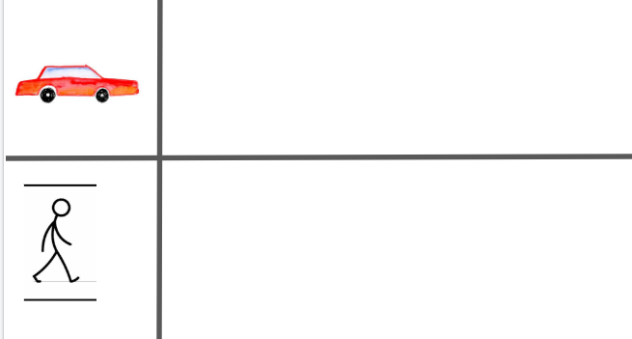

- How do we differ from others?-
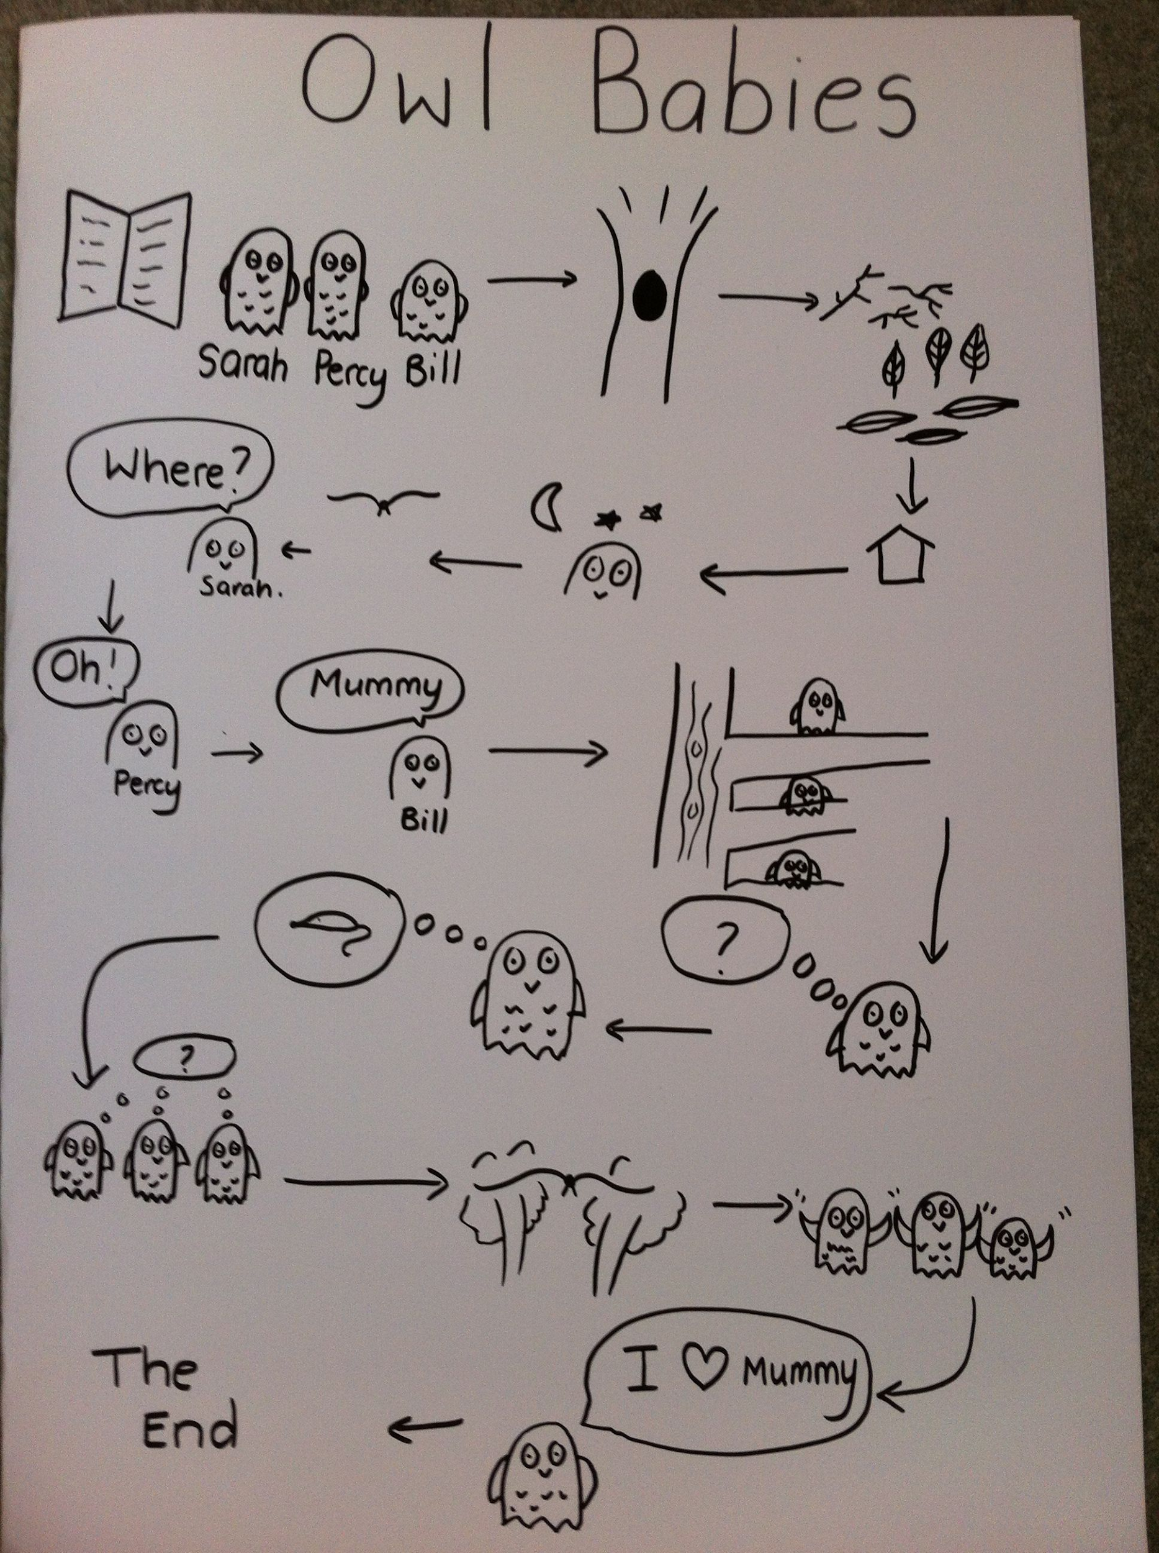
  - Ask your child to look in a mirror at their hair colour, eye colour, skin colour. Ask them to create a self-portrait using either felt-tips, crayons or paint. Look at some pictures in books and magazines. Does everyone look the same way as them? How do people look different?

- Imagine another world outside the window-
  - Close the curtains and ask your child to imagine that the house is in a new imagined world. What do they imagine? Is it snowy? Are there dinosaurs/ monsters in the new world? Ask them to tell you a story about it…
Your child could create a story map to show what happens in their imaginary world (see right).

- Go on a sight hunt-
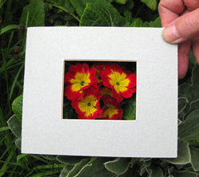
  - Support your child to make a viewfinder. Cut out a square of card from an old cereal box/ cardboard. Cut a smaller square out of the centre. Take your viewfinder around the house and garden and explore what things you can see. Alternatively, you could create a pair of binoculars as pictured.
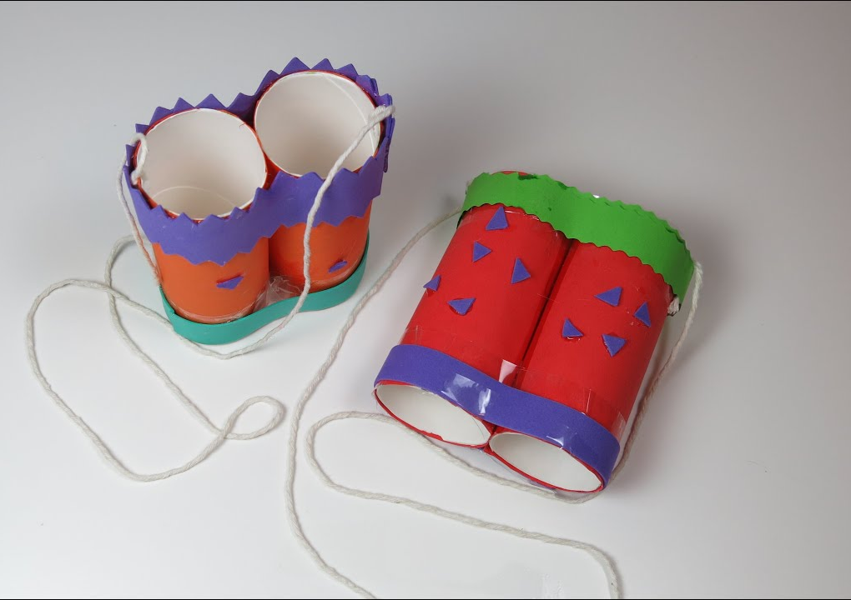
  - Your child could write a list of the things they see or draw/ paint a picture.
  - If you have a tablet or phone that could be used by your child they could do the same activity but using photographs to record.

Additional learning resources parents may wish to engage with
Classroom Secrets Learning Packs - These packs are split into different year groups and include activities linked to reading, writing, maths and practical ideas you can do around the home.
Twinkl - to access these resources click on the link and sign up using your own email address and creating your own password. Use the offer code UKTWINKLHELPS.
Headteacherchat - This is a blog that has links to various learning platforms. Lots of these are free to access.
#TheLearningProjects

