
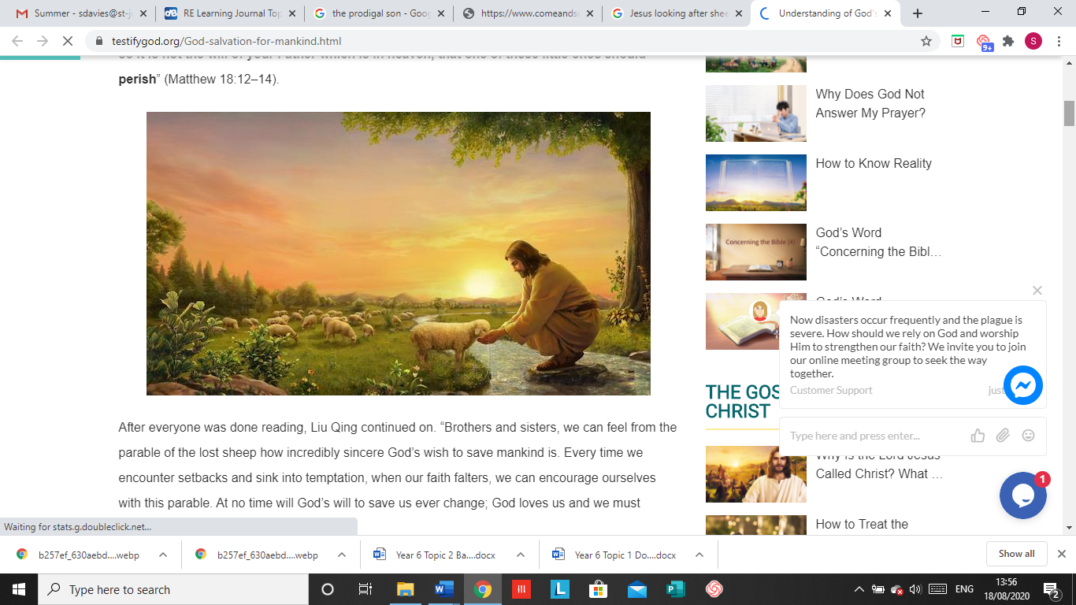
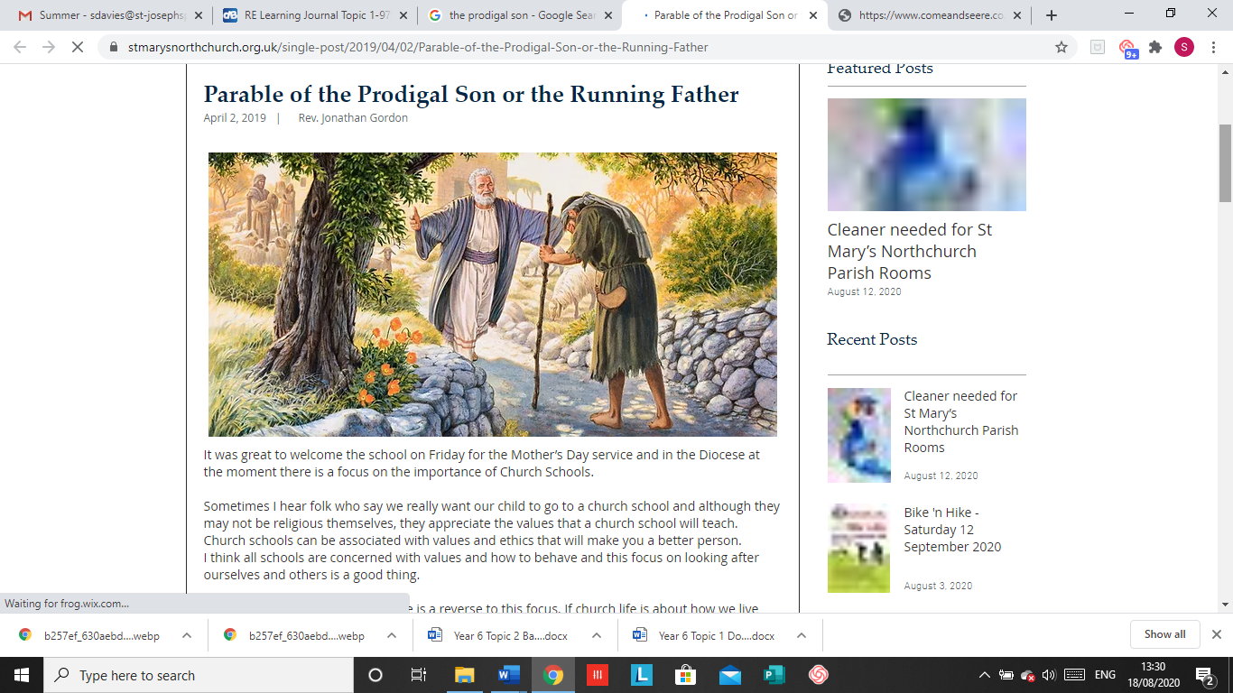

SCRIPTURE
Isaiah 40: 1-5,9-11,28-31 Prepare for God’s coming
Psalms 23 and 136 God cares for me like a shepherd cares for his sheep
Luke 15: 11-32 It was fitting to be glad your brother was lost and now is found
Matthew 5: 1-12, 44-48 Blessed are the pure of heart they will see God
John 15: 9-14 My commandment is this: love one another, just as I love you.
Ephesians 4:26, 31-32 Get rid of bitterness, rage and anger
Titus 3: 4-8 God poured out the Holy Spirit abundantly on us through Jesus Christ our Saviour

OUR BIG QUESTION
Which Bible stories tell us about God’s love and how can we put these into action?

LOVING
Year 6 Topic 1
REFLECTION
Father, creator of all,
you ‘ordered the earth’ to bring forth life
and crowned its goodness by
creating family life.
Teach us the beauty of human love,
show us the value of family life
and help us to live in peace
with everyone.
Amen.

KEY VOCABULARY
unconditional, forgiveness, mercy, prodigal, parable, reconciliation
A parable is story used by Jesus to illustrate a moral.
Unconditional does not have restrictions/conditions imposed.

God’s love is unconditional and eternal.

God himself is an eternal exchange of love, Father, Son, and Holy Spirit, and he has destined us to share in that exchange.
God is the loving parent of the human family and Jesus was born and lived in a human family.

