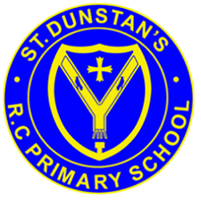

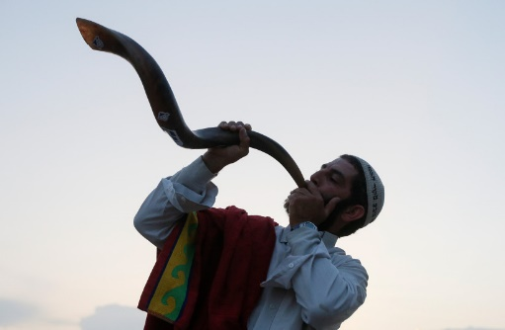
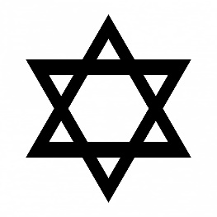
OUR BIG QUESTION
How do the Jewish people make a new start?

Many Jews will refrain from work, fast and/or attend synagogue services on this day.
There are 10 Days of Awe before Yom Kippur to put things right with others.
It is a day set aside to atone for the sins of the past year.
Yom Kippur is probably the most important holiday of the Jewish year.
KEY VOCABULARY
Rosh Hashanah
Yom Kippur shofar
forgiveness confession
The name ‘Yom Kippur’ means ‘Day of Atonement’.
JUDAISM – Yom Kippur
Year 6

