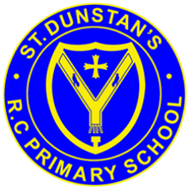
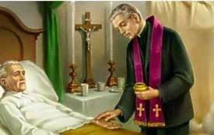

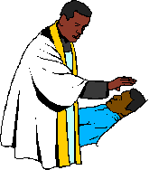
SCRIPTURE

Mark 6: 13 The followers forced many demons out and poured olive oil on many sick people and healed them
Luke 18: 35-43 Jesus Heals A Blind Man
Luke 10: 30-37 The Parable of the Good Samaritan
James 5: 14-15 If one of you is sick, he should call the church’s elders. The elders should pour oil on him in the name of the Lord and pray for him. And the prayer that is said with faith will make the sick person well. The Lord will heal him. And if he has sinned, God will forgive him.
OUR BIG QUESTION
Who needs healing?

During the sacrament, these words are spoken. ‘Through this holy anointing may the Lord in his love and mercy help you with the grace of the Holy Spirit. May the Lord who frees you from sin save you and raise you up.’
The sacrament of anointing of the sick is given to those who are seriously ill by anointing them on the forehead and hands with duly-blessed oil.
The Church believes that the anointing of the sick is one the seven sacraments. It is intended to strengthen those who are ill.

KEY VOCABULARY
care sickness hospice compassion
Sacrament anointing Lourdes

REFLECTION
I have chosen the way of faithfulness;
I set your ordinances before me.
I cling to your decrees,
O Lord; let me not be put to shame.
I run the way of your commandments,
for you enlarge my understanding.
Teach me, O Lord, the way of your statutes,
and I will observe it to the end.
Give me understanding that I may keep your law
and observe it with my whole heart.
Amen.

HEALING
Year 6 Topic 8

