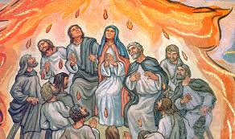
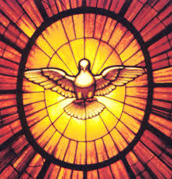
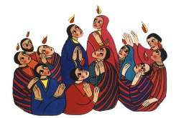
The feast of Pentecost is a celebration of the gift of God’s Spirit and its transforming power.
It is the work of the Spirit to enable people to hear God’s message, to respond and share it.
Christians believe that the Spirit of God is active in each person and in a special way in the community of believers, which is the church.
KEY VOCABULARY
transform energy Holy Spirit change
Gift Fruits of the Spirit

REFLECTION
Father, pour out your Spirit upon your people,
and grant us a new vision of your glory,
a new faithfulness to your Word and a new
consecration to your service, that your love
may grow among us, and your kingdom
come: through Christ our Lord.
Amen.

TRANSFORMATION
Year 5 Topic 7


SCRIPTURE
Galatians 5: 16-17, 22-23 We have freedom now because Christ made us free. So stand strong.
Luke 24: 13-35 On the Road to Emmaus
Acts 2: 32-39, 41-42 Change your hearts and lives and be baptised, in the name of Jesus Christ for the forgiveness of your sins.
Acts 22: 6-16 The Road to Damascus
Romans 8: 14-17 The true children of God are those who let God’s Spirit lead them
OUR BIG QUESTION
How can energy transform?

