
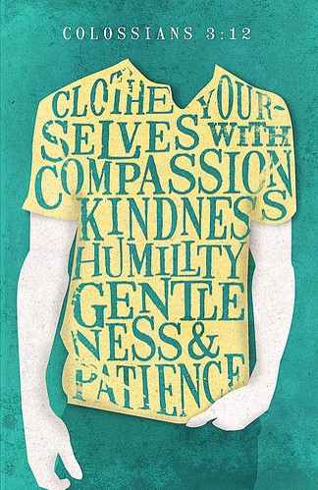
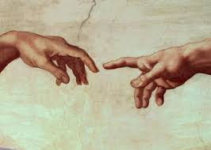
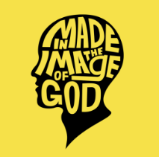
SCRIPTURE
Genesis 1: 26 –28 God said, “Let us make human beings in our image and likeness.”
Colossians 3: 10 -11 Christ is all that is important.
Colossians 3: 12-17 God has chosen you and made you his holy people. He loves you.
Philippians 4: 4-9 Be full of joy in the Lord always.
Hosea 11: 1-4 I led them with cords of human kindness with ties of love.

KEY VOCABULARY
qualities talents unique challenge
responsibility dignity peacemaker

REFLECTION
Father, creator of all,
you ‘ordered the earth’ to bring forth life
and crowned its goodness by
creating family life.
Teach us the beauty of human love,
show us the value of family life
and help us to live in peace
with everyone.
Amen.

Everyone is made in the image and likeness of God.
We should know ourselves and appreciate that our value and uniqueness is central to our wellbeing.

We have all been gifted with different human qualities which can be developed.
OUR BIG QUESTION
Who am I?

OURSELVES
Year 5 Topic 1

