
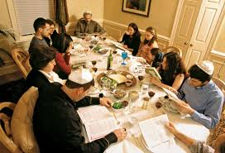
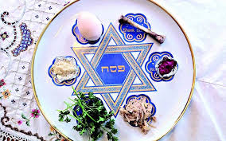

The name Passover comes from the story of the angel of death passing over the house of the Israelites.
Hospitality is important at Pesach.
It is a time people thank God for their freedom.
Pesach or Passover is a spring festival which lasts for 7 or 8 days.
OUR BIG QUESTION
Why would Jews want to celebrate Pesach in Jerusalem?

Pesach comes from the paschal lamb which was once sacrificed.
KEY VOCABULARY
Passover seder
kosher mezuzah
remembering

JUDAISM – Pesach
Year 5

