
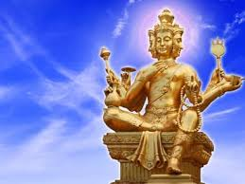
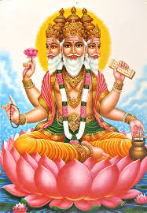
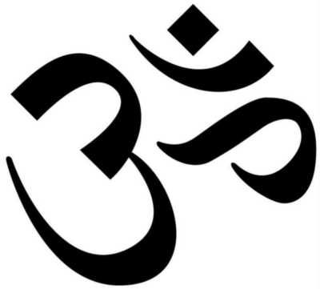
Brahman has three major qualities/trimurti (meaning three gods) Brahma, Vishnu and Shiva.
KEY VOCABULARY
Brahman
pilgrimage
supreme God
Hindus have a belief in one supreme Being called Brahman who takes many different visible forms.
OUR BIG QUESTION
What is special about Brahman?

It is a flexible religion which allows people to express their belief and worship in different ways.
Hinduism has no known founder.
Hinduism is one of the oldest religions of the world.
HINDUISM – Brahman
Year 5

