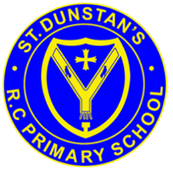
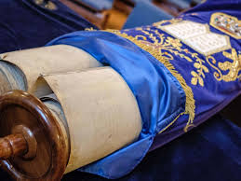
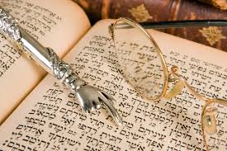
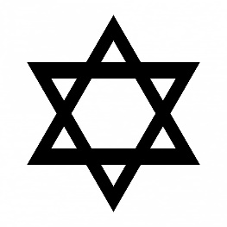
The Sefer Torah, or Torah scrolls are treated with great respect.
OUR BIG QUESTION
How is the Torah looked after?

The Torah shows how God wants the Jewish people to live.
For Jewish people their scriptures are very important.
Jewish people believe God dictated the Torah to Moses on Mount Sinai.
The first five books of the Hebrew scriptures are called the Torah.
KEY VOCABULARY
Tenakh Sefer Torah
scroll scribe
yad Ark
JUDAISM – The Torah
Years 3 and 4

