

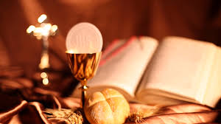
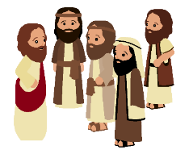
SCRIPTURE
Romans 12: 8-11 Love each other like brothers and sisters. Give your brothers and sisters more honour than you want for yourselves. Do not be lazy but work hard. Serve the Lord with all your heart.
Mark 3: 13-19 Jesus chose 12 men and called them Apostles.
Acts 6: 2-13; 7: 57-60 Saint Stephen’s persecution
KEY VOCABULARY
responsibility parish laity ministries
pastoral area deanery service

OUR BIG QUESTION
What makes a community?

The whole liturgical life of the Church revolves around the Eucharistic sacrifice and the Sacraments.
Lay people help to build up the local community of the parish.
In the local church, lay people of all ages are called to undertake various roles called ministries.
REFLECTION
Lord, you fulfilled the hope of Simeon who did not die
until he had been privileged to
welcome the Messiah.
In Sacramental Celebrations we meet the Risen Christ.
May he continue to give us life.
Amen.

MISSION
Years 3 & 4 Topic 4

