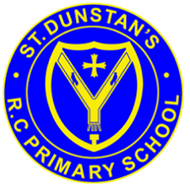
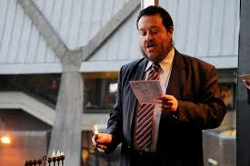
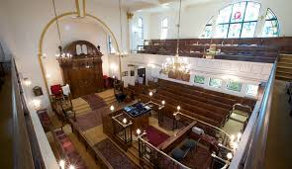
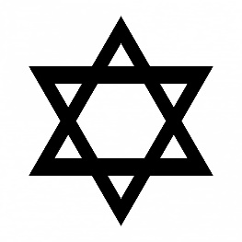
If possible, synagogues are built facing in the direction of where the Temple was in Jerusalem.
The synagogue is a special building where the Jewish community meet to pray, study and celebrate.
When boys and men go into the synagogue, they must cover their heads, the hat they wear is a kippah.
Women often cover their heads, and men wear a tallit (shawl) as a sign of respect.
OUR BIG QUESTION
How might you recognise a synagogue?

As well as a place of worship it is a place where the community gathers.
KEY VOCABULARY
worship synagogue
rabbi Ark
bimah kippah
JUDAISM – The synagogue
Years 3 and 4

