


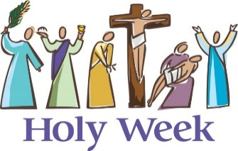
SCRIPTURE
Matthew 5: 1-17 The Beatitudes
How blessed are those who are pure in heart, because it is they who will see God!
Luke 4: 1-4 Jesus is Tempted in the Desert
Mark 14:26-31, 32-46, 15 21-27 The Easter Story
Matthew 25: 31-40 The Easter Story
Luke 23:33-35,38-43 The Easter Story
Luke 24: 1-12 Jesus’ resurrection

OUR BIG QUESTION
What makes some people give everything for others?

KEY VOCABULARY
self-giving courage Ash Wednesday Holy Week
praying fasting almsgiving Resurrection

Lent and Holy Week is a time of giving in different ways and remembering the total giving of Jesus.

Lent is the season when Christians practise both giving and giving up, to identify with the complete self-offering of Jesus.
In his Gospel, Matthew makes it clear that in loving and caring for other people we are loving and caring for Jesus.

REFLECTION
Lord, when I am hungry give me someone to feed;
When I am thirsty give water for their thirst.
When a burden weighs upon me lay upon my shoulders the burden of my fellows.
Lord, when I stand greatly in need of tenderness, give me someone who yearns for love. May your will be my bread;
Your grace my strength; Your love my resting place.

GIVING ALL
Years 3 and 4 Topic 6

