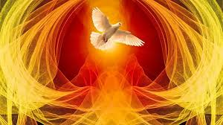
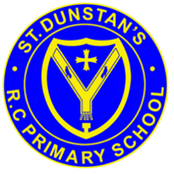
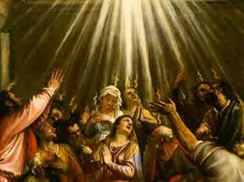
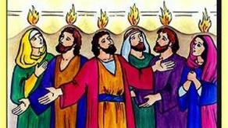
SCRIPTURE
Matthew 28: 1-10 Jesus rises from the dead
John 16: 5-7 The promise of the Holy Spirit
1 Corinthians 12: 4-8, 11 Something from the Spirit can be seen in each person, to help everyone.
Acts 1: 6-11 Jesus’ Ascension
Acts 2: 1-18, 43 This noise filled the whole house where they were sitting. They saw something that looked like flames of fire. The flames were separated and stood over each person there. They were all filled with the Holy Spirit, and they began to speak different languages. The Holy Spirit was giving them the power to speak these languages.

OUR BIG QUESTION
What is the use of energy?

KEY VOCABULARY
warmth wind energy power gifts
Holy Spirit Rosary Glorious Mysteries

At Pentecost, the disciples were filled by the gifts of the Holy Spirit and went out courageously to carry the Gospel of Jesus to the whole world.
The symbols used for the Holy Spirit – wind and fire – are symbols of power and energy.
Christians believe that the gift of the Holy Spirit within them gives them energy and the power to live the way of Jesus.
REFLECTION

Father, pour out your Spirit upon your people,
and grant us a new vision of your glory,
a new faithfulness to your Word and a new
consecration to your service, that your love
may grow among us, and your kingdom
come: through Christ our Lord.
Amen.

ENERGY
Years 3 and 4 Topic 7

