
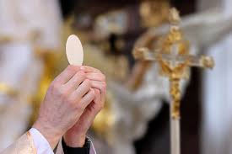
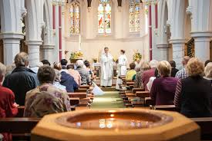
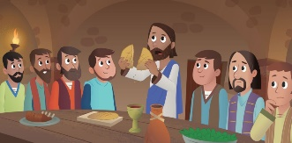
OUR BIG QUESTION
What should we be grateful for?

SCRIPTURE
Luke 22: 19-20 9 Jesus took some bread. He thanked God for it, broke it, and gave it to the apostles. Then Jesus said, “This bread is my body that I am giving for you. Do this to remember me.” In the same way, after supper, Jesus took the cup and said, “This cup shows the new agreement that God makes with his people. This new agreement begins with my blood which is poured out for you.”

REFLECTION
Lord Jesus Christ, in you we know the love of God. When we gather in your name, we experience the marvel of your loving presence which challenges us to live for one another. Help us to follow your example so that we may never become complacent. Help us to listen to your constant call to us to continue the work you began, you who lived and died for us.
Grant this through your Spirit of Love.
Amen.

The Eucharist is another name for the Mass.
The parish family gathers to give thanks to God, most of all for the gift of Jesus, his Son.
The word Eucharist means ‘thanksgiving’.
KEY VOCABULARY
thank you thanksgiving thoughtful eucharist
eucharistic prayer

THANKSGIVING
Years 1 and 2 Topic 5

