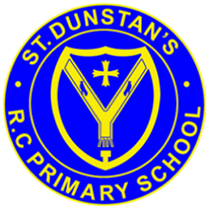


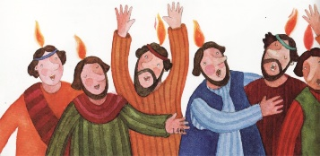
SCRIPTURE
Luke 24: 1-9 Jesus rises from the dead
Luke 24: 48-52 Jesus goes back to Heaven
Act 2: 1-4 The Coming of the Holy Spirit
The apostles were all filled with the Holy Spirit, and they began to speak different languages
I Thessalonians 4: 13-14, 18 We believe that Jesus died and that he rose again. So, because of Jesus, God will bring together with Jesus those who have died.
Romans 8: 22-28 The Holy Spirit helps us with our weaknesses
John 13: 33; 14:18, 15, 26; 16:5,7,13

OUR BIG QUESTION
Why should we spread good news?

KEY VOCABULARY
message risen resurrection Holy Spirit ascension witnesses blessing Pentecost promise

We share in the mission of the Church by spreading the Good News of the message of love of the risen Christ.
The gift of Holy Spirit, which is celebrated at Pentecost, strengthens Christians.

It is the work of the Spirit to enable people to hear God’s message and to live Jesus’ way of service.
REFLECTION
Father, pour out your Spirit upon your people,
and grant us a new vision of your glory,
a new faithfulness to your Word and a new
consecration to your service, that your love
may grow among us, and your kingdom
come: through Christ our Lord.
Amen.

SPREAD THE WORD
Years 1 and 2 Topic 7

