
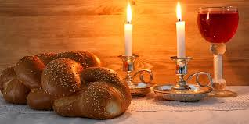

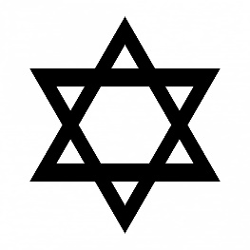
KEY VOCABULARY
creation Shabbat
challah havdalah
Kiddush
Jews stop working and make time for God and family life.
It begins Friday evening and ends on Saturday evening.
It is the day on which Jews remember the seventh day of creation.
The most important day of the week is Shabbat (the Sabbath).
The family and community are very important within Jewish life.
OUR BIG QUESTION
What makes Shabbat special?

JUDAISM – Shabbat
Years 1 and 2

