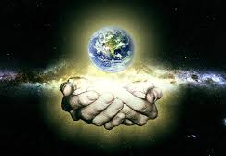
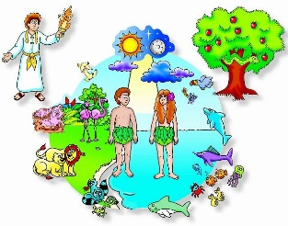
The eternal God gave a beginning to all that exists outside of himself: he alone is Creator.
We often need help to begin anything new.
God is present in every beginning.

OUR BIG QUESTION
Who made the world and everything in it?

BEGINNINGS
Years 1 and 2 Topic 1



SCRIPTURE
Genesis 1: 1- 9, 20, 24-26 In the beginning God created the sky and the earth….
Psalm 8: 3-11 I see the moon and stars,
which you created.
Psalm 139: 14-18 I praise you because you made me in an amazing and wonderful way
Ephesians 1: 3-5 God decided to make us his own children.
KEY VOCABULARY
beginning new start family friend
creation psalm litany

REFLECTION
Father, creator of all,
you ‘ordered the earth’ to bring forth life
and crowned its goodness by
creating family life.
Teach us the beauty of human love,
show us the value of family life
and help us to live in peace
with everyone.
Amen.

