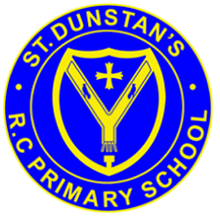
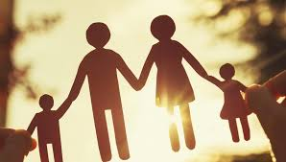
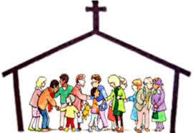
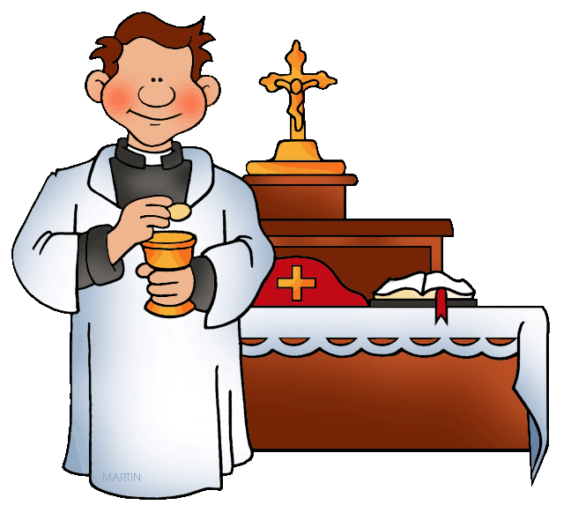
On Sunday, in church, we meet people who do special jobs as we gather to celebrate the Good News of Jesus.
KEY VOCABULARY
church community temple altar servers special
ministers readers choir priest

OUR BIG QUESTION
What makes people special?

REFLECTION

Lord, you fulfilled the hope of Simeon who did not die until he had been privileged to welcome the Messiah. In Sacramental Celebrations we meet the Risen Christ.
May he continue to give us life.
Amen.

As in any family there are people who have special roles within the parish.
All families who live or worship in a parish are part of the parish family.

SPECIAL PEOPLE
Years 1 and 2 Topic 4
SCRIPTURE
Luke 2: 23-40 Simeon sees Jesus
Luke 2: 41-52 Jesus as a boy lost and found in the temple.
Jesus asked, “Why did you have to look for me? You should have known that I must be where my Father’s work is!”

