

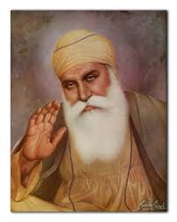
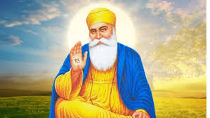
OUR BIG QUESTION
What does it mean to be wise?

KEY VOCABULARY
Guru Nanak
teacher wise
stories
Sikhs believe that your actions are important.
Sikhism is still based on His teachings.
Guru Nanak founded Sikhism.
Sikhs believe in one God who guides and protects them.
SIKHISM – Guru Nanak
Years 1 and 2
Guru Nanak was a wise teacher.

