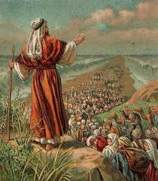

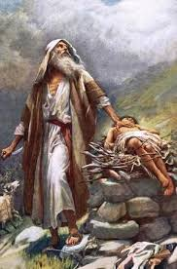

KEY VOCABULARY
Abraham Moses
leaders promised
Pharaoh
OUR BIG QUESTION
Why is Abraham special?

Abraham helped people understand there is only one God.
Abraham answered God’s call to go on an unknown journey.
Moses led the Jewish people to escape from slavery.
Moses was a descendant of Abraham.
JUDAISM – Abraham & Moses
Years 1 and 2
Abraham is the father of the Jewish nation.

