

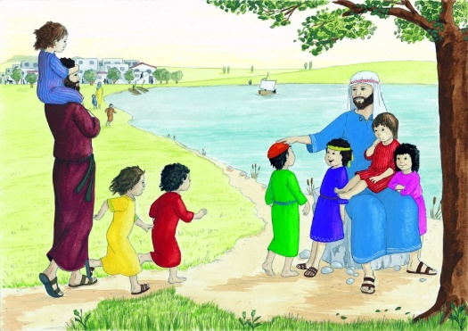
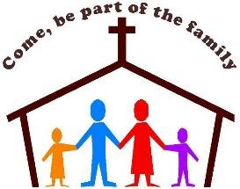
SCRIPTURE
Psalm 16: 7-9 I praise the Lord because he guides me. Even at night, I feel his leading.
I keep the Lord before me always.
Psalm 28: 6-8 Praise the Lord. He heard my prayer for help. The Lord is my strength and shield.

KEY VOCABULARY
family belong God love care different
God’s children psalm family of God response
A psalm is a sacred song of hymn

OURSELVES
Years 1 and 2 Topic 1
It is in the love of a family that Christians first experience the reality of Church.
Everyone belongs to the family of God.
REFLECTION
Father, creator of all,
you ‘ordered the earth’ to bring forth life
and crowned its goodness by
creating family life.
Teach us the beauty of human love,
show us the value of family life
and help us to live in peace
with everyone.
Amen.

OUR BIG QUESTION
How do families show love and care?

The family is the community in which from childhood we can learn moral values, begin to honour God and make good use of freedom.

