

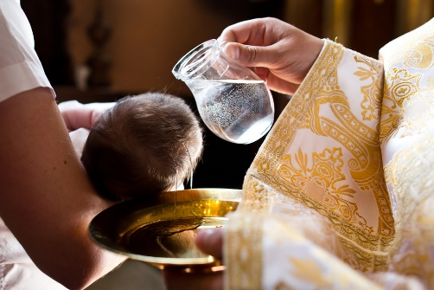
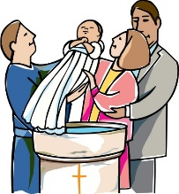
SCRIPTURE
Mark 10: 13-16
Jesus said, “Let the little children come to me. Don’t stop them. The kingdom of God belongs to people who are like these little children. I tell you the truth. You must accept the kingdom of God as a little child accepts things, or you will never enter it.” Then Jesus took the children in his arms. He put his hands on them and blessed them.
KEY VOCABULARY
Sign of the Cross belong friends sacrament invitation welcome Baptism God-parents sign

REFLECTION
Almighty and eternal God,
you keep together those you have united.
Look kindly on all who follow Jesus your Son.
We are all consecrated to you by our common baptism;
make us one in the fullness of faith
and keep us one in the fellowship of love.
Amen.

Baptism enables people to belong to God’s family in a special way.

Christians believe that everyone is invited to share in the life and work of God through Baptism.
Baptism makes us members of the Body of Christ: ‘Therefore… we are members one of another.’
OUR BIG QUESTION
What does it mean to belong?

BELONGING
Years 1 and 2 Topic 2

