

Year 1
Writing

- Write some sentences which are correctly demarcated.
- Use ‘and’ to join ideas.
- Use conjunctions to join sentences (e.g. so, but).
- Use standard forms of verbs, e.g. go/went.
- Introduce use of:
  - capital letters
  - full stops
  - question marks
  - exclamation marks
- Use capital letters for names and personal pronoun ‘I’.
- Write a sequence of sentences to form a short narrative [as introduction to paragraphs].
- Use correct formation of lower case – finishing in right place.
- Use correct formation of capital letters.
- Use correct formation of digits.

Reading

- Identify which words appear again and again.
- Recognise and join in with predictable phrases.
- Relate reading to own experiences.
- Re-read if reading does not make sense.
- Re-tell stories with considerable accuracy.
- Discuss significance of title and events.
- Make predictions on basis of what has been read.
- Make inferences on basis of what is being said and done.
- Read aloud with pace and expression, i.e. pause at full stop; raise voice for question.
- Recognise:
  - capital letters
  - full stops
  - question marks
  - exclamation marks
- Know why the writer has used a particular piece of punctuation in a text.
- Know the difference between fiction and non-fiction texts.

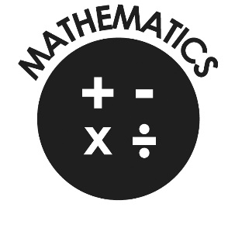
Mathematics

- Count to and across 100, forwards & backwards from any number.
- Read and write numbers to 20 in numerals & words.
- Read and write numbers to 100 in numerals.
- Say 1 more/1 less to 100.
- Count in multiples of 2, 5 & 10.
- Use bonds and subtraction facts to 20.
- Add & subtract 1 digit & 2 digit numbers to 20, including zero.
- Solve one-step multiplication and division using objects, pictorial representation and arrays.
- Recognise half and quarter of object, shape or quantity.
- Sequence events in chronological order.
- Use language of day, week, month and year.
- Tell time to hour & half past.

Navigation Primary School
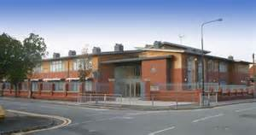
End of Year Expectations
for Year 1
This booklet provides information for parents and carers on the end of year expectations for children in our school. They are all taken from the National Curriculum and they outline what each child is working towards by the end of the year.

All the objectives will be worked on throughout the year and will be the focus of direct teaching. Any extra support you can provide in helping your children to achieve these is greatly valued.

If you have any queries regarding the content of this booklet or want support in knowing how best to help your child please talk to your child’s teacher.

At the end of the year your child will be assessed as either working towards these expectations, meeting these expectations or exceeding these expectations.

