
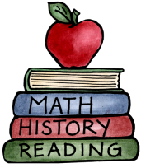
Class: 1 |  | Date to hand in: 23rd October 2026
Choose at least one of these tasks to complete for your homework this half term.
Inspired by the book Supertato, create a superhero out of a potato. If you wanted to make something different or a few superhero characters, you could use a carrot or pepper too! Think of a name for your hero and write it with the help of an adult.  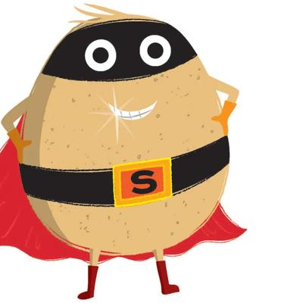 | You can be a superhero by looking after the planet! Talk to an adult about some different ways that you can help to look after the world around you. You could even make a poster informing people about how to look after the world around them.  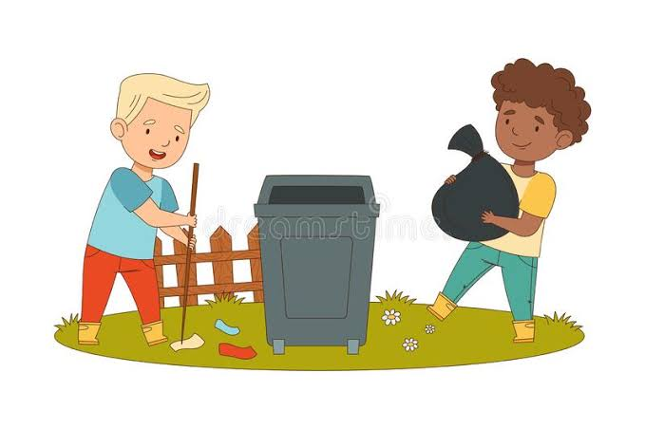 |  | Using your superpowers, subitise objects on a journey. For example, how many windows are there on a house or how many eggs in an eggbox?  Subitise means to look at a small amount of objects and instantly know how many there are without counting them.  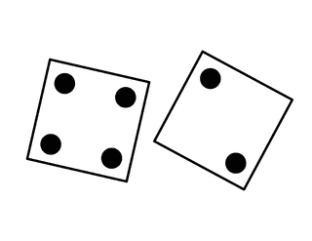 | Superhero Physical Challenge: How many star jumps can you do in a minute?  