
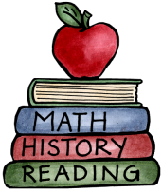
Class: 3 – The Stone Age |  | Date to hand in: 23/10/2026
Choose at least 1 task to complete for your homework this half term. There are tasks the children can do independently.
To be completed at last 3 times a week:  - 10 minutes spelling.  - 10 minutes times tables practice.  - 10 minutes (or more) reading.  - 10 minutes discussing what you’ve read. | Build a cave or shelter suitable for someone from the Stone age. |  | Plan and plot a journey. Remember to calculate the distance you are going to travel and the supplies you will need to bring!
Write a diary entry of a day in the life of a Hunter-gatherer. | Use your hunter gatherer skills and make something delicious! Make sure to record the recipe and take a picture so we can see the final product. |  | Create a shadow and take a picture. Think about the different shadows that could have been seen on the cave walls in the Stone Age.
Create a poster to demonstrate your knowledge of life during the Stone Age. | Create a word search or crossword puzzle using key words and facts you have learnt about the stone age. |  | Create top trumps for the different roles people had during the Stone age.

