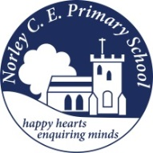
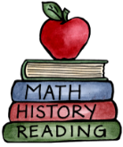
Class: Four |  | Hand in date: Friday 17th July 2026
Choose at least ONE task to complete for your homework this half term – There are several tasks that the children can complete independently.
Maya Hero Story  Write a Mayan hero story, like the ancient myths they told. | Maya Calendar  Can you find out about the Mayan calendar? What was it? Present your findings however you like! |  | Design and make a Maya Headdress  Can you design and create your own Mayan headdress? Write a paragraph about why they wore them.
Poka-tok  Find out about the Mayan ball game of Poka-tok then write a set of instructions explaining how to play it  http://mayas.mrdonn.org/ballgames.html | Hot Chocolate  Create your own Maya hot chocolate recipe and have a go at making it. |  | Maya Gods  Can you find out about the different Mayan gods? Can you draw a picture of what you think they looked like? Write about what you have found out.
Top 10  Write your own top 10 interesting facts about the Maya people. | Maya Stars  The Maya studied the stars. Google and download “Stellarium” and use it to research 3 different constellations. Draw them if you can. |  | Maya Temple  Can you draw or make a Mayan temple? Write about why the temples were so important to the Mayans.

