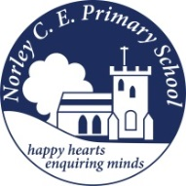
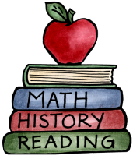
Class: 2 |  | Date to hand in: Friday 17th July
Choose at least one of the homework tasks to complete this half term.
There are several tasks that the children can complete independently.
Visit the library and find books about plants, gardens and minibeasts. You could look for both fiction and nonfiction books. If possible bring your favourite book(s) into school to share or you could write a book review to share with friends. | Find out about food or drink produced in the local area.  Can you make a dish using some locally produced ingredients? |  | What makes Norley special?  Can you make a comparison between Norley and another place you have visited?
Take a walk in your local area.  Write about what you have seen on your walk.  You could include what you saw, heard, felt and smelt. | Butterflies have symmetrical wings. This means their wings are the same on both sides.  Try making your own symmetrical shapes by folding pieces of paper in half and cutting out some pieces. When you open it out, it will be a symmetrical shape. You could also decorate it to be symmetrical too. |  | Draw a map of the journey from your house to school.  You could include a key to represent landmarks you might see along the way.
Can you make a song all about minibeasts?  Write, play, sing or record your song. | Create a drawing or painting of your favourite place in your local area. |  | Create a mini beast using natural materials in the style of our artist Andy Goldsworthy.  Take a photo of your art work to share.

