

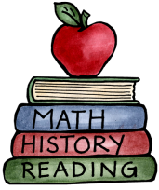
Class: One |  |  | Date to hand in: Wed 20th May
Choose one task to complete for your homework this half term. Please encourage the children to be as independent as they can.
Thank you for looking after Pom, our class bear.  Write/share a character description of you – From what you look like to what you enjoy doing and don’t forget to add your picture too! | Maths  We are looking at counting to twenty and beyond  Can you make collections of 10 or more from items you would find in or around your home?  e.g Duplo, pencils etc.  After counting out the amounts, think creatively how you can share this with us? | Reading and Phonics  Keep the daily reading going, it is making a difference and the children are enjoying changing their own books – how independent!  Keep sharing the tricky words, encouraging the children to spot them out and about, not just when they are reading their books – menus, cereal packets etc. |  | Topic  This term our topic is ‘Garden Explorers- investigating minibeasts and how our garden grows’’  Make a fact file about a Minibeast from within your garden, so we can share some amazing facts with our friends.

