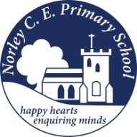
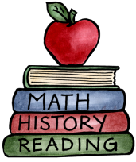
Class: 3 – Anglo Saxons and Vikings |  | Date to hand in: Wednesday 20th May
Choose at least 1 task to complete for your homework this half term. There are tasks the children can do independently.
To be completed at least 3 times a week:  - 10 minutes spelling.  - 10 minutes times tables practice.  - 10 minutes (or more) reading.  - 10 minutes discussing what you’ve read. | Design or make an Anglo-Saxon or Viking settlement/house. |  | Create a map of Britain showing the Anglo-Saxon kingdoms and how they changed when the Vikings invaded.
Write a poster explaining the different Anglo-Saxon or Viking Gods and Goddesses. | Design or make an Anglo-Saxon shield. |  | Write a message for someone using runes.
Write about the similarities and differences between yourself and an Anglo-Saxon child. Include information about their day, school, family, toys, pets and work. | Create a Viking menu. It could be fun to have a go at making a recipe or two! Take pictures of you making it. Unfortunately, we cannot bring tasters into school. Remember to include the ingredients and recipes. |  | Create a timeline for Britain during the Viking and Anglo-Saxon period.

