
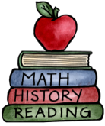
Class: Four |  | Hand in date: 31st March 2026
Choose at least ONE task from each of the coloured columns to complete for your homework this half term.
Darwin Biography  Write a well researched biography of Charles Darwin, organised into sections.  Research Biographies. What needs to be included in them? How are they written? | Unusual Characteristics  Explore and investigate unusual characteristics. Why do Kangaroos jump? Why don’t Kiwis fly? How do bats see in the dark? Why do Giraffes have such long necks?  Present your research as you choose. |  | Finches  Create top trump cards for Darwin’s Finches.  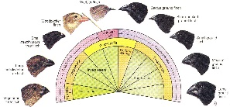
Diary or Report  Write a diary extract from the  viewpoint of Charles Darwin from his visit to the Galapagos Islands. This website might help:  http://darwin-online.org.uk/content/frameset?viewtype=text&itemID=A575&pageseq=1 | World Foods  Write a recipe for a dish from around the world.  It could be your favourite dish or something that you have never tried.  Have a go at making your chosen dish. |  | Island Design  Create a map showing your own Island. Design your Island and consider what animals will live there. How will they be adapted to live on your island?
Family Inheritance  What is inheritance?  What have you inherited from your parents? Example: eye colour, dimples, etc., but how are you different from your parents?  Write a report on your findings. | Adaptation  Draw an animal and/or plant and label the characteristics that have allowed them to adapt to their environment. |  | Timeline  Create a timeline for the development of life on Earth.

