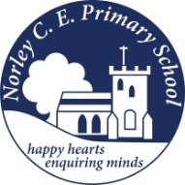

Class: Two |  | Date to hand in: Tuesday 31st March 2026
Choose at least one task from each of the coloured columns.
Create a poster to encourage people to stop global warming and the ice caps from melting.  You could include information about the effect it’s having on the animals and people who live there. | Use some building bricks (Lego, Duplo, wooden blocks) or cardboard boxes to make a model igloo. |  | Design a coat for a scientist working in Antarctica. What special features would it need?
Imagine you are on board Ernest Shackleton’s ship, Endurance. Write a diary entry of what life was like. | The Northern Lights, also known as the Aurora Borealis can be spotted in Antarctica. Can you create a piece of art work inspired by this? |  | Use a map to plot Ernest Shackleton’s journey to the Antarctic.
Can you create a poem about snow and ice focusing on your senses? | What do Inuit’s eat?  How does their diet differ from ours? |  | Look into animals which live in the Arctic. Can you draw a food chain and label it?

